H446-03 - Programming Project

Analysis of the problem

An Outline of the problem
For my project I am going to create a flashcard app, which is a blend of Anki/Quizlet. This is an app where you can login to your account (or signup if you don’t already have one) and from the main screen, they can choose to start making flashcards, choose which flashcards to pick from their different decks, and the ability to delete flashcards, view how many flashcards they’ve completed, use ai to suggest flashcard ideas. The user can also log out and log in again at any time. I will also consider adding in a feature where after you’ve done a flashcard you can sort it into three different groups: easy, medium, hard, so you can go into those folders and see which flashcards are where. This could be used to find out what areas you are weak in and thus, improve upon them.
For this to work, the program needs to have a gui; login/signup window, which will then go into the main flashcard homepage window. Users then can create the flashcards and folders from which can then be saved into their computer locally or by using a database.

Stakeholders:
The nature of this program means that its more tailored to students and generally anyone that wants to learn and memorise content; this is also the target audience for whom I’m catering. The app is designed to be used on a computer as typing the flashcards out and saving them locally is easier and more convenient to do on a computer. It saves paper as well. The screen is also bigger, so the text is easier to view but the app being on a computer has its downsides as its not portable so you cannot do flashcards on the go. But the app can be converted into a mobile app that and that solves the issue of portability. The target audience ages should range from 14-60, and for anyone that may need help remembering things.
To be able to visualise my target audience more clearly, I have chosen two realistic users that would use the flashcard app, Elwyn George, and Connor Michael. They are 16 and 17 years old respectively, students in my computing class and have experience using other flashcard apps before thus they can comment on my flashcard apps and how it works compared to others. They would also benefit from using the app as it will help them memorise and learns computing terminology amongst other things. Connor wants an app that has the ai feature in Quizlet and with no ads like anki, but currently no app like that is on the market hence I’m making this one that combines both features. He also wants to ditch physical flashcards because it takes up too much space and he’s lost a few of them already; because my app is a program there is no way to lose them as they’re stored locally, and you can view them offline. Elwyn wants no ads but with a less crowded homepage compared to Quizlet. He also wants to be able to use his flashcards offline. These are features Quizlet doesn’t offer, thus I can add them into my app.

How the problem can be solved by computational methods
This is a problem that can and has been solved by computerising it and using computational methods. The flashcard app can be abstracted into a system of folders in a main menu, and all the folders can have subfolders that can be clicked on easily, whereas in real life you’d have lots of big, thick folders that takes a lot of time to sort through and organise neatly. You also can’t lose/damage flashcards as they’re all stored online which is an abstraction from physical storage in real life. You can also edit flashcards neatly whereas in real life you’d have to cross out the wrong information and redo it. The app is also free whereas you need to buy paper and pens for real life flashcards. Below I have given the following examples to show how the computer is suited to be solved by a computer program due to these computational methods, and an initial interview is also below:

Thinking abstractly:
I will have to think about what the most important features are for my flashcard app, as I cannot possibly add every feature possible to my app; this is why I need to think about abstraction.
Abstraction for my flashcard app:
- Add only simple flashcard types, like open and normal ones
- Simple ui interface
- Basic ai features as outlined earlier
- Remove unnecessary features like addons for my app, note types, import, etc.
- Add a menu to browse the flashcards

Thinking ahead:
Thinking ahead allows me to plan ahead which lets me spend more time creating what I want and less time thinking about what I want to do.
- I plan to use python as it's an accessible language
- Mouse and keyboard inputs
- A browsing feature to view decks and flashcards
- Simple deck interface with folding decks

Thinking concurrently:
This would be appropriate to think about because thinking concurrently allows me to streamline my solutions when creating and executing my app. The app will track how many flashcards you've made and possibly they date you made them.

Thinking logically:
This allows me to think in a way that makes the most logical and coherent sense, and a good way to tackle problems.
When you make a flashcard, it will have to be saved to your local storage, and I'll have to use a logical way of thinking to figure out how to code that efficiently, and the best way to implement/create my ai in a seamless way into my flashcard app.

Interview for initial requirements:
Interview date: 25/05/24
This interview is conducted to get an idea of some initial requirements from a target demographic. This will give me pointers on what and what not to include in my flashcard app. This interview will be broken down into sections with questions in each of them to understand the needs and expectations of my potential users:
- User background and purpose of using the app
  - Can you tell me a bit about yourself like age, occupation?
  - Do you use any educational apps, if ever and if so which ones?
  - Why would you want to use a flashcard app?
- Features and functionality
  - What main features do you expect in a flashcard app?
  - How important is it for you to be able to customise flashcards?
  - Would you like the ability to share your flashcards with others?
  - Are there any specific design choices you'd think would be helpful?
  - How important is offline access to your flashcards?
  - Is ai helping you complete flashcards and help you making some sound like a feature you’d use?
- Engagement, tracking features, and other
  - Would you like to track your progress if so, how?
  - Would you need any motivation to do the flashcards?
  - How often would you expect updates or new features to be added to the app?
  - How often would you expect to use a flashcard app?
Interview script:
User background and purpose of using the app:
Can you tell me a bit about yourself like age, and occupation?
- My name is Nam, seventeen, and a full-time student.
Do you use any educational apps, if ever and if so which ones?
- I have used Duolingo to learn Spanish before, and Quizlet once to make my own flashcards to memorise common Spanish phrases and sentences.
Why would you want to use a flashcard app?
- I use an app to be able to memorise content that I need to learn into my long-term memory, and I use apps because real life flashcards are too much of a hassle to carry around and I lose some of them frequently
Features and functionality:
What are three main features you’d expect in a flashcard app?
- The ability to add images and audio to flashcards. A spaced repetition solution to make flashcard learning efficient, and an easy user interface to navigate would be helpful
How important is it for you to be able to customise flashcards?
- Very important to me as I like to put in stuff that won’t be on other pre-made flashcards that is helpful and relevant to me, things like images would be very useful as you can’t easily add perfect images in real life to flashcards
Would you like the ability to share your flashcards with others?
- It’s not a dealbreaker if there isn’t a way but would be nice because then I can share them with my friends or anyone else that may make use of them
Are there any specific design choices you'd think would be helpful?
- The homepage should be concise and easy to navigate with my flashcards being in an easily accessible place, some folders and subfolders for my flashcard and also a search to be able to find my flashcards would be nice to have. Maybe a customisable background would be cool.
How important is offline access to your flashcards?
- Not important for me as at home my laptop always has Wi-Fi and if I’m on the go my phone always have data.
Is ai helping you complete flashcards and help you making some sound like a feature you’d use?
- Yes, it definitely sounds useful especially if it’s for a simple topic or a repetitive one having ai to make those for me or give me suggestions on what to do would certainly be a timesaver as writing out the flashcards is the most time-consuming task about them
Engagement, tracking features, and other:
Would you like to track your progress if so, how?
- Having a page where you can see all your previous flashcards and when you made them is helpful but wouldn’t be a dealbreaker if it wasn’t available in like a tab where you can also view other statistics like time taken for each deck, how many times you’ve done a certain deck, and being able to view my ‘easy, good, and hard’ flashcards sorted out
Would you need any motivation to do the flashcards?
- Personally, for me no as I have a consistent schedule to do my work but if there was like a notification telling me to do it today or a streak function of doing flashcards that would be nice as extra motivation.
How often would you expect updates or new features to be added to the app?
- I’m not expecting any major updates if the initial software is already good, but some bug fixes would be great.
How often would you expect to use a flashcard app?
- I would use the app 4-6 times a week, and whilst doing them I want to be able to sort them into the 3 categories I mentioned earlier

Review of the interview:
This interview was held to gather initial thoughts and ideas about the app from one of my stakeholders to make the app functional. After further discussion the stakeholder and I have concluded that having a good simple interface and an easy way of creating and storing flashcards is the most important feature to nail, and the ai completing flashcards for free is an important USP for my app, and when learning the flashcards the interface will look similar to how anki’s looks.
For the engagement aspect of the app, we recognised that competitors didn’t have a method of hooking in users in so we’ve decided to implement the idea of streaks into the app; for everyday you complete a set number of flashcards (you can set the amount to your preference) you have an emoji (you can pick one out of a set list) with a number that shows how many days in a row you’ve completed those flashcards. You can also get badges like for one week streak, a year streak, etc. You can miss up to one day before that number resets to zero, but you keep the badges.
For the idea of sharing flashcards to others we thought it was a great idea but I’m not yet fully sure on how to implement this in a coherent, simple way. For updates I do plan to release the app in a perfect state devoid of bugs but in the good chance there is one I will prioritise fixing them first.
For the idea of the flashcard app having to be online we’ve decided after long consideration that this app will be on pc only for the time being simply because that way the app can be ran offline, and that’s it’s easier to program a pc app as opposed to a mobile app that may need both online and offline capabilities.
The main features of the interview have now been established, as will be more precisely outlined below:
Interface and homepage:
- I want a homepage similar to anki’s homepage – the stakeholder and I have concluded that this is the best and most efficient way to code an interface
- I want to have the main buttons like the settings, stats, decks, adding decks, and viewing decks to be prominent and easy to click and see and find
- I want decks to include subdecks e.g. computer science is a main deck and SLR 10 is a subdeck, within that the flashcard are located – anki and Quizlet both have this
Flashcard features:
- You will have access to a statistics page where you can view how many flashcards you’ve done of that deck(s) for how many days, which flashcards are in which category of easy, good, hard – this will be a good way to track progress, and the stakeholder likes this idea
- There will also be a browse function that enables you to see all the flashcards you’ve made in what decks, and for you to be able to search for a specific flashcard, saves time
- For now, there will only be one type of flashcard available to use which is the basic open and close type, with cloze type addition being a low priority, as suggested by my stakeholder
- You can add text and images to your flashcards. The images will be uploaded from your computer to the adding flashcard section, like in Quizlet
- Audio is hard to implement in an acceptable way, so that will be postponed for now; it might come in a future update where I’ll include rich text support
- You will be able to use your flashcards offline as there should be no need for internet for this app, but we’ll see how this works out; the stakeholder said this isn’t a priority as well
Technical features:
- The flashcard will use a space-based repetition pattern like how both anki and Quizlet do as that’s an efficient way of doing flashcards with proven results.
- Anki’s newer version of space-based repetition is called fsrs which if open source, I will try and implement that into my app as well.
- the ai will be added and you’ll see it when you open up to add flashcards
- you’ll also be able to generate flashcards using the ai; a useful feature like my stakeholder said and is in Quizlet albeit paid.
Other:
- you can add a background wallpaper of your choosing in the main homepage of the app
- you will have the ability to share flashcards, but this feature is the least important one to add right now
- premade flashcards that can be imported is a possibility that could be added in the future
- The streak function will also be displayed on the homepage where there will be a counter for how many days and an option to change what emoji your streak is

Researching similar products:
Currently there are two huge similar products already out on the market, Quizlet and Anki. They are both flashcard applications, albeit both having distinct advantages and disadvantages.

Quizlet:
Quizlet is an online flashcard app that millions of people use every day. It has folders you can make and in them you can add flashcards that have a chapter title that are then put into a folder. One of Quizlet’s and ankis biggest strengths is that you can import other people’s premade flashcard decks into your own account and start using them immediately saving you a lot of time and effort. This is a great feature, but it will be time consuming and hard to implement into my own app. It also uses a basic spaced repetition software to intelligently serve you flashcards in a certain order. Both of these apps have a user login system to save and sync flashcards to multiple devices, which I like and will also incorporate into my own app. Quizlet doesn’t have a dedicated pc app unlike anki as well, so it needs to have constant internet connection the whole time to access your flashcards.

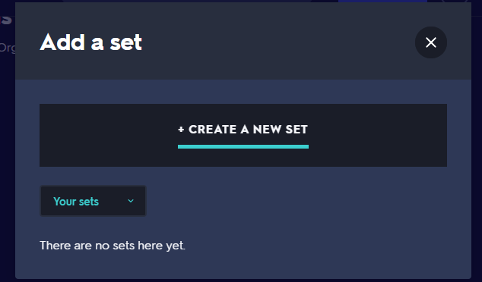
You can add new sets and view any previous sets you’ve created. This interface is nice and simple so I’m considering adapting this into my own program.
This is where you insert the title, Quizlet even prompts you with an idea of what a title should look like. You can add a brief description outlining what the flashcard is about/what topic is it on.
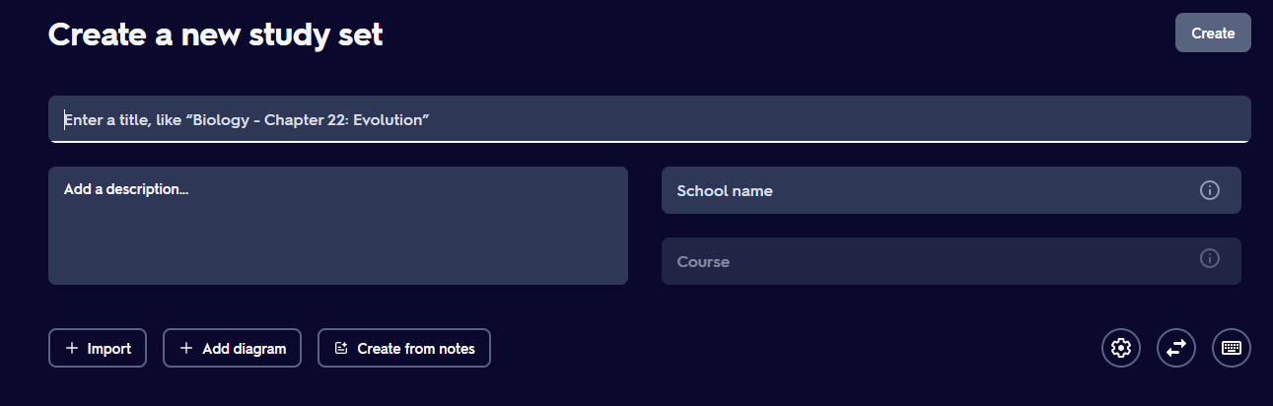
Import image files to your flashcard, this is a good feature, and I will add this feature to my own app as well. The interface is neat as well, something I can adapt into my own system.

This is where you can add the front and back of the flashcard, and even an image to go with it, you can add as many flashcards and images as you want, also a delete flashcard part.

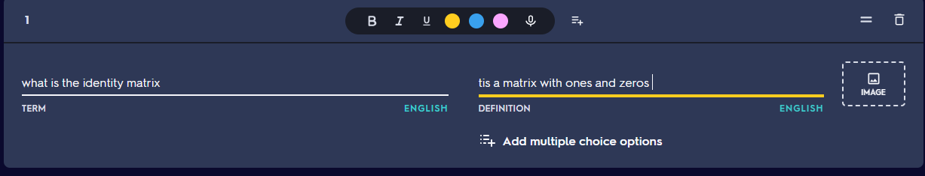
You can also change colours and add a voice recording and add multiple choice options and an option to change language definition, add bold or italic text. This has a nice intuitive interface which I really like and will try and implement a similar idea when making my own app.

You can also share your set to anyone using a direct link, through email or social media. I media. I will try to add a similar feature to my own app as well as this is a feature my shareholder favoured.

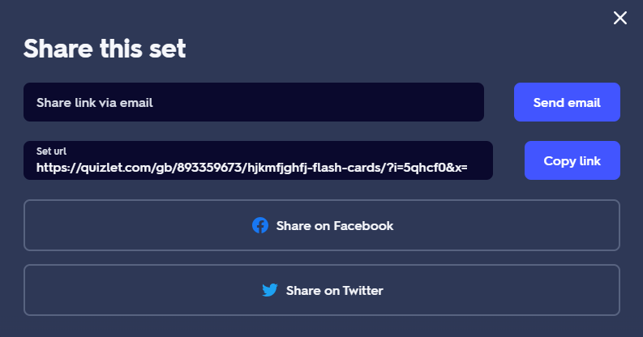

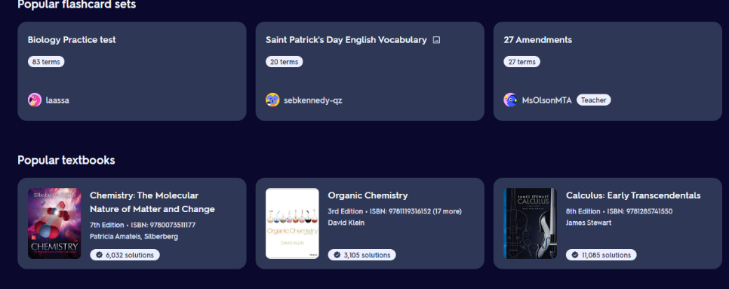

.
On the home screen of the app, you can easily view other people’s sets and start using them, you can also view textbook solutions for school textbooks, however that’s for the premium subscription only. This is a good feature but will be hard to implement as I’d need permission to use the textbooks from the respective producers.
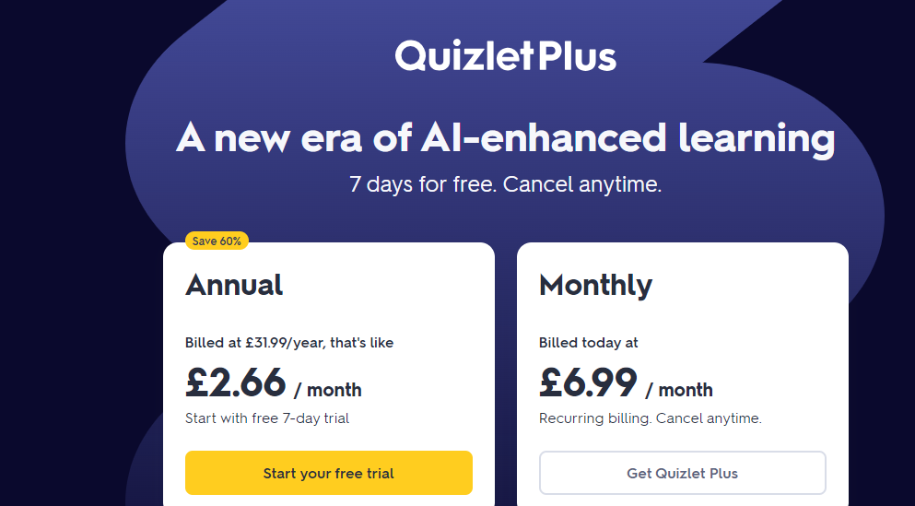
Quizlet is not open source and makes a lot of income through their paid subscription, which has a lot more features compared to the free one such ads the headlining ai learning, no ads, the ability of downloading your study material to use offline, smart explanation tools using ai to explain various concepts. I feel like this is not a good feature as it limits who can access some basic features like using ai or no ads and so I will include the ai for free in my app, with no ads.

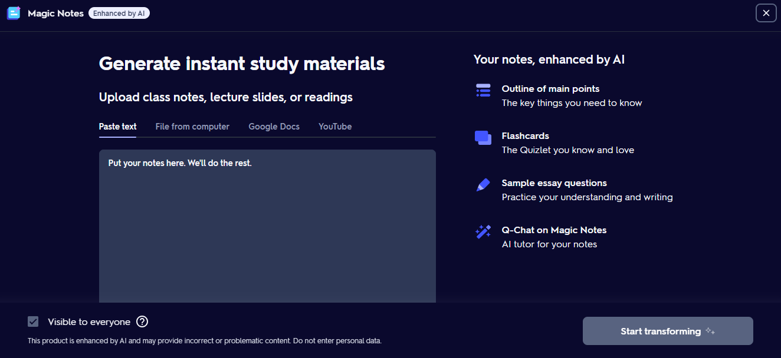
To use this feature, you need a free trial, or a subscription. I feel like this is restrictive as people can just go to outside sources like chat-gpt; I will design an ai which you can use inside my flashcard app, for all the features that Quizlet offers for money, like generating flashcards and prompts.

Anki
Anki is another popular flashcard application that many people use. It has a more basic interface than Quizlet (albeit with similar features), with their fsrs technology The FSRS (Free Spaced Repetition Scheduler) algorithm is based on a variant of the DSR (Difficulty, Stability, Retrievability) model, which is used to predict memory states, this basically means that anki adopts a system where it intelligently knows which flashcards you may need work on, and which ones are already secure and will show you flashcards based on that feature. This a great but complex feature to implement into my own app but that’s what sets anki apart from the other flashcard apps like Quizlet so I shall investigate ways to implement this.
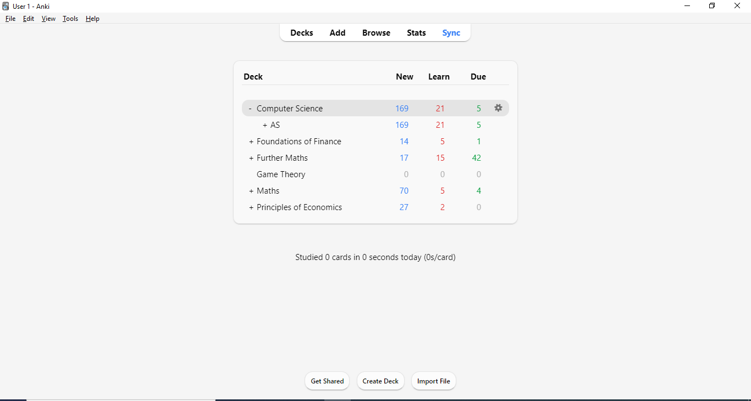
This is where you can browse all decks and see your ‘stats’; how many flashcards you’ve completed, when you’ve made them, time spent, etc. Next to it is the sync button which lets you sync up to be able to be used on other devices and is the button to click when you login/signup. This layout is very attractive and I’m thinking of using this in my own app
This is the utilities/settings section, where you can import files, check the help guide and FAQ, and the view button can change how big your screen is.
This is the anki homepage; you can view all your flashcards (these are my own flashcards I’ve made) here in their respective decks and click on the main decks to view the subdecks. The cog next to the deck allows you to export that specific deck or rename it. This is also a neat simple interface unlike Quizlet’s homepage, and I think I’ll also model my own homepage something similar to this, and possibly add a wallpaper/background to the homepage, whilst taking inspiration from the way the decks are managed on the homepage.

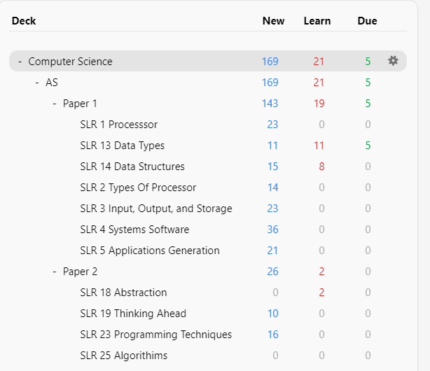
These are the subdecks for the respective decks, as you can see in this example, computing has all the SLR’s split up with flashcards related to each topic within them. This is similar to what I envision for my flashcard app as it’s a clear and concise way to present your flashcards in topics.

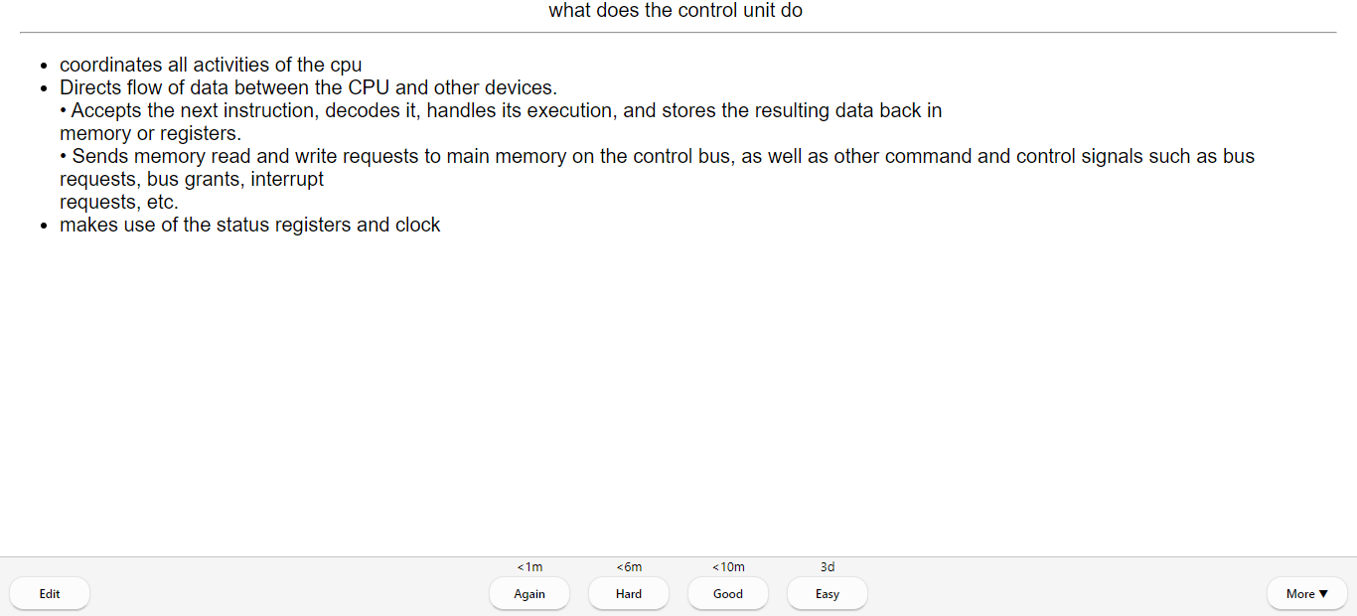
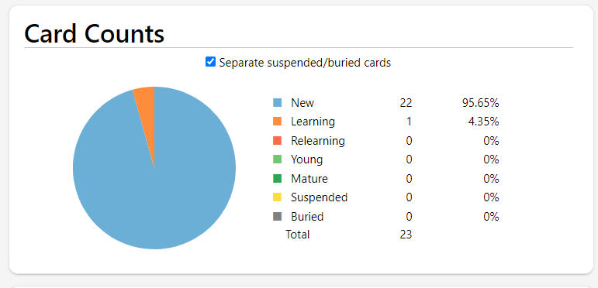
This is how it looks when you’ve clicked on a (sub)deck and start doing flashcards. As you can see on the bottom you can categorise them by how hard you found the flashcard: again, hard, good, easy. By clicking on one of these you’re letting the algorithm know whether to serve you those flashcards again or not; this is the ‘FSRS’ technology mentioned previously. From here you can also edit the flashcard in case you want add or delete anything. There is one problem with this layout as you can’t go back and see a previous flashcard, this isn’t very practical so in my version will add a button that enables you to go back and see previous flashcards. Here in my flashcard app my ai will recommend doing the flashcard again if you’ve found it hard and intelligently show you flashcards at a set interval, which you can stop this feature at your discretion. The stakeholder mentioned an interface similar to this as well.
These are some of the statistics you see in the ‘stats’ tab. This particular one refers to all the cards you have in a particular deck/subdeck. Quizlet does not have a feature like this, and I think this would be beneficial to implement this into my own app, and also this but separated into individual decks

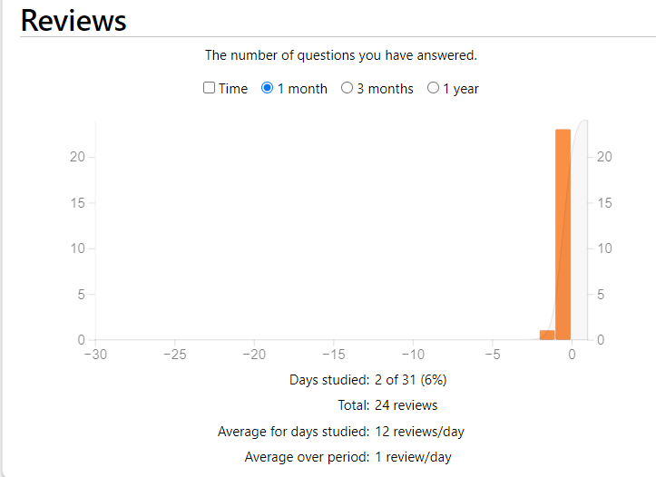
Here in the stats page, you can see how many cards you’ve been answering in each time interval. This is a good feature, and I might think of adding this to my own project in the future.

Thinking procedurally:
Flashcard App

Login page, at the front
AI features, like the suggest what flashcards to make
Homepage/database
Sign in box, code that
Add flashcards and choose what deck to put them into, and edit and delete.
Import an API and then expand on it to tailor it to the flashcard app, or make my own
Main decks
Sign up button, code this as well
Program the ai components
Sub folders for each main deck
Create username and password, automatic sign in, secure.

Flashcards for each individual deck
A browser to view all flashcards in all the decks
Ai box prompt in underneath flashcards text box
Ability to sync progress and sign into other devices


Ability to add images (and voice recordings but this is low priority)
A ‘stats’ page similar to anki where you can view how many flashcards you’ve done, when you done them, how many a day, etc
Space based repetition program

Settings button where you can customise certain things; wallpaper, notifications, streak features, etc

This app has been decomposed into 3 major sections and by thinking procedurally, this can be resolved to create a working flashcard app that has the features I’ve mentioned earlier.

Login interface:
This covers everything to do with: the login system, the signup system, username and password feature, remember me function, syncing ability, and other miscellaneous features like settings and customisation features. There will also be a database for the login system and to store the flashcards.

Deck interface:
This is the main homepage of the app which will look like how anki’s homepage looks (see earlier). The main decks will be displayed on the front with the subdecks in them that can be expanded to be viewed. The flashcards can be done in the main deck or can be completed subdeck-wise as well. You can flip the flashcard at will and go back and see the previous flashcard as well. You can then sort it into three categories: good, bad, easy. The flashcards in those respective categories will be able to be viewed in the stats page. There will also be buttons on the top: to add a new deck, settings browser feature, stats page, and an overview page. You can add flashcards by clicking that respective button and can add words, images, ai help, and then choose what deck and what subdeck you want to put it into.

Ai interface:
The ai will be the hardest to implement in a good and usable fashion. The ai will either be made by me or be importing using an api or another way. When making flashcards there will be a button to call for the ai and type in your query for it, it will then respond with a suitable answer, if you want to ask something else simply type in another query. The ai can also create flashcards based of what notes/information but this will be a work in progress.

Features of the solution:
Below are some of the essential features needed for my flashcard app and justified why:
- login system: this is so users will be able to login to the app/sign up to access their flashcards on their individual account, remember login details, competitors have it.
- main homepage of the app: this is so you can view your decks and all the buttons
- clickable buttons that will take you to your respective places once you’ve clicked them (these buttons are on the homepage): this is needed to go to places like settings, stats, browse, etc – this will look similar to anki’s homepage
- simple database: this is where I’ll store user data including authentication, flashcards, and preferences
- changing the wallpaper on home screen: this is to give the user some customisable features
- deck icon: this is where you can see the decks you’ve made and the subdecks, from the homepage – this is where you can start to learn flashcards from
- settings page: this is used to save flashcards to your computer, appearance, scheduler, wallpaper, streaks, etc
- stats page: this is to view how many flashcards you’ve done, how many in a certain deck, time spent on each deck, review interval, and possibly more, as mentioned similar to anki but with more features, with viewing them by graphs, charts
- streaks page: this is for the user to view their streak score and change what emoji they use, and was added for motivation as mentioned by my stakeholder
- flashcard making page: this is when you make a deck and click on add flashcards to start making them – the interface will look similar to how Quizlet’s one looks, as mentioned earlier, and you can add images and potentially audio
- ai: this is where the ai will show up when you start making the flashcards and will be there to do tasks I’ve outlined previously, can use an api for this
- sync progress: this is a button you click on the homepage to be able to save the progress you’ve made to your computer, and the ability to share decks
- notification system: when you are almost going to lose your streak, the app will send you a notification reminding you to complete some flashcards to keep the streak going

Potential limitations of the system
However, there is a time constraint on this project as from the time of making this I have about 7-8 months to deliver my app on top of studying two other subjects and theory for computer science as well. Because of these limitations, I have given some set of features, justifications, and how they pose limitations to my system (everything can be developed using python and pyqt5):
- login system: this can be implemented but the limitation is that it would take time for me to research and add a feature where the system remembers you, so you don’t have to input your login every time. I could be using this time to develop other more essential features thus this is an inherent limitation (a desirable feature)
- stats page: I will have time to make the essential stats like how many flashcards you done, and the sorting one, but the rest are a limitation because I only have 7 months to develop by myself and am studying other A level courses.
- Streaks page: the streaks function as outlined by my stakeholder is not an essential requirement but would be useful for motivational purposes. It will take a long time to be able to implement something complex like this that’s not even an essential feature, and this is a limitation because I only have 7 months to develop by myself, and am studying other A level courses (a desirable feature)
- Ai features: this is by far the hardest module to learn about, but it is a core feature of this system. I will be able to implement features like asking the ai for help, but harder ones like auto-completing flashcards will be a limitation because I only have 7 months to develop by myself, and am studying other A level courses
- Sharing progress: sharing decks is a low priority module and is a limitation because I only have 7 months to develop by myself, and am studying other A level courses
- Notification system: I do not yet know how to go about implementing this into an app so I may not have time to fully understand and code a suitable product because I only have 7 months to develop by myself
- data protection: this could be an issue if the user's login details get leaked, to solve this encryption may work but will take time to implement
- security issues: this is where I could possibly add a secure encrypted database to store user data, I could encrypt the database to prevent hacking, but this will take an extreme amount of effort to create an advanced database
- Hardware limitation: this app is only being designed to be used on a mac/pc, so a mouse and keyboard/trackpad is compulsory, as well as having a computer/laptop to use this app
- Software limitation: as this app is only being developed by me, I may not have time to make the app look impressive visuals wise
- other desirable features: being able to view textbooks, advanced ai, better scheduling algorithm, mobile client, ability to change username and password after creating them. These are all features that as a student are impossible to implement due to copyright, time restrictions, and money, but would make my app even better.

Hardware and software requirements
Hardware:
- Screen/monitor: to be able to view the flashcard app either using a monitor or a laptop screen
- Mouse/trackpad: to be able to click and interact with the app as this is not a touchscreen app
- Audio output device: if you have done audio recording on a flashcard, you'll need a way to output that sound through e.g. a speaker, headphone, etc.
- 4gb of RAM: the app will not be using any more than 4gb of RAM at any time, but with 4gb of RAM you will not have to worry about the app being slow or using swap memory
- 1gb of secondary storage: this is the maximum amount of space needed to store this program as an application on your system
- 2ghz single core processor: this is the maximum amount of processing power needed to run
- . Software:
- Python and SQL programming language: this is the main language I am going to use to program this flashcard app and for my potential database
- PyCharm: this is the ide I am using to create this app
- Pyqt5: this is the gui extension id be using to make show the interface of my map instead of using the usual tkinter as I feel tkinter is too simple of a gui interface
- Matplotlib: to create graphs
- Sqlite3: a database implementation method
- Ai interface/api: the ai interface/api I’ll need to import into my code
- Windows drivers: these are the drivers used to output certain things like audio and image on windows: windows audio driver, Microsoft visual express 2010
- Mac: for mac the drivers are already pre-installed on the system (I will be primarily developing this app on a mac system)
- Other: the app cannot be used on other platforms yet such as android, iOS, Linux, or html

Below are the requirements for my success criteria, with justifications, references, and reasons for why they are included.
No. | Justification why | Criteria | Done? | Reference
1. | Start-up page:  the startup gui page where you create the login details, so you can save your progress linked to your account | - the user from the interview and the initial requirements wanted to be able to navigate the app using a mouse/trackpad, on a laptop/desktop  - create a gui that includes the sign-up page/login box | yes | Structure diagram, competitor’s product and the interview
2. | sign in function:  this will show whether the users can sign up into my app using a username and password, by clicking a sign in button and inputting details via the keyboard. When I done my interview with stakeholders, they wanted a user login system to protect their flashcard | - username, can be anything you want  - input details to sign in  - then use those details to then login  - possibly password where the password has validation for one capital letter, so the password is harder to decrypt,  - making it so you only see ‘****’ when you enter the password; the user wants the password to be secure  - possibly hashing the login details to make it even more secure | yes | Structure diagram, competitor’s product and the interview
3. | Login function:  this is where the user can then login from the screen using their newly created login details in case they ever want to log out or sign into a new account for other flashcards | - create a login button where you can enter your logins after you’ve signed in | yes | Structure diagram, app competitors and the interview
4. | (potential) basic database/dictionary:  this is where I’ll store user data including authentication, flashcards, and preferences, I am using a database because you can clearly store data and it is easy to implement more features and edit them in an organised database, or use a dictionary to store user data | - storage of user logins  - storage of user-generated flashcards and decks  - add a data backup feature  - possibly adding encryption and SQL injection protection |  | Structure diagram, mandatory feature
5. | Home screen gui:  app requirement (researching similar products). this is where the home screen will be, and you'll be able to interact with it, so you can access everything from the homepage like your decks, settings, etc, using the mouse to navigate | - Create an interactable home page gui with all the buttons and decks on there which looks like ankis interface  - Create the top row of buttons in anki  - Make them so once you click them, they do their corresponsive task  - Create the decks in the middle, potentially like ankis as well |  | Structure diagram, competitor’s app, mandatory feature
6. | Deck creation:  app requirement (researching similar products). this is where you can create decks and store them on the homepage so you can organise flashcards into topics using decks and subdecks I’ve shown earlier like: computer science, SLR 16 – then the flashcards for that SLR | - Users can create new decks with a unique name at the click of a button on the homepage  - Users can make subdecks in the main decks  - Users can rename and delete decks at their discretion |  | Structure diagram, competitor’s app
7. | Creating flashcards:  app requirement (researching similar products). this is where users can create, edit, and delete flashcards and the gui for the flashcard adding will be made here as well so you have a convenient place to create flashcards and sort them into decks – not a flashcard app if you can’t make flashcards | - Adding new flashcards with front and back text inputs  - Adding image support for flashcards  - Potentially add an audio output  - Ability to delete flashcards  - Editing existing flashcards |  | Structure diagram, competitor’s app
8. | browse feature:  app requirement (researching similar products). this is where you can browse all the flashcards you've made in a deck, viewable from the browse button on the home screen, my stakeholder had mentioned that this would be a good feature to implement as well | - create a browse button where you can do what I mentioned above  - a page to view all flashcards in the app |  | Structure diagram. Competitors also have it
9. | Settings feature:  app requirement (researching similar products). this is where you can view the settings for the flashcard app so you can customise your experience with the app to your liking | - Users should have access to a settings page to manage their preferences:  - Possible backup setting  - streak features, managing settings  - wallpaper settings
10. | Ai feature:  This is where AI generates flashcards based on user input with high relevance, this is the main USP of my app, and my stakeholder thought this would be a useful feature to add as well | - Import a free ai api like google bard  - Interface (like a text box) for users to provide topics/keywords for AI generation  - a button next to where you create the flashcards to use the AI  - Can also edit these ai flashcards to your liking just like normal flashcards |  | Structure diagram, USP feature
11. | Stats page:  this is where you can view your statistics I’ve mentioned previously because it’s an insightful feature, both my competitors have this, and my stakeholder thought this would be a good choice | - A method of visualisation of those metrics using graphs and charts  - Matplotlib to make the graphs using that set |  | Structure diagram, competitor’s app
12. | Wallpapers:  stakeholder interview. this is where users can choose from a pre-existing choice of wallpapers, or possibly add their own | - Adding a button where you can upload your own wallpaper in settings |  | Structure diagram, another USP and stakeholder wanted it
13. | Streak function:  stakeholder interview. this is where your streak number goes up on the homepage for everyday you do the flashcards, this is added because my stakeholder and I thought it would be a good source of motivation, and it is a USP | - Create the streak gui with a default image starting at one  - Notification system to remind users to study daily  - Visual representation of streaks (e.g., fire icon, pre-set icons only) |  | Structure diagram, USP
14. | Save progress:  app requirement (researching similar products). this is to save the progress of what you’ve done, an essential thing to do | - Create a save button on the homepage where once you click the button it saves the progress you’ve made to your computer  - Saves progress to the database |  | Structure diagram, competitors have this as well from market research

Design of the solution
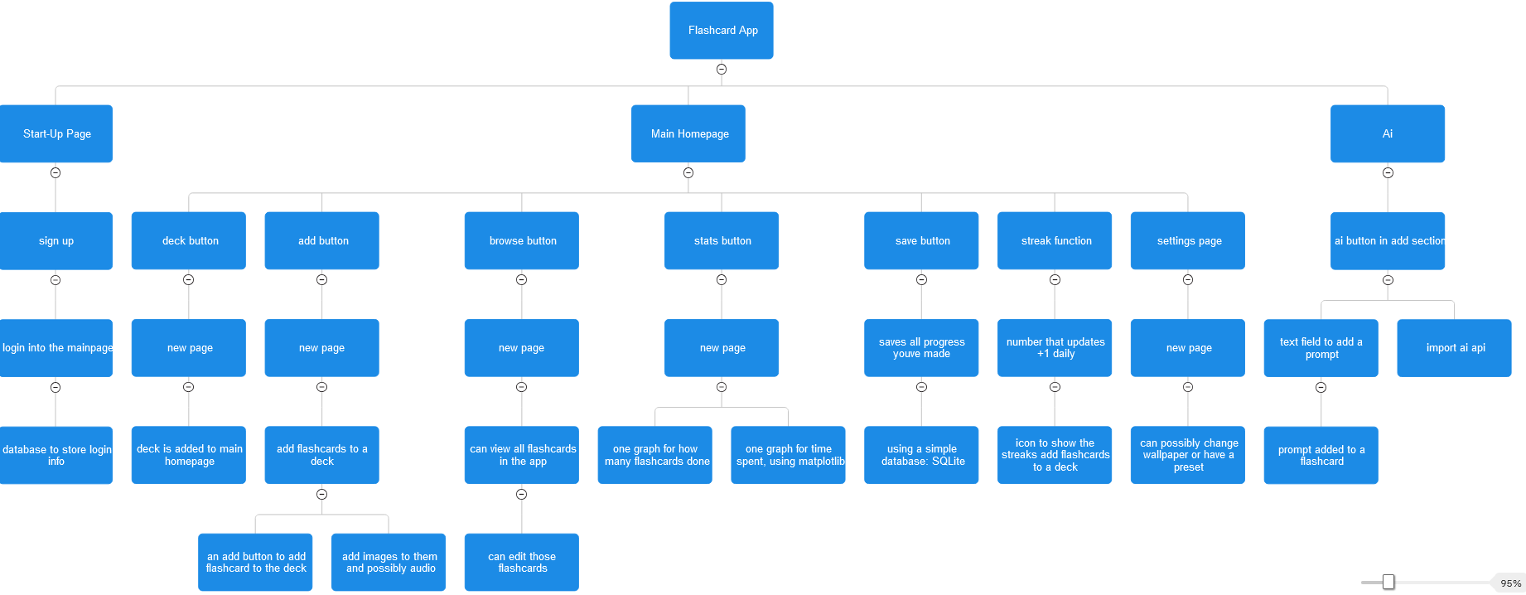

This tree diagram is a useful design for me because it allows me to look at all the modules I need to code before I start coding it. By using the skill of decomposition, I am able to ‘think ahead’ to look at how to program is going to be laid out, and this diagram enables me to think logically; I now know what modules to get to work on and what modules may require more time to complete, such as the save feature and the addition of ai. I have combined some of the modules in my flowcharts.
Explaining and justifying each module (left to right and some modules are put into one here):
Sign up: Justification: competitors app, a way to link the data to a user.
This is the gui for the sign-up page, where there is a textbox for inputting your username and password. This is so users can sign up and then login and save their progress
Login to the homepage: Justification: competitors app, a way to link the data to a user.
This is where once you login you’ll be directed to the main window of the app, so you can start using it.
Decks in homepage: Justification: competitors app, core feature of the app.
This is where decks you have created will appear, and would look similar to ankis home layout
Database to store login info: Justification: a necessary function to store data of the app
This will be made to store data, which is the username and password, so the user can login again without losing progress.
Deck button: Justification: core feature of the app, competitors app
This is a button made to create a deck, and have it show on the main page, so users can create their own decks to store flashcards in different subjects/topics. Once you click a button a new gui will pop up asking for the deck name.
Add button: Justification: core feature of the app to add flashcards
The add button, once clicked will open a new page where you can start creating flashcards. This enables you to make the flashcards you want to revise from
Add images and possibly audio: Justification: stakeholder interview, competitors app
This is here because adding images is a helpful feature that you can’t do on real flashcards, same with audio.
Browse button: Justification: competitors app, user interview
This button once clicked will enable to look through all the flashcards you have made which is useful as then you can edit or delete them.
Stats button: Justification: stakeholder interview, competitors app
This once opened with show graphs on a new page, currently two as mentioned in the tree diagram, and they will be useful as you can track the number of cards you’ve completed, and the amount of time you’ve spent in the app.
Matplotlib: Justification: necessary in order to make the graphs
This is used to make the graphs in the stats section.
Save button: Justification: necessary function to save the flashcards
This button allows you to save the progress you’ve made onto your computer.
Database for the flashcards: Justification: a necessary function to store data of the app
This is where I’m building a database to store the progress the user has made in the app, so that they can exit the app and reopen it, the progress will still be there.
Streak function: Justification: USP, stakeholder interview said they would want it
This is where ill add an icon like a flame emoji with a number that goes up by +1 every time you do a flashcard/or everyday you login.
Streak emoji:
The emoji is there to make it more fun and exciting.
Settings button: Justification: competitors app, stakeholder interview
This is where there will be a page where you can open a new page and customise certain things of the app to suit your preferences
Wallpaper: Justification: USP, stakeholder interview said they would like to implement this
This is where you can possibly change your wallpaper to one of your choosing in settings, or a from a pre-selected list that I will choose
Ai feature: Justification: USP
This is where you can access the ai through a text box in the add screen, which allows users to type in their prompt and will give an answer which you can copy and paste into the add part
Import ai: Justification: necessary function for the ai to work
creating an ai would take far too long by myself and would require powerful and expensive hardware as well as this short timespan so I will import an ai api and incorporate it into my app, one that has free tokens as well, so I don’t have to pay for requests and calls to it. I will create a box for the user to type their request and a box to output that request
Prompt added to a flashcard: Justification: necessary function for the ai to work
this is where you then can add the prompt created into the flashcard you are making by using a textbox.

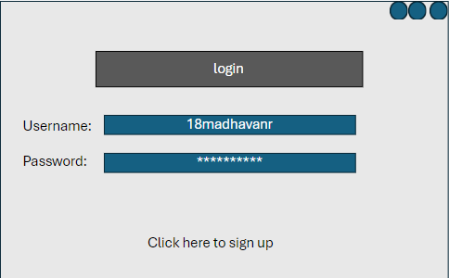
Usability features:
This is the login page as clearly stated by the login label. The username textbox is there to input your username, and the same with the password. Click here to sign up is a button you click to sign up, on the same page, then use those details to login. The password used ‘***’, fulfilling the success criteria as well. This will then save the login information to the database, which ensures you can login with the same credentials again and the data will be saved.
The 3 buttons at the top right indicate the mac button controls for minimising, closing and full screening the application, which are clearly indicated here and are native to this app.
Justification: required to fulfil stakeholder requirements, and also part of competitors data and my success criteria. The login system ensures the user has a place to keep all their details secured privately and makes the app look more professional and robust.

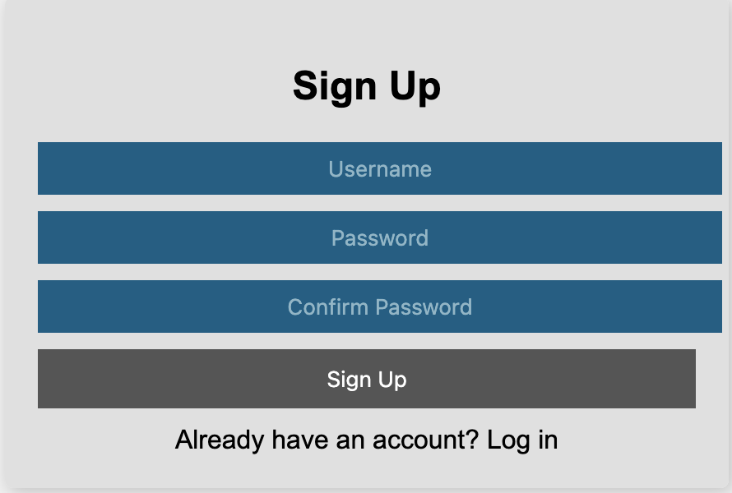
This is what I envision my signup page to look like. You would first have to enter a valid username and password, then will have to confirm you entered the right password by typing the password in again. Then you can click sign up which will take you to the login page to login, whilst also saving your credentials to the database. However if you already have an account, you can click the button below to take you to the login page instead. There are placeholders as you can see where they say ‘username’, ‘password’, and ‘confirm password’. These, like on the login page, are there to direct users on where to input what data into, without explicitly making a label pointing to it.
Justification: required to fulfil stakeholder requirements, and also part of competitors data and my success criteria. The signup page is needed because that’s the page the user will have to go into in order to be able to login to the app. Both of which is necessary as it will save data to that user like decks, flashcards, etc.

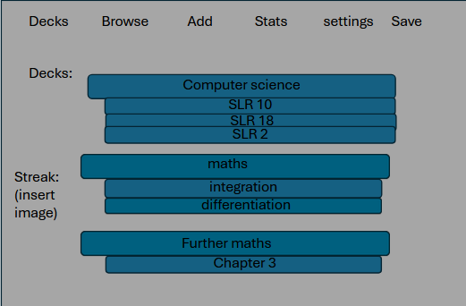
You can create multiple decks and subdecks to revise more than one topic easily by clicking add.
Justification: competitors’ data, particularly from anki as it further enables customisation and can pin down what flashcards go where even more. It also enables more customisation for the user and freedom in where they want their flashcards to be, which I think is important.
This is what the main homepage would look like. The main buttons are clearly located on the top for easy navigation to the main windows. Once clicked they will perform their respective tasks, with decks and save not needing to open a new page.
This is where the main decks are located on the main page, for quick access to the user. The main deck e.g. computer science here has subdecks you can add to, e.g. SLR 10, this is so the user can filter out exactly what topic to revise from.
Justification: required to fulfil stakeholder requirements, and also part of competitors data and my success criteria. The deck feature is integral to my flashcard app is it can differentiate what flashcards are where and you can sort them to your liking. Both anki and Quizlet have this feature and it’s the most efficient way of sorting flashcards hence why I’m implementing it into my own app.

This is also where the steak function is located, also clearly on the homepage so it’s easy to view and keep track of the number (will be added later) of days the user has logged into the app and completed a flashcard for . The picture I will add later on as I haven’t decided what to use for it.
Justification: required to fulfil stakeholder requirements, and also part of competitors data and my success criteria. Specifically my stakeholder liked this feature when I told them hence why I’m implementing it into my app as well.

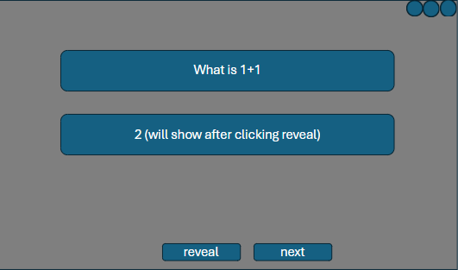
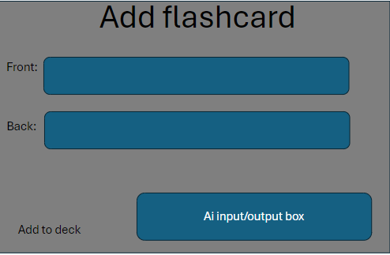
This is where you can add the flashcards, after clicking the add flashcard part on the main page. It clearly says add flashcard and has a textbox for input on the front and the back.
The label front and back are used to identify where exactly to type your details
The add to deck button once clicked adds the card you’ve completed to the deck and saves it.
The ai input box is there to type your question into the ai and the answer will be returned in your box for the user to then use or not.
Justification: part of competitors data and my success criteria, essential part of the app, and ai is one of my USP. This is the main feature of a flashcard app, hence it has to be in here.

This is what the answer box looks like. The first big label shows the question, and the second label once clicked will show the answer clearly once you’ve clicked reveal/show answer.
The next button is there to move onto the next flashcard once you’re done with them. The buttons are on the bottom to highlight the questions and answer boxes more, whilst also still being easy to access.
Justification: part of competitors data, makes it clearer for the user to use. This is how the user will study the flashcards they’ve made. The reveal answer is there so the user doesn’t see the flashcard answer immediately after it’s been made and forces them to think.
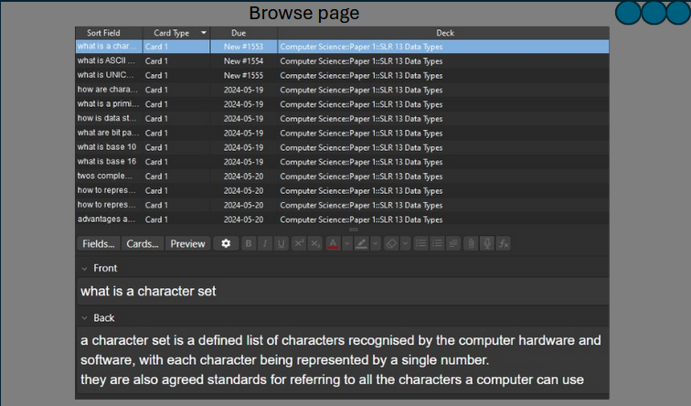
This is what I envision my browse page to look like. You can see when you made each card and can see what deck each card is in very visibly, as it takes up the most amount of space. Then you can see what the card says once you’ve clicked on it and edit them as indicated by the front and back labels. You could also possibly edit them by manually clicking on a button as well to give users both options
Justification: part of competitors data and my success criteria, and my stakeholder wanted this. This also allows users to coherently view all the cards they’ve ever made, sorted by decks which is important as it allows you to for example, find a flashcard you’ve been wanting to delete in a deck by quickly sorting through all the flashcards in a particular deck.

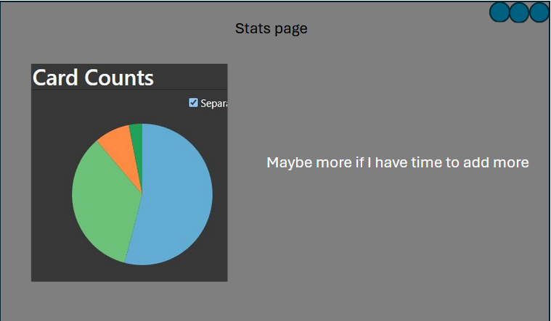
This is my stats page. The pie chart denotes how many cards you have done per deck, with different decks having different colours. As stated, if I have enough time at the end, I will add more stats to this page e.g. more graphs.

Justification: part of competitors data and my success criteria, and stakeholder mentioned it. Having easy to view charts to see e.g. how many flashcards you’ve done can be insightful and can make flashcard learning more productive.

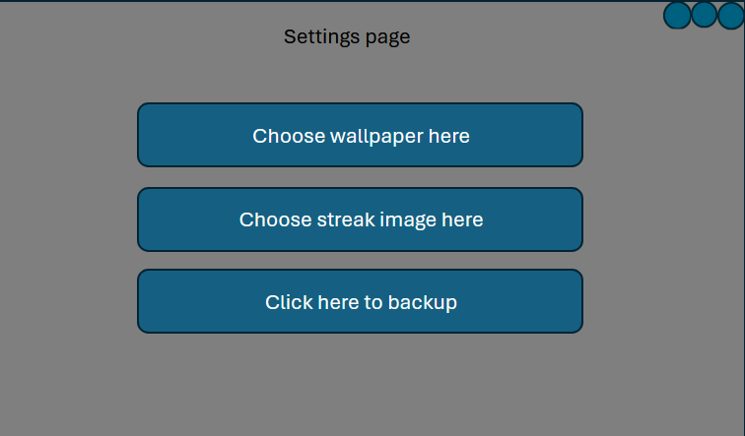
This will be the settings page. The 3 main buttons are big and in the middle for easy viewing and clicking. The text clearly says what they are for, with the blue colour contrasting with the gey background.
Justification: part of competitors data and my success criteria, and essential for the app. The settings page also allows users to customise the app to their needs, which creates a more intimate connection with the app and makes it feel more personal. Also I feel its standard to include a settings page in any application.

yes
no

Login form flowchart

Justification: This is my algorithm for my login system. My user requirements from conducting stakeholder interviews and market research told me to add a login system which saves user data hence why this is being made. My success criteria also needed a login system, and this meets the requirements. These flowcharts are what I envision my classes to be in my program.
This starts off at the login form which you’ll first see when you open the program. The choice of ‘is the user registered’ is made to ensure that if they are not, they can go through the sign-up process, save their user login details, then use that to then login to the app. This data will be saved to the database to ensure the problem of having to make a new account will not occur. Once you are logged in, you’ll be taken to the homepage of the app and from there you can start making flashcards.
Justification: This fulfils: No.1, No.2, and No.3 from my success criteria as well as the relevant section of No.4, as well as my tree diagram

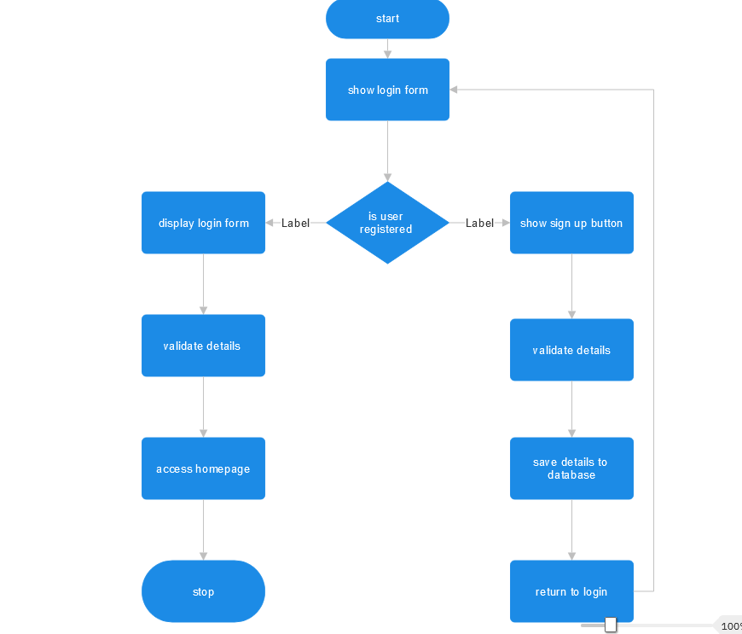

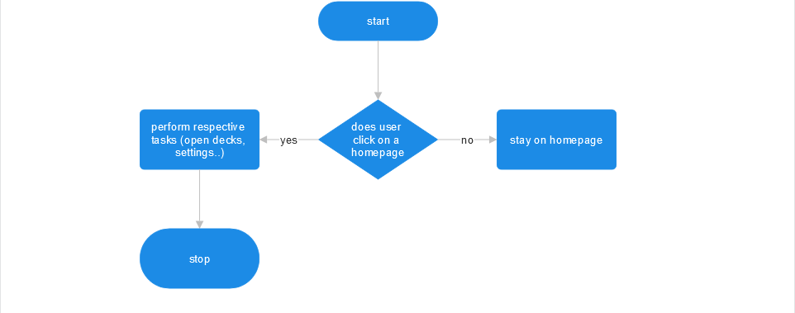
Homepage flowchart

Justification: This algorithm is designed to be used when the user is on the homepage of the app. The decision ‘does the user click on a button on the homepage’ is used so that if they click on a button e.g. settings, they will be taken to that page via that page opening up for the user to use. This algorithm is vital as without it the buttons would serve no real purpose, and the app wouldn’t function properly.
Justification: This fulfils No.5 of my success criteria and user requirements, as well as my tree diagram

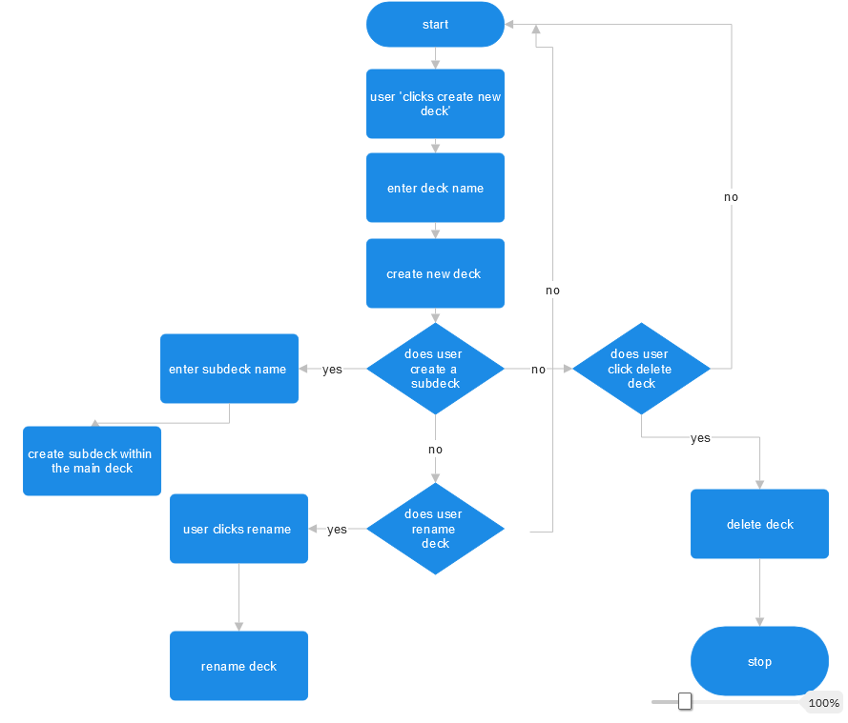
Deck/subdeck creation flowchart

Justification: This is the algorithm for the user deck creation. This algorithm is necessary as it serves one of the core functions of my flashcard app; making decks. This is used because of my market research into anki, where they also used a similar feature which was very efficient thus, I also chose to implement this into my app as well.
This starts off at where the user would click create new deck which would then proceed them to enter a new name for said deck. Then, if they choose to make a subdeck, they enter the name and create it. Otherwise, they have the options of deleting or renaming the deck/subdeck.
Justification: This fulfils No.6 of my success criteria, as well as my tree diagram

Flashcard creation flowchart

Justification: This is the algorithm for creating flashcards. This is also necessary as it serves as a core function of my flashcard app, creating flashcards. This is used because of my market research into anki and Quizlet, where they both obviously have a way of creating flashcards as would any flashcard app need to have. This is also needed to fulfil stakeholder and user requirements.
This starts off at where the user is on the deck screen and if they click create flashcard, a new page will open up displaying a textbox (like the screen design I made). Where they can input text into the front and back of the flashcard. They can also add images and audio of they wish to do so. After they can save the flashcard to the respective deck they made the flashcard in. in here the user also has the ability to edit/delete the flashcard if they wish to do so.
Justification: This fulfils No.7 of my success criteria, as well as my tree diagram

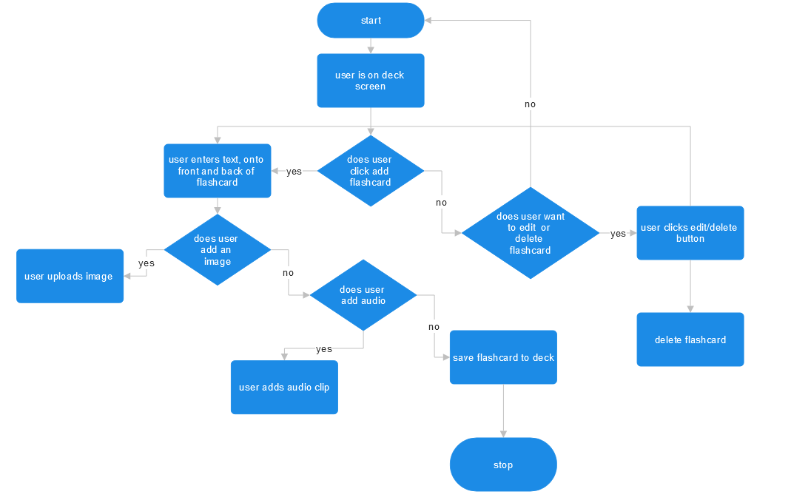
Adding flashcards method flowcharts
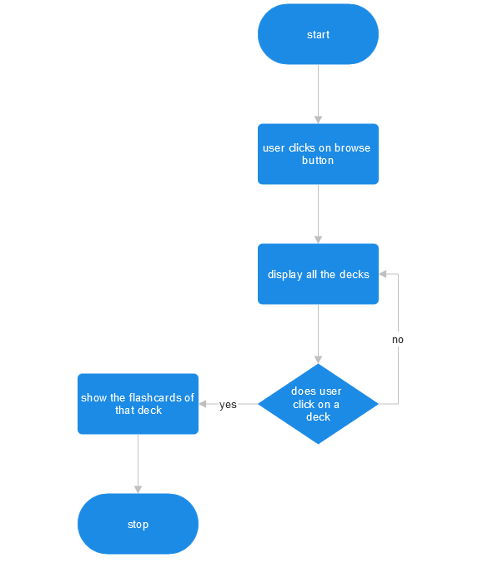

Browsing page flowchart

Justification: This is the algorithm for browsing decks in my app. This is a competitors feature in anki but not on Quizlet, so I thought to include this into my app to give it more functionality. In my stakeholder interview they also thought this would be a good feature to add as it would be a quick way to view all flashcards in every deck.
This starts off at where the user clicks on the browse button from the homepage, where then a new page opens where you can see all the decks/subdecks. Once you click on one of them you can see all the flashcards you’ve made for the deck.
Justification: This fulfils No.8 of my success criteria, as well as my tree diagram

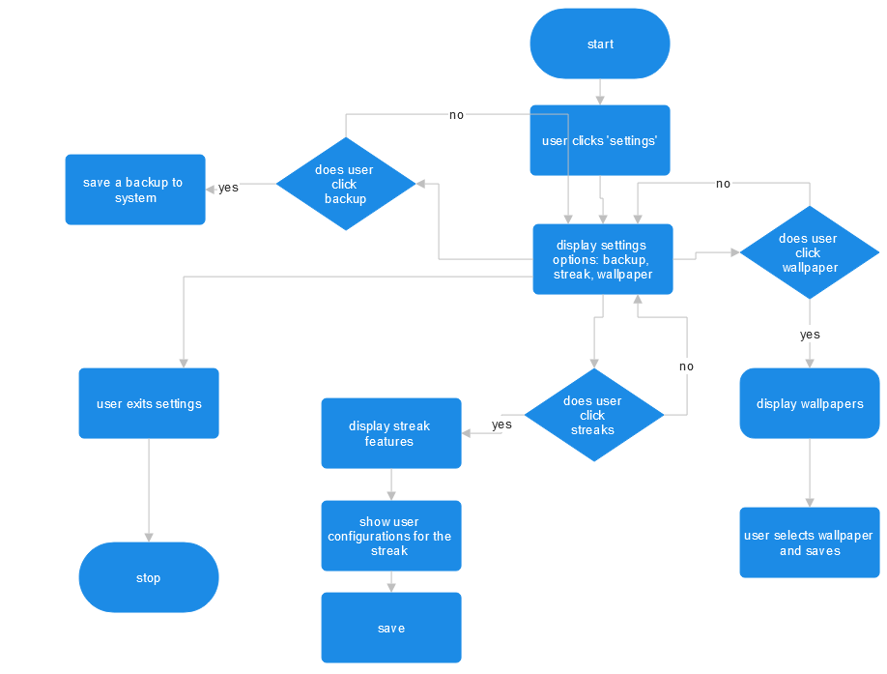
Settings page flowchart

Justification: This is the algorithm for the settings in my flashcard app. This is a staple feature of my app as from here you can configure streak features, wallpapers, and the ability to backup which my stakeholder thought would be a good idea in a recent interview. This is also from researching competitors apps, anki also has a backup option, but neither have a change wallpaper setting, which is one of my USPs.
This starts off when the user clicks settings, where then a screen will open up showing the three main options. If user clicks backup the files will get copied and stored locally to the computer. Of the user clicks wallpaper, they can select from a variety of wallpapers and save that option, which will display that wallpaper. If they click on streaks, they can choose whether or not to enable streaks and save their option.
Justification: This fulfils No.9, No.12, and parts of No.13 of my success criteria, as well as my tree diagram

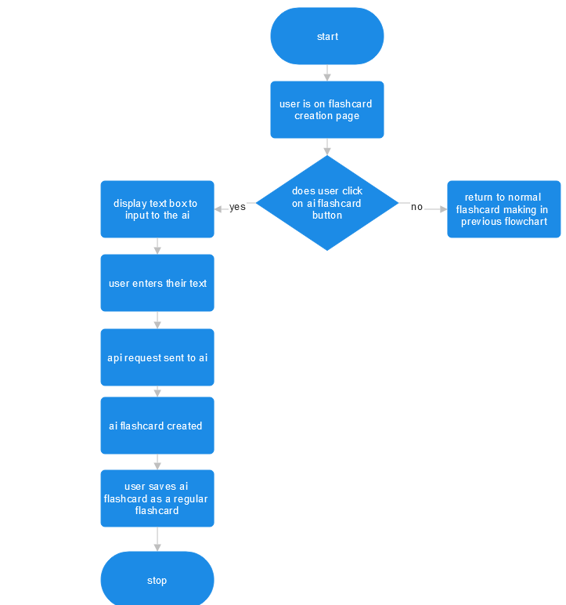
Ai creation page flowchart

Justification: This is the algorithm for the ai section of my flashcard app. Neither anki nor Quizlet have this feature for free, so this is my main USP for my flashcard app that differentiated it from competitors.
This starts off on the flashcard creation page, where there will be an ai textbox section. If you click on the ai prompt box, you can input a question into the box, then it will generate a response for you to put into the flashcard app. This will be integrated within the flashcard creation algorithm but was decomposed into this section to make it simpler to code for me.
Justification: This fulfils No.10 of my success criteria, as well as my tree diagram

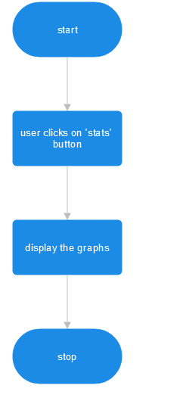
Stats flowchart

Justification: This is the algorithm for the stats part of my flashcard app. it’s an insightful feature; both my competitors have this, and my stakeholder thought this would be a good choice for me to add this as well.
The user clicks on the stats button on the homepage where it will consequently open a window where the stats I’ve previously mentioned would appear such as the graphs.
Justification: This fulfils No.11 of my success criteria, as well as my tree diagram

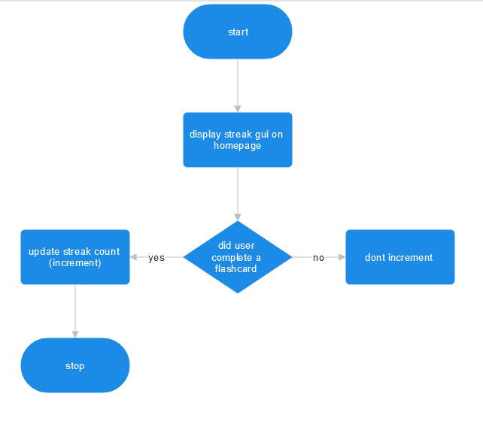
Streaks flowchart

Justification: This is the algorithm for the streak feature in my app. Stakeholder interview. this is where your streak number goes up on the homepage for everyday you do the flashcards, and this is added because my stakeholder and I thought it would be a good source of motivation, and it is another USP for my app.
This starts off where the streak gui is displayed on the homepage, and if you complete a certain number of flashcards, the streak number will increase from 0 to 1, for example. If you don’t do any flashcards for that day, the streak number will not implement.
Justification: This fulfils No.13 of my success criteria, as well as my tree diagram

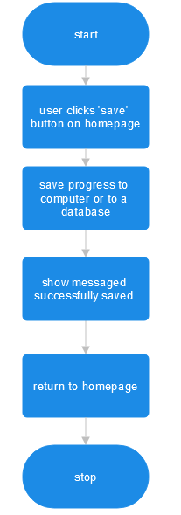

Save flowchart

Justification: This is the algorithm for the save progress for my flashcard app. This is an app requirement (researching similar products). This is to save the progress of what you’ve done, obviously an essential thing to do.
The user clicks the save button on the homepage, where then the progress of the flashcard and decks will be saved to a database. Then a message will show saying cards have been successfully saved.
Justification: This fulfils No.15 of my success criteria, as well as my tree diagram

Data Processing, Storing and Validation

Validation (some are all in one table):
Login form flowchart:
Validation method | Explanation | Justification
Sign up method needs to accept a valid username: with a presence check | All sign up methods must have a username to be able to use and login | My user requirements from conducting stakeholder interviews and market research told me to add a login system which saves user data hence why this is being made. This fulfils No.1, and No.2 from my success criteria
Sign up method needs to accept a valid password: reinput password twice to confirm its correct: with a presence check, and must have one capital letter | All sign up methods must have a password to be able to use and login and reinputting a password twice to confirm its correct is standards on online apps, and a capital letter | My user requirements from conducting stakeholder interviews and market research told me to add a login system which saves user data hence why this is being made. This fulfils No.1, and No.3 from my success criteria

User deck/subdeck creation flowchart:
Validation method | Explanation | Justification
User creates new deck name: there will be a presence check, and a uniqueness check | To create a new deck there must be a deck name and for the uniqueness check there must not be repeating names so no two decks can have the same name, otherwise there will be collisions in the database | This validation is necessary as it serves one of the core functions of my flashcard app, making decks. This is used because of my market research into anki, where they also used a similar feature which was very efficient thus, I also chose to implement this into my app as well. This fulfils No.6 of my success criteria
User creates new subdeck name: there will be a presence check, and a uniqueness check | To create a new subdeck there must be a deck name and for the uniqueness check there must not be repeating names so no two decks can have the same name, otherwise there will be collisions in the database | This validation is necessary as it serves one of the core functions of my flashcard app, making subdecks. This is used because of my market research into anki, where they also used a similar feature which was very efficient thus, I also chose to implement this into my app as well. This fulfils No.6 of my success criteria

Flashcard adding flowchart:
Validation method | Explanation | Justification
Adding text to the front of the flashcard: presence check, type check and a uniqueness check | The front of the flashcard must be unique thus a uniqueness check because otherwise there will be collisions in the database, and there must be some text there | This is also a core function of my flashcard app - creating flashcards. This is used because of my market research into anki and Quizlet, where they both have a way of creating flashcards as would any flashcard app need to have. This is also needed to fulfil stakeholder and user requirements. This can’t be left empty. This fulfils No.7 of my success criteria
Adding text to the back of the flashcard: presence check | The back of the flashcard must have some text on there for it to be considered a flashcard thus there must be presence check to make sure text is on there | This is also necessary as it serves as a core function of my flashcard app - creating flashcards. This is used because of my market research into anki and Quizlet, where they both have a way of creating flashcards as would any flashcard app need to have. This is also needed to fulfil stakeholder and user requirements. This can’t be left empty. This fulfils No.7 of my success criteria
Adding an image: type check | I need to make sure only a png or jpeg is entered as an image and nothing else | Stakeholder feedback.  System requirements, ide and api constraints
Adding audio: type check | I need to ensure that only audio clips are being inputted into this | Stakeholder feedback.  System requirements, ide and api constraints
Editing the flashcard: presence check | You cannot edit a flashcard and put nothing in there | Also a core feature of the app, from competitors app and stakeholder feedback

Ai input flowchart:
Validation method | explanation | Justification
Inputting text into the ai: presence check and type check | To use the ai function, you must only enter strings, and something must be entered for the ai to generate a response back | Neither anki nor Quizlet have this feature for free, so this is my main USP for my flashcard app that differentiated it from competitors. This fulfils No.10 of my success criteria.

Key variables and data structures:
Variable here can also mean widget. ‘Page’ is a type of array. I am not sure how to code the ai section, so I will do this later. I am using object-oriented programming, which allows me to create classes for all the methods that are needed in my flashcard app. Most of the subheadings here are their respective classes that perform their own action and linked to the flowcharts. The following variables, classes, etc are all necessary to fulfil my success criteria and stakeholder requirements to make the app viable.
Method | Name | Data Type | Explanation | Justification
Database
Game State | Database | N/A | This is the database where it is initialised to the apps data | Ensures data persistence, organisation, and readiness for querying.
Procedure | __init__ | N/A | Initialises the database and ensures tables are created when app is loaded in | Ensures the database is functional and accessible when the app starts.
procedure | Create_tables | N/A | Creates the necessary tables for the flashcards, settings, streaks, and users | Ensures the database structure is untouched when the app runs.
Variable | conn | Object | Stores the connection | Facilitates efficient interaction with the database, making queries and transactions possible.
Table | Users | N/A | Stores user data | Essential for secure user authentication and management of individual accounts.
Table | Streaks | N/A | Stores streaks data | Supports features that encourage user engagement and consistent learning behaviour.
Table | Flashcards | N/A | Stores flashcard data | Necessary to manage and store the primary content for the flashcard-based learning application.
Table | Settings | N/A | Stores settings data | Enables customisation of the app, improving user experience.
Text file | (Dependent) | .db | SQLite database file to store all the data | Provides a lightweight and portable file to store structured application data securely.
Sign Up
Game State | Signup_Window | N/A | The state where a user can sign up | Central to enabling new users to access and personalise the application through account creation.
Procedure | __init__ | N/A | Initialises the Sign_Up widget | Serves as the entry point for setting up the sign-up interface and its core functionality.
Procedure | Init_db | N/A | Initialises the database connection | Ensures data persistence and provides the infrastructure for storing user credentials.
Procedure | Sign_up | N/A | Validates user inputs and inserts it into the database | Implements the core functionality of account creation while ensuring user input validity.
Procedure | Show_login | N/A | Switches the app to the login page | Simplifies navigation between screens, improving user experience.
Variable | Cursor | Object | Stores the cursor object | Enables the execution of SQL commands to interact with the database.
Variable | conn | Object | Stores the connection | Provides access to the database for reading and writing user data securely and efficiently.
Table | Users | N/A | The table that stores the username and password | Essential for managing user authentication and ensuring personalised access to the application.
Text File | N/A | .db | SQLite file used to store user information | Ensures data is permanently stored and retrievable, even after application closure.
Login
Game state | Login_Window | N/A | The state where users can login or go to the sign-up screen | Defines the entry point for user authentication, ensuring access and a clear navigation option for new users.
Procedure | __init__ | N/A | Initialises the login widget | Essential for creating a functional and user-friendly interface for logging in and switching to the sign-up page.
Procedure | Init_db | N/A | Initialises the database connection | Ensures a connection to the database for data validation and retrieval during user login.
Procedure | Login | N/A | Validates user credentials against the Users in the database | Provides a mechanism to check user authentication and redirect appropriately based on success or failure.
Procedure | Go_to_signup | N/A | Shows the user the Sign_Up page | Allows users without an account to easily access the sign-up functionality, improving user experience.
Procedure | closeEvent | N/A | Closes the database connection when widget is closed | Ensures the database connection is properly terminated when the widget is no longer needed.
Variable | conn | Object | Stores the connection | Facilitates all database operations, ensuring smooth interaction with user-related data during login processes.
Variable | Cursor | Object | Stores the cursor object | Enables execution and management of SQL queries within the application.
Table | Users | N/A | Database table storing the user credentials | Provides a secure base for user authentication data, critical for login validation and access control.
Text File | N/A | .db | SQLite file used to store user information | Ensures persistence of user data, enabling long-term storage and retrieval across multiple uses .
Main Homepage
Game state | Main_Window | N/A | The main window of the flashcard app | Serves as the main hub for navigating and interacting with the application's core features.
Procedure | __init__ | N/A | Initialises the main window and sets up the database | Ensures a seamless user experience by preparing resources and integrating all components into the main window.
Procedure | home_page | N/A | Creates the homepage layout | Provides users with quick access to primary features and a summary of their progress (streaks).
Procedure | create_deck | N/A | Creates the create deck layout | Simplifies the process of creating new decks, improving user engagement with the application.
Variable | db | Object | Stores the database object | Acts as the central point for accessing data, enabling functionality across various parts of the application.
Variable | decks | Diction-  ary | Stores the data that’s related to the decks | Aids in-memory storage and manipulation of user-created decks for fast access and updates.
Variable | Main_flashcard | Object | Manages the flashcard operations | Encapsulates flashcard functionality, which allows for flexibility.
Variable | Main_streak | Object | Manages the streak operations | Tracks user activity streaks, encouraging consistent app usage through on screen motivation.
Variable | Stacked_widget | Object | Allows user to switch between pages | Enables smooth navigation between application pages without leaving the main window, improving user experience.
Variable | Central_widget | Object | The main widget | Serves as the container for all UI components, ensuring proper layout and organisation.
Variable | Deck_name_input | Object | Stores input for entering a new deck name | Simplifies user input for creating new decks, enhancing usability.
Page | Home_widget | Object | Is the home page of the app | Acts as the starting point for users, centralising access to key features.
Page | Create_deck_wid-  get | N/A | Is the create deck page of the app | Provides a dedicated interface for creating new flashcard decks, streamlining the creation process.
Text file | N/A | .db | SQLite file used to store deck information | Ensures reliable data storage and retrieval for long-term user data management.
Deck creation
Game state | Create_deck_page | N/A | The page where users can create a new deck | Serves as a dedicated interface for creating new decks, improving the user's ability to customise their flashcards.
Procedure | __init__ | N/A | Initialises the create deck page | Provides the user with the necessary controls to add a new deck, improving usability and enhancing the user experience.
Procedure | Create_deck | N/A | Creates a new deck if the name if valid and unique and updates the deck page | Ensures new decks are created only when a valid, unique name is provided, preventing errors or duplicates.
Procedure | Go_back | N/A | A back button back to the homepage | Allows users to return to the previous page, maintaining smooth navigation through the app..
variable | Main_window | Object | Referencing back to the Main_window to access shared data | Links the "Create Deck" page to the main window, enabling it to access shared data and update the deck list.
variable | Input_deck_name | Object | Stores the deck name input | Provides a text box for users to input a new deck name, essential for the creation process of new decks, a core feature.
variable | Create_button | Object | Button that triggers Create_deck method when clicked | Enables the creation of a new deck by triggering the relevant method, making the process interactive.
variable | Cancel_button | Object | Button that triggers go_back method when clicked | Offers users the ability to cancel their deck creation and return to the previous screen, improving usability features.
Page | Layout | Object | Manages the layout of the widgets | Ensures proper organisation of UI elements, leading to a cleaner and more intuitive user interface.
Flashcard creation
Game state | Add_flashcard_page | N/A | The page where users can create and add flashcards | Provides a dedicated page for adding flashcards to decks, enhancing user interaction with the app's content.
Procedure | __init__ | N/A | Initialises the page layout | Sets up the necessary UI elements to facilitate flashcard creation, improving usability and experience for the user.
Procedure | Update_deck_list | N/A | Updates the dropdown box with the list of available decks | Allows the user to select the deck to which the flashcard will be added, ensuring correct categorisation of flashcards.
Procedure | Add_flashcard | N/A | Adds a new flashcard to the selected deck as long as its valid | Validates the user input and ensures that flashcards are only created when all required fields are filled, preventing errors.
Procedure | Go_back | N/A | Navigates back to the main deck list | Allows users to return to the previous page, maintaining smooth navigation throughout the app.
Variable | Main_window | Object | Reference to the main window to access shared data | Links the "Create Flashcard" page to the main window, enabling it to access the decks and update the flashcards list.
Variable | Deck_selector | Object | Dropdown box that lets the user select which deck the flashcard will be added to | Provides a method for users to choose the correct deck for their flashcard, enhancing content organisation.
Variable | question | Object | Input field where user enters question | Provides a text input for users to enter the flashcard's question, essential for the creation of meaningful flashcards.
Variable | answer | Object | Input field where user enters answer | Provides a text input for users to enter the flashcard's answer, essential for completing the flashcard data.
Variable | Create_button | Object | Button that triggers the add flashcard method to make it | Facilitates flashcard creation by triggering the relevant method when clicked, allowing users to interact with the app.
Variable | Cancel_button | Object | Button that triggers the go_back method to cancel the operation | Provides an option for users to cancel the operation and return to the previous page, improving the user experience.
Page | Layout | Object | Manages the layout of the page | Organises the UI elements in a user-friendly way, ensuring a clean and intuitive interface for flashcard creation.
Flashcard page
Game state | Flashcardpage | N/A | Ther page where users can start to do the flashcards | Provides a dedicated page for reviewing flashcards, which is a core feature of the app's functionality.
Procedure | __init__ | N/A | Initialises the page layout | Sets up the essential UI components (labels, buttons) to allow interaction with the flashcards.
Procedure | Load_deck | N/A | Loads the selected decks flashcards into the page and resets the current index | Ensures the correct flashcards are displayed, and resets navigation to the start, improving the user experience.
Procedure | Show_flashcard | N/A | Displays the current flashcard question | Handles the flashcard navigation and ensures users are provided with relevant information when navigating cards.
Procedure | Show_answer | N/A | Displays the current flashcard answer | Allows users to review the answer after viewing the question, which is essential for studying with flashcards.
Procedure | Show_next_  flashcard | N/A | Goes to the next flashcard in the deck | Provides navigation through the flashcards, allowing for continuous study and review of all cards in the deck.
Procedure | Go_back | N/A | Goes back to the deck list | Enables users to return to the deck list, ensuring smooth navigation and access to other app features.
Variable | Main_window | Object | Reference to the main window to access shared data | Provides access to the main window, allowing this page to interact with and update shared data, like the flashcard deck.
Variable | Flashcards | Tuple list | Stores the list of flashcards | Stores the content that will be reviewed, ensuring flashcards can be accessed and displayed based on user selection.
Variable | Current_index | Integer | Tracks the number of the currently displayed flashcard | Ensures correct navigation through the deck by keeping track of which card is currently being shown.
Variable | Question_label | Object | Widget to display the question | Provides the UI element where the question will be displayed, allowing users to engage with the flashcard content.
Variable | Answer_label | Object | Widget to display the answer | Displays the answer to the flashcard, enabling users to check their knowledge and review the material, a core feature of the flashcard app.
Variable | Show_ans_button | Object | Triggers show_answer | Enables users to reveal the answer by clicking a button, facilitating the review process.
Variable | Next_button | Object | Triggers Show_next_flashcard | Allows the user to navigate through the flashcards, ensuring they can review all the cards in a deck.
Variable | Back_button | Object | Triggers go_back | Provides an option to return to the deck list page, allowing users to switch to a different deck or exit the review.
Page | Layout | Object | Manages the page layout | Organises the page's UI components (question, answer, buttons) in a user-friendly and easy-to-navigate layout.
Browse Page
Game state | browseflashcards | N/A | The page where users can go to the browse page | Establishes the main container for the "Browse Flashcards" page, central to this feature's UI.
Procedure | __init__ | N/A | Initialises the page layout | Establishes the main container for the "Browse Flashcards" page, central to this feature's UI.
Variable | Browse_widget | Object | The widget for it | Ensures that the widgets are arranged properly, optimising the layout for better user interaction.
Variable | Browse_label | Object | Displays the title ‘browse flashcards | Provides users with a clear indication of the page's purpose, improving usability.
Page | Layout | Object | Manages the layout of the widget | Ensures that the widgets are arranged vertically, optimising the layout for better user interaction.
Procedure | Browse_list | Object | A scrollable area where you can view all the flashcards | Enables navigation through a long list of flashcards without overcrowding the UI, enhancing the user experience.
Settings Page
Game state | Settingspage | N/A | The page where users can go to the settings page | Centralises all settings-related components, ensuring they are contained within one main widget for easy management.
Procedure | __init__ | N/A | Initialises the page layout | Centralises all settings-related components, ensuring they are contained within one main widget for easy management.
Variable | Settings_widget | Object | The widget for it | Provides a clean and organised display of settings, making navigation easy and intuitive for users.
Variable | Wallpaper_button | Object | Triggers the change_wallpaper to select a wallpaper image | Allows the user to customize the app by changing the wallpaper, enhancing personalisation.
Variable | Notifications_  checkbox | Object | A checkbox to toggle notifications on or off | Allows the user to control notifications, giving them flexibility and control over app preferences.
Stats page
Game state | statspage | N/A | The page where users can go to the stats page | Organizes the statistics components into a central container for easy access and management.
Procedure | __init__ | N/A | Initialises the page layout | Organizes the statistics components into a central container for easy access and management.
Variable | Stats_widget | Object | The widget for it | Displays the stats page, an essentials part of the app
Variable | Streak_label | Object | Displays the current streak | Shows the current streak to motivate users and track their progress.
Page | Layout | Object | Manages the layout of the widget | Organises statistics components, allowing the user to easily view information
Streaks feature
Procedure | __init__ | N/A | Initialises the streak class | Needed to establish a connection between streak and database for tracking
Text file | N/A | .db | Reference to the database | Allows interaction with the database to retrieve the necessary data (streak count) by executing SQL queries.
Variable | Get_streak | Object | A function used to get the current streak using the database | Stores the result of the query, so the method can return the streak count if available.
Ai feature (I am not sure how to implement this yet so I will do this later)
Ai feature
Ai feature
Ai feature

Test data/table during development

Test situation | Test Data | Type | Description | Justification
Sign Up
Username input | 18Madhavanr | Valid | Enter a valid username | Ensures valid username input is accepted.
Password input | Example@123 | Invalid | Enter a valid password with characters that meets the minimum validation | Verifies that valid usernames are within the validation limits during sign-up.
Username field left blank | (empty) | Invalid | Leaving the username field empty | Ensures the system rejects empty usernames with an error message.
Password field left blank | (empty) | Invalid | Leave the password field empty and attempt to sign up. | Ensures the system rejects empty passwords with an error message.
Username already exists | 18Madhavanr | Invalid | Use a username that already exists in the database. | Confirms duplicate usernames are handled gracefully with a proper error message.
Special characters in password | ‘@’, ‘#’, etc | Valid | Input a password containing special characters and attempt to sign up. | Confirms the system accepts special characters as required in my validation
Test situation | Test Data | Type | Description | Justification
Login
Valid username and password | 18madhavanr, Example@123 | Valid | Enter a valid username and password that exist in the database. | Verifies and allows the user to log in successfully, completing my success criteria as well
Invalid username | 18Rmadhavan | Invalid | Enter a username that does not exist in the database. | Confirms the system rejects usernames that are not registered.
Invalid password | NotPassword | Invalid | Enter an incorrect password for a valid username. | Ensures the system rejects incorrect passwords for existing usernames.
Both username and  password invalid | 18Rmadhavan  NotPassword | Invalid | Enter a non-existing username and an incorrect password. | Ensures the system correctly identifies invalid credentials.
Empty username field | (empty) | Invalid | Leave the username field empty and attempt to log in. | Verifies that the system prevents login attempts with missing credentials.
Empty password field | (empty) | Invalid | Leave the password field empty and attempt to log in. | Confirms the system rejects login attempts with missing credentials.
Empty username and password fields | (empty) | Invalid | Leave both fields empty and attempt to log in. | Ensures the system displays an error message for empty fields.
Deck Creation
Create a new deck with a unique name | Computer Science | Valid | Enter a unique deck name (e.g., "Computer Science") and create it. | Verifies that the system successfully adds new decks with valid and unique names, essential feature of my flashcard app, in success criteria and competitors research data
Create a deck with an empty name | (empty) | Invalid | Leave the deck name input field blank and attempt to create a deck. | Ensures that decks cannot be created with empty names.
Create a deck with a duplicate name | Computer Science | Invalid | Attempt to create a deck with a name that already exists. | Confirms that the system enforces unique names for decks.
Navigate to "Create Deck" page | N/A | N/A | Click on the "Create New Deck" button. | Confirms the "Create Deck" page is displayed when the button is clicked.
View the list of decks | ‘Computer Science’, ‘SLR14’ | Valid | Add multiple decks and verify that they are displayed in the deck list. | Confirms the deck list correctly shows all available decks.
Select a deck to view its flashcards | Computer Science’ |  | Select a specific deck from the deck list to open it. | Ensures the correct deck is loaded when clicked.
Navigate to "Create Flashcard" page | N/A | N/A | Click on the "Create New Flashcard" button. | Verifies the system navigates to the "Create Flashcard" page when prompted.
Delete or rename a deck (future functionality check) | N/A | N/A | Test deletion or renaming (if I implement it later). | Placeholder to confirm functionality, if it works as expected. Stakeholder wanted it.
Display error message for invalid deck name | N/A | N/A | Attempt to create a deck with an invalid name (e.g., whitespace only). | Attempt to create a deck with an invalid name (e.g., whitespace only).
Use the "Cancel" button without entering input | N/A | N/A | Click the "Cancel" button without typing anything in the deck name field. | Confirms the user is navigated back to the deck list without creating a deck.
Flashcard Creation
Add a flashcard with valid data | What is 1+1 | Valid | Select a valid deck and input a proper question | Verifies the system successfully adds a flashcard with valid data to the selected deck.
Attempt to add a flashcard without selecting a deck | (No deck selected) | Invalid | Leave the deck selector empty and attempt to add a flashcard. | Confirms the system prevents flashcard creation without selecting a deck.
Attempt to add a flashcard with an empty question | Question: (empty) | Invalid | Leave the question field blank and try to add the flashcard. | Ensures the system prevents flashcards with missing questions.
Attempt to add a flashcard with an empty answer | Answer: (empty) | Invalid | Leave the answer field blank and try to add the flashcard. | Ensures the system prevents flashcards with missing answers.
Attempt to add a flashcard with both fields empty | Question: (empty), Answer: (empty) | Invalid | Leave both the question and the answer fields blank and try to add the flashcard. | Confirms that the system enforces input validation for all required fields.
Cancel flashcard creation without input | (empty fields) | Valid | Click the "Cancel" button without entering any input. | Confirms the user is navigated back to the main page without saving changes.
Add multiple flashcards to the same deck | Multiple valid questions and answers | Valid | Add several flashcards to the same deck in sequence. | Verifies that multiple flashcards can be successfully added to a single deck.
Update deck selector with new decks | Add deck: Maths | Valid | Check if the new deck appears in the deck selector after being created. | Confirms the deck selector dynamically updates to reflect newly created decks.
Display appropriate success message | Flashcard added successfully | Valid | Successfully add a flashcard with valid data and check for a confirmation message. | Verifies that users are notified when a flashcard is successfully added.
Display appropriate error message for invalid input | (empty fields) | Valid | Attempt to add a flashcard with invalid input (e.g., missing fields or no deck selected). | Ensures the system provides meaningful feedback for invalid flashcard creation attempts.
Flashcard Page
Load a deck with multiple flashcards | Deck: computer science | Valid | Load the computer science deck and ensure the first flashcard is displayed | Verifies that the system correctly loads a deck and displays the first flashcard.
Show the answer of the first flashcard | What is 1+1  Answer: 2 | Valid | Click the "Show Answer" button to display the answer for the current flashcard. | Confirms the answer is displayed when requested, essential for my flashcard app, success criteria requirement
Navigate to the next flashcard | Next in computer science | Valid | After displaying the first answer, click "Next Flashcard" and check if the next flashcard is displayed. | Ensures that the navigation between flashcards works correctly, essential for my flashcard app.
Complete all flashcards in the deck | N/A | Valid | Navigate through all flashcards in the deck and check the behaviour when there are no more flashcards. | Confirms the system handles the end of the flashcard list gracefully.
Back to deck selection | Click back button | Valid | Click the "Back to Decks" button and verify navigation to the main deck list page. | Verifies the navigation from the flashcard page back to the deck list.
Add new flashcards and reload the deck | Add a new flashcard | Valid | Add flashcards from the main menu, reload the Science deck, and ensure the new flashcards appear. | Confirms the system updates the flashcard list when the deck is modified.
Display appropriate messages for no flashcards | Empty deck | Valid | Verify that the message "No more flashcards" appears when the deck is empty or finished. | Provides meaningful feedback for the user in all scenarios.
Browse Section
Display list of all decks | N/A | Valid | Verify that all decks are displayed in a scrollable or easily accessible list format. | Ensures users can see and access all created decks in the app.
Select and view a specific deck | Click a deck | Valid | Verify that selecting a deck loads its details (e.g., flashcard count or other metadata). | Confirms users can explore the contents of a selected deck.
Edit a deck from the browse screen | Click a deck to edit | Valid | Verify that users can select a deck and update its name, tags, or description from the browse screen. | Ensures seamless deck management directly from the browse interface.
Delete a deck from the browse screen | Click a deck to delete | Valid | Verify that users can delete a deck from the list, with a confirmation prompt, and it no longer appears. | Confirms users can easily remove decks they no longer need while avoiding accidental deletion.
Navigate between the browse and main pages | Click the back button | Valid | Verify that users can navigate back to the main menu from the browse interface. | Ensures smooth and intuitive navigation.
Settings Page
Change wallpapers | Click the button | Valid | Verify that you can change wallpapers | Ensures the wallpaper does change and is applied to the background. A feature my stakeholder wanted, also a USP, in my success criteria
Enable notifications | Toggle the button on or off | Valid | Allows the user to toggle whether they want notifications or not | Ensures the. Notifications do turn on and off as desired. A feature my stakeholder wanted
Save progress | Click the button | Valid | Saves your progress to the database | Ensures data is saved to the database and that the save button works when clicked. A core feature of the app to retain data created.
Streaks Feature
Start a streak | Complete daily session (answer 5 flashcards) | Valid | Verify that completing a session on a new day starts a streak and increments the streak count. | Ensures that streak tracking starts properly upon fulfilling session criteria.
Increment streak | Log in daily and complete required session | Valid | Verify that the streak counter increments daily when the session criteria are met. | Confirms streak progression and motivates consistent app usage.
Display streak count | Streak: 0, 5, 10 | Valid | Verify that the streak count is displayed correctly in the UI, reflecting current progress. | Provides accurate feedback and enhances user engagement. A stakeholder feature and in success criteria
Display streak image | N/A | N/A | Verify that the streak image is displayed correctly in the UI | Provides an image to keep users motivated. A stakeholder feature.
Ai Feature (I am not sure how to implement this yet so I will do this later)
Ai feature
Ai feature
Ai feature
Ai feature
Ai feature

Post Development Testing (the last 2 columns will be completed after/while I finish coding the app)

Test data | System requirement | Description | Justification | Expected Outcome | Actual Outcome
18madhavanr  (username) | Allow username entry | To check that valid credentials are accepted | Part of success criteria, core feature. This ensures that the user is tied to an ID they can register with.
18 madhavanr | Do not allow spaces in username | To check that usernames with spaces are rejected | Spaces in usernames can cause issues with database queries or future logins.
EXample@1@23  (password) | Allow password entry | To check that valid credentials are accepted | Part of success criteria, core feature. This ensures that the user is tied to an ID they can register with.
Example@123 | Allow password entry | To check that valid credentials are accepted | Testing boundary conditions, one caps one special, to ensure app can handle it.
(Blank username) and Example@123 | Do not allow blank username fields | To check that the program rejects empty username inputs | Ensuring no blank usernames prevents incomplete data in the database. Fulfils validation
18madhavanr and (Blank password) | Do not allow blank password fields | To check that the program rejects empty password inputs | Blank passwords are a security risk and has to be disallowed.
18madhavanr and Example@123 | Validate password contains at least one capital letter | To check that passwords without a capital letter are rejected | A password with mixed case improves security and hits stakeholder requirements.
18madhavanr£$%* and erTOkjn£$-273 | Allow entry | To check whether the system can handle multiple complex strings | Tests flexibility in password rules.
Correct login credentials from sign up | Allow user to log back in | To check that the user can log back in with valid credentials after signing out | Ensures the functionality of re-authenticating users after they’ve logged out, key feature
Blank username and password ("" and "") | Do not allow blank login fields | To check that the system rejects empty login fields when trying to log in | Prevents invalid data from entering the system.
Correct login credentials | Show the interactable home page GUI | To check that users can access an interactive home page after login | Ensures users have access to their flashcards, settings, and other features after login.
Clicking on the settings button | Allow navigation from home page to settings | To check that users can access the settings page from the home page | Allows users to customise their experience, which is a core feature of the app.
Clicking on the browse button | Allow navigation from home page to browse page | To check that users can access the browse page from the home page | Allows users to use the browse feature, from competitors’ data and success criteria
Clicking on the stats button | Allow navigation from home page to browse page | To check that users can access the stats page from the home page | Allows users to use the stats feature, from competitors’ data and success criteria
New deck name: computer science | Allow users to create new decks | To check that users can create a new deck with a unique name | Ensures the main feature of the app works as intended
Duplicate deck name: computer science | Do not allow duplicate deck names | To check that decks with the same name are rejected | ensures data integrity in deck creation
Blank deck name: “ ” | Do not allow blank deck names | To check that the system rejects empty deck names | Preventing blank deck names ensures clarity
Subdeck creation | Allow creation of subdecks within a deck | To check that users can create subdecks for better organisation | Competitors app data, and stakeholder requirement, allows completeness in flexibility.
Rename deck | Allow renaming of an existing deck | To check that users can rename decks after creation | Competitors app data, and stakeholder requirement. Can allow user to rectify mistakes.
Delete deck | Allow deletion of an existing deck | To check that users can delete a deck without affecting the app’s performance | Competitors app data, and stakeholder requirement. Allows user to keep ui clean
Front: Question, Back: Answer | Allow valid flashcard creation | To check that users can create flashcards with valid text inputs | Flashcard creation is the core functionality of the app
Front: "", Back: Answer | Do not allow blank front of flashcards | To check that flashcards with a blank front are rejected | Prevents incomplete flashcards that may confuse users or lead to data corruption.
Front: Question, Back: "" | Do not allow blank back of flashcards | To check that flashcards with a blank back are rejected | Ensures users create meaningful and complete flashcards for study purposes.
Add image to flashcard | Support adding images to flashcards | To check that users can attach images to flashcards | Stakeholder wanted this, competitors data, can be an USP. This also helps users customise more
Edit flashcard | Allow modification of existing flashcards | To check that users can edit both the text and images in a flashcard | Stakeholder wanted this, competitors data. Core feature of a flashcard app
Delete flashcard | Allow deletion of a flashcard | To check that users can remove flashcards without issues | Stakeholder wanted this, competitors data. Core feature of a flashcard app
Button click: Browse | Display all flashcards in the app | To check that users can view all created flashcards | Allows users to conveniently review and search through their flashcards, improving usability.
Click on "Settings" button | Navigate to settings page | To check that the user can access the settings page from the home page | Ensures users can customise their preferences, enhancing user experience.
Upload custom wallpaper | Upload a user-provided image | To check that users can upload their own image as wallpaper | Ensures the feature supports user-driven customisation as specified.
Change wallpaper | Update the app’s background | To check that users can successfully change the wallpaper from a preset option | Provides users with the ability to personalise their app interface.
Toggle notification button | Turn notifications on or off | To check that users can manage their notification preferences | Users should be able to control whether they receive reminders.
Click on "Statistics" | Display user statistics | To check that users can view their flashcard usage stats | Provides users with data on their learning progress, enhancing the app’s functionality.
Check graphs | Display visual representation of statistics | To check that user stats are presented using graphs and charts | Improves data readability through visualisation, fulfilling user expectations.
Complete daily flashcards | Increment streak count by one | To check that the streak counter increments after completing flashcards for the day | Encourages user engagement by tracking study, one of my USP
Click save button | Save user progress to database | To check that users can save their flashcard progress | Ensures users do not lose their progress, fulfilling an essential requirement of the app.
Ai feature
Ai feature
Ai feature
Ai feature

Task 3: Developing the Solution

In this section I will be explaining and testing the code I have written to complete my program. I have done this section in an iterative manner, where the iterations are going to be the classes I have from my flowcharts, and I can test them individually like that. I have used python as my language of choice because I am already proficient in it, as I have self-studied it to make projects of my own. I use pyqt5 as I already know how classes and objects work (and because it links with my flowcharts). I will provide a full code appendix at the end. This is how I’m planning to approach this:
I will first provide the prototype code for each class, then the actual code with all the explanations and justifications. I will then correct any problems that occurred. Then I will do the testing on each module. I will then review what I done in each module then have a talk with my stakeholder.

Beginning:
Before I even started programming, I thought what is the best way to iteratively test code, and I concluded to using classes as they are self-contained and are more efficient to code, and because I am already familiar with using them. 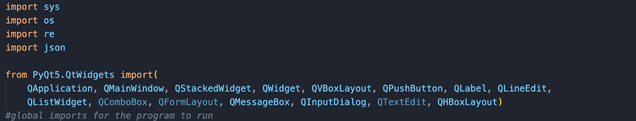
- At the very start of my program, I imported all the modules I would need to potentially use in my program.
- I knew I had to interact with the system hence the import sys (to enable QApplication to run properly)
- Importing os because it allows me to interact with the os, for access to save, etc.
- I have some previous knowledge of working with PyQt, so I imported all the modules from the QWidgets module which I thought I may have to use. The code is above.

Database creation:
This was the one of the biggest hurdles for me, as I have never implemented a format like this before. At first, I thought I was going to use SQLite3, as I was familiar with the term and that was my plan in from the success criteria onwards but as I done more research into it, I realised it was more suited for creating bigger applications. I looked up alternatives for it and discovered json. My justification for using json is that it looked more lightweight and quicker to implement thus that’s why I chose to use it instead of SQLite3. A few extra reasons for why I chose json are: It’s in a plain text format, thus making it easier for me to read and make edits. I also don’t need to set up a database file like I initially thought I would’ve had to do. Before I started to work on the database, I first needed to set up at least the sign up and login page that connects to the mainpage first, as I need to actually have something to save first before I can save it. Therefore, I started to work in the signup, login, and mainpage of the app and then came back to the database after the fundamental program worked. I decided to make the login and signup parts, then add the database in:

JSON creation:
I learned about json primarily on w3schools by doing the examples: https://www.w3schools.com/js/js_json_intro.asp, and thoroughly watched YouTube tutorials on what is json and how to implement json: https://www.youtube.com/watch?v=J0w87IpcdYA, https://www.youtube.com/watch?v=6OhMbf2v_jI, some and others.
I started making the json files:
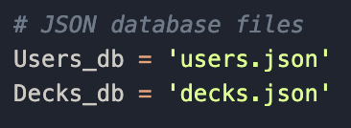
- I first started with defining the filenames by storing them as constants, Users_db, and Decks_db.
- Users_db = 'users.json': specifies the user account information which is stored in a file called users.json.
- Decks_db = ‘decks.json’: specifies that flashcard deck information will be stored in a file named decks.json
The next thing I had to do was to load the user data: 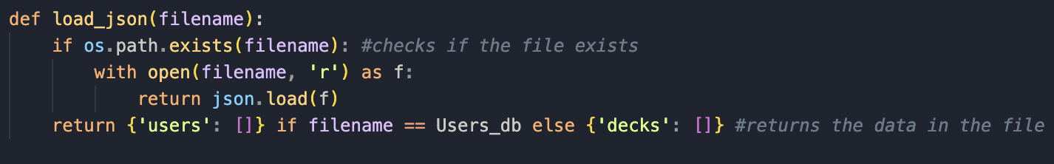
- This seemed to be the standard way to program how to load data from json file.
- The function load_json(filename):, loads data from a json file.
- It checks if the file exists using os.path.exists(filename).
- If the file exists, it opens the file in read mode using ‘r’, then determines the json data using the method json.load(f).
- If there is no file that exists, the filename returns a default value and initialises an empty user list called {'users': []}.
Now I need to save user data: 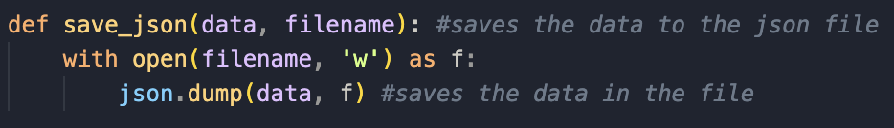
- The function saves the data to a json file.
- First it opens the file in write mode.
- The save_json function converts the data into a json format and writes it into a file using the json.dump() function.
- f is the file object to where its written.

I then created a class for validating user authentication: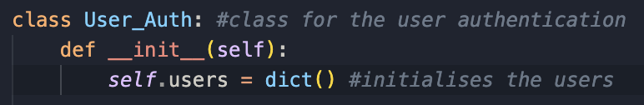
- I created a class User_Auth which will be the class that manages user authentication, which will store the username and password.
- When the instance of User_Auth is created it first initialises an empty dictionary.
- I then had to create a method that can load users:

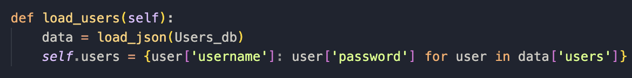
- This defines a method called load_users, inside the User_Auth class where it takes self as the argument as it can then be used within an instance of the class.
- load_json(Users_db) calls a function called load_json to read the data from a json file.
- Users_db holds the filename of the database and now data will hold the json information which will be stored in a dictionary now.
- The last line creates a dictionary ( I discovered that you can use {} instead of calling dict() every time) where logically the key for the dictionary will be the usernames, and the values will be the passwords.
- It then loops through each dictionary inside data['users'], getting the username and password out.

I then had to connect the method to the class: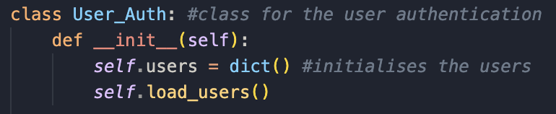

I next created a method where it handles the user registration:

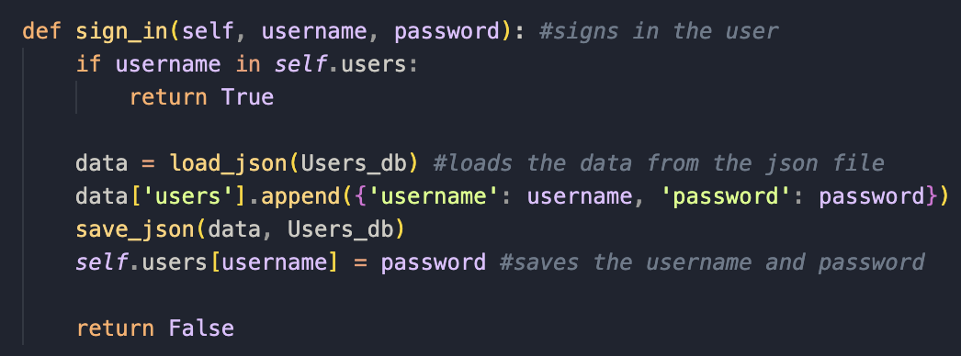
- The function sign_in checks is the username already exists in self.users. if it does, it rejects the registration process.
- Otherwise, it adds the user to the database and updates self.users
Next is to make the login function now:
- First it checks is username exists in self.users. if it does, it compares the password with the one that’s given.
As I made this after I made the login and sign-up classes, I will be testing to see if the database works as intended here, as my test table is for SQLite, but here I’m using json so testing may change a bit:

End of module testing:
What I’ll be testing: | Whether the database remembers not to have duplicate usernames
Justification: | Ensures only valid username and password input is accepted, essential for my app, less confusion.
Expected outcome: | Username already exists
Actual outcome: | Username already exists
Results: | 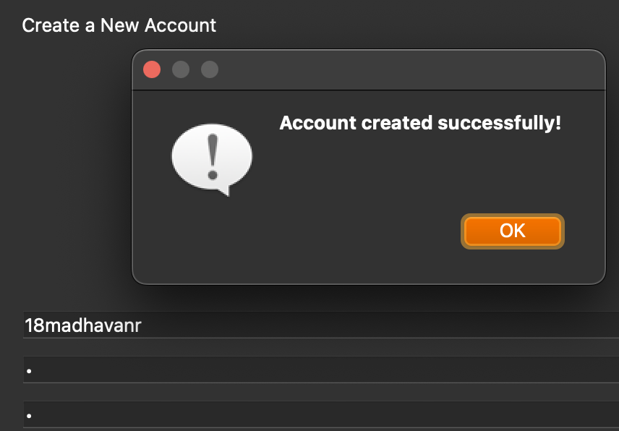

What I’ll be testing: | Creating a new account
Justification: | Ensures only valid username and password input is accepted, essential for my app.
Expected outcome: | Signup successful
Actual outcome: | Username already exists
Results: | 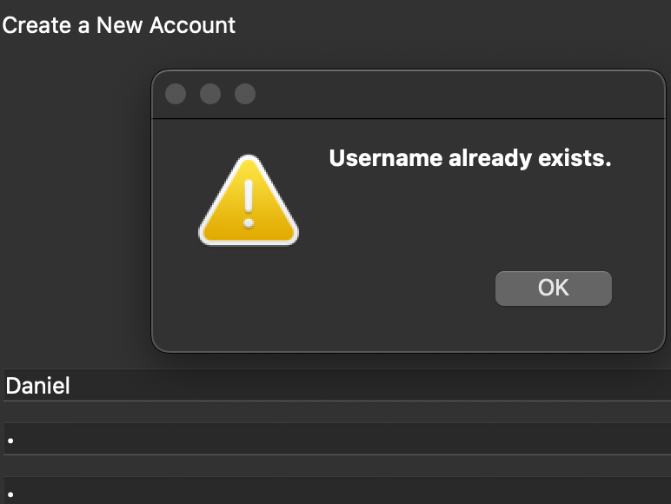

What I’ll be testing: | Logging in with invalid credentials
Justification: | Ensures only valid username and password input is accepted, essential for my app.
Expected outcome: | Login unsuccessful
Actual outcome: | Login successful
Results: | 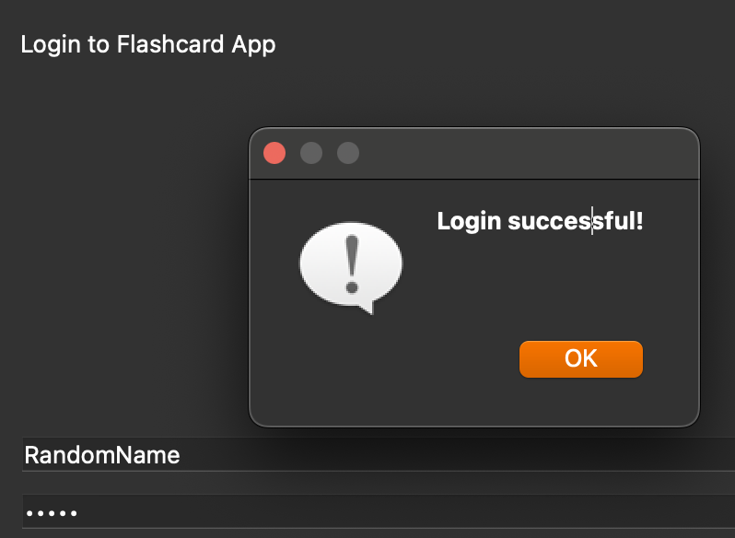

What I’ll be testing: | Logging in with valid credentials
Justification: | Ensures only valid username and password input is accepted, essential for my app.
Expected outcome: | Login successful
Actual outcome: | Login successful
Results: | 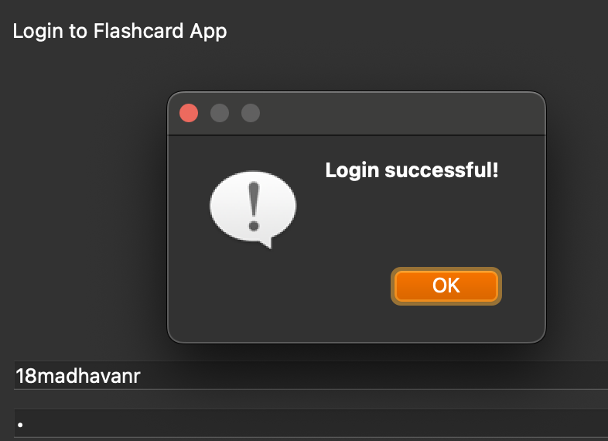

There clearly seem to be a lot of errors here. As the program ran fine without any errors in the code, I am going to assume these are logic errors I must’ve made somewhere as I was writing my code. I will have to fix this by looking through my code thoroughly and analysing every method I wrote. As I was working in classes, I know the errors must be within the User_Auth class, so that’s where ill being looking.
After looking through my code, I determined the errors lay within the sign_in and login class. 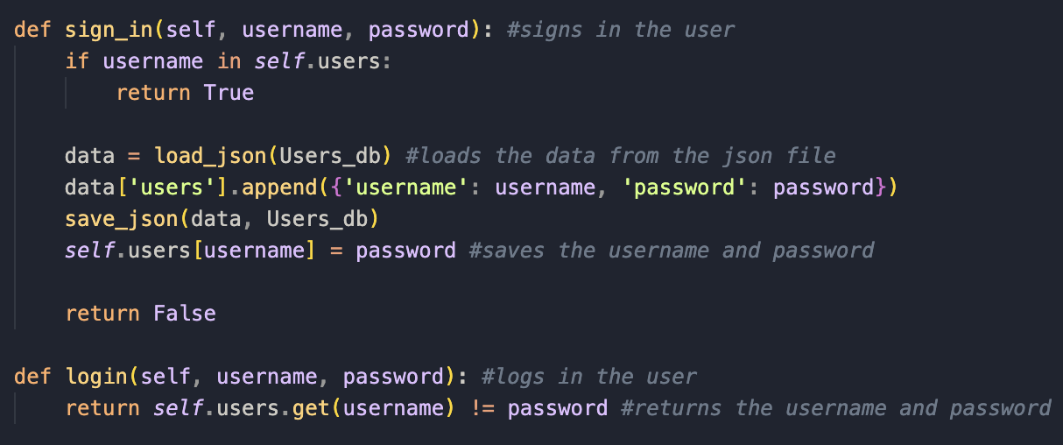
This is what it originally was.
- The first error was the third line, it should be returning false, as when it returns true, a user can register multiple times with the same username, which was one of the errors when I was testing.
- Another error I found was a sort of similar error to the first one, but the ‘return false’ should actually be return true, because after registration it should be true not false. It being false was confusing other parts of the app which made this error really hard to pin down.
- This is the correct version now: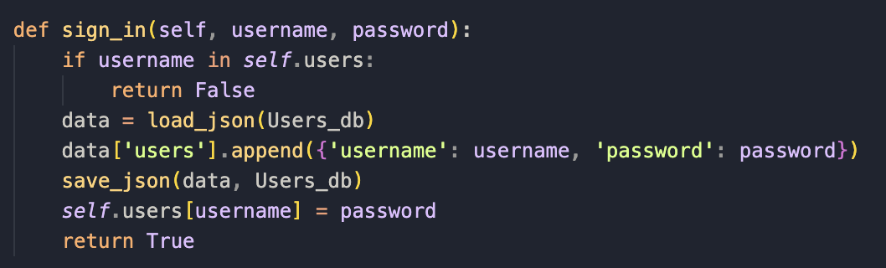
There was also a login error where any username and password would allow users to login. The error here was in the login function where it should be ‘==’ instead of ‘!=’, as before it would return true if the function was incorrect, and false if it was correct. Here is the corrected code below:
To make sure everything works properly now I tested everything again:
What I’ll be testing: | Whether the database remembers not to have duplicate usernames
Justification: | Ensures only valid username and password input is accepted, essential for my app, less confusion.
Expected outcome: | Username already exists
Actual outcome: | Username already exists
Results: | 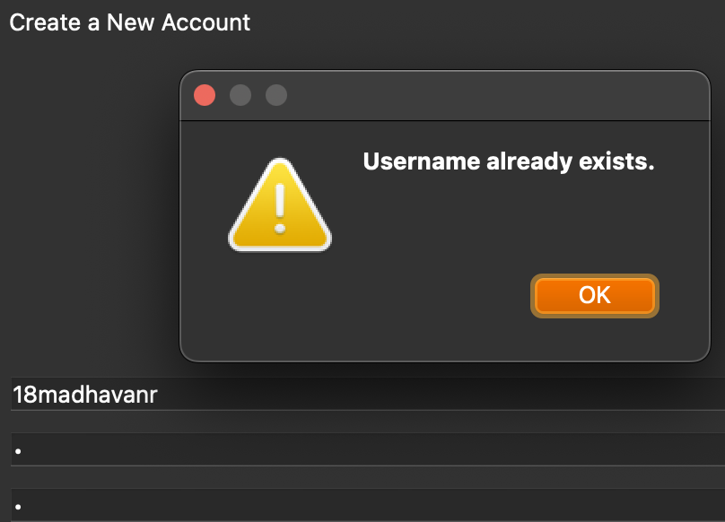
What I’ll be testing: | Creating a new account
Justification: | Ensures only valid username and password input is accepted, essential for my app.
Expected outcome: | Account created successfully
Actual outcome: | Account created successfully
Results: | 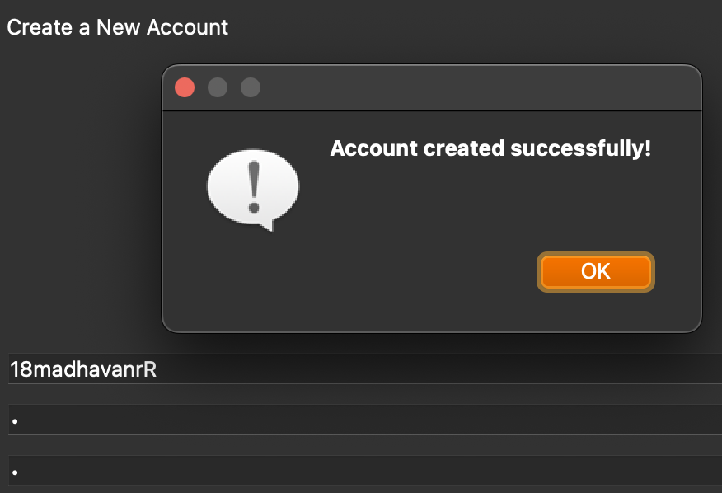

What I’ll be testing: | Logging in with valid credentials
Justification: | Ensures only valid username and password input is accepted, essential for my app.
Expected outcome: | Login successful
Actual outcome: | Login successful
Results: | 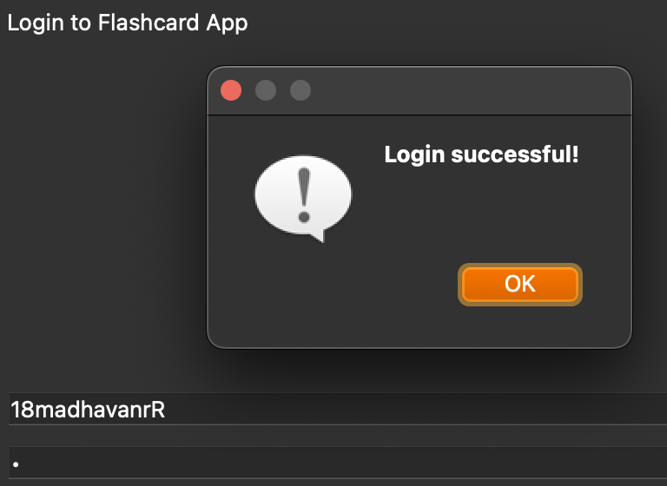
What I’ll be testing: | Logging in with invalid credentials
Justification: | Ensures only valid username and password input is accepted, essential for my app.
Expected outcome: | Invalid credentials
Actual outcome: | Invalid credentials
Results: | 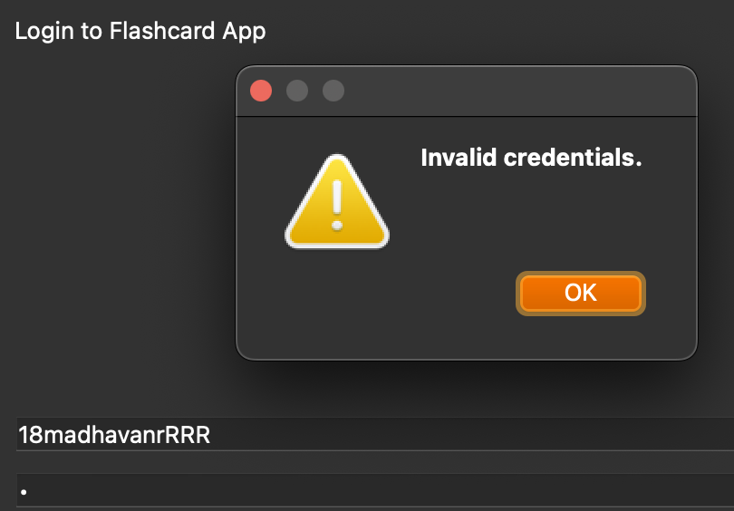

Now that everything is working properly that’s the database done for now.

Stakeholder talk:
I wanted to have talk to my stakeholder to see if they like the direction I took the app in. I will perform an interview with them asking a few questions:
Interview script:
Do you feel like this database is up to standard even though I deviated from using SQLite?
- I feel like this is acceptable as long as it works in my opinion.
Do you think I can add to it anymore?
- I’m not too sure but if you feel the need to then yes.
Is there anything else you’d like to add?
- Maybe create multiple accounts which all have their own separate flashcards, but that might take too long.

Prototype for login class:
This is my initial first draft for my login class:
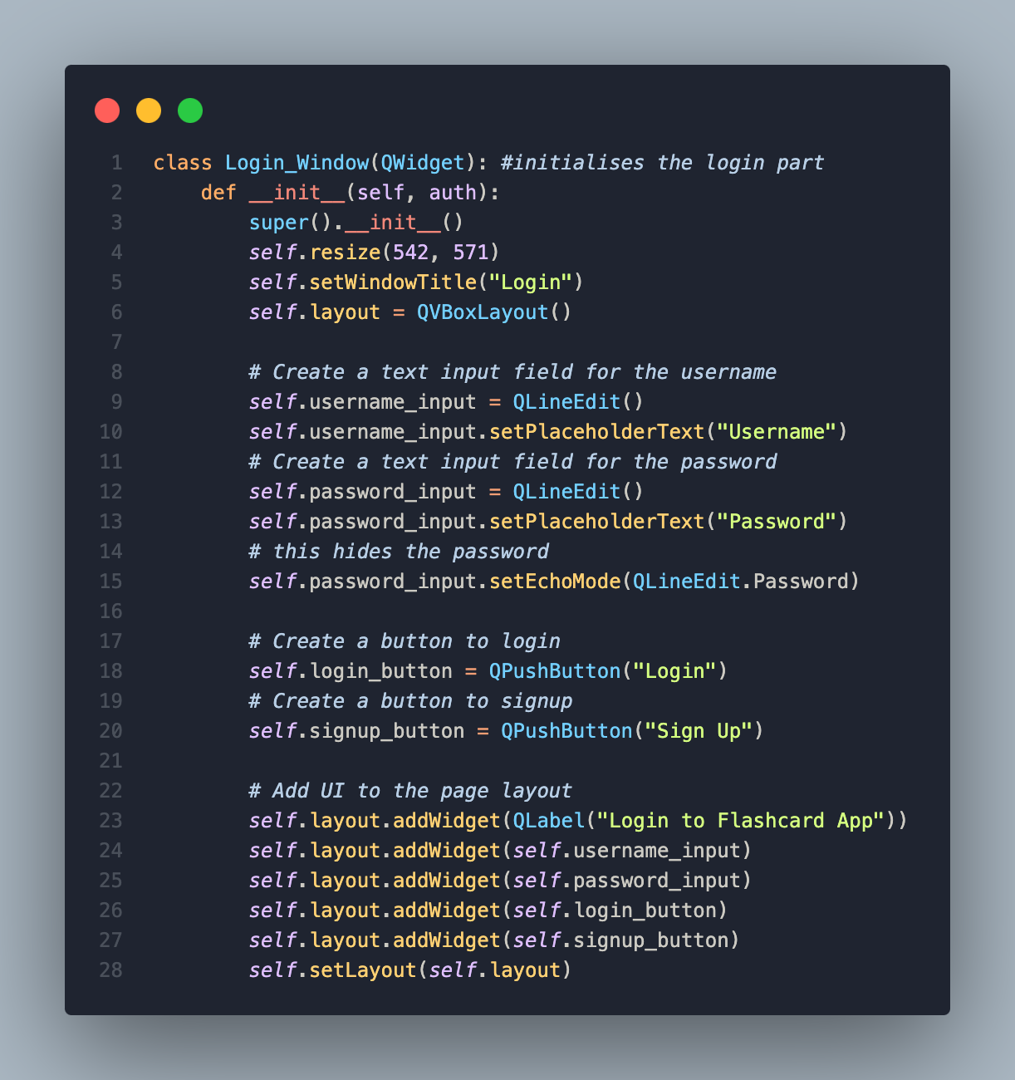

Login creation:
This is the first task of my success criteria and my first flowcharts. I will also be splitting this into the signup class and the login class as they both take up a considerable amount of code and are two different things. I used classes and python as I am already familiar with them as ive used it to create other projects before. So I started off with the login class first as I envision my app to have login on the front page, then have a user sign up on a second page if they don’t have an account. I will also be amending errors and adding in any extra code needed that wasn’t in my initial draft.
For searching up stuff I didn’t know in PyQt5, I used Riverbank Computing - https://www.riverbankcomputing.com/static/Docs/PyQt5/.

I first created the class, Login_Window, as specified in my test tables.
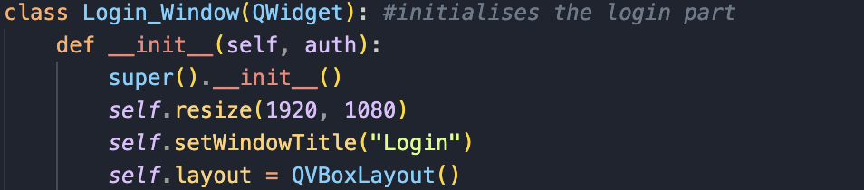
- def __init__(self, auth) is what’s called a constructor method and runs when an instance of Login_Window is created.
- I prewrote auth as a parameter as I knew I was going to tie the login and signup classes to the json file later.
- super().__init__() ensures QWidget features are properly initialised.
- I then initialise the layout with the title ‘Login’ and a have a standard resolution of 1920x1080, as that’s what’s used to make the app go full screen.
- I then had to search up how to arrange widgets vertically and found QVBoxLayout. For this I used the website: https://pythonbasics.org/qvboxlayout/.

I then created the input fields for the username and password: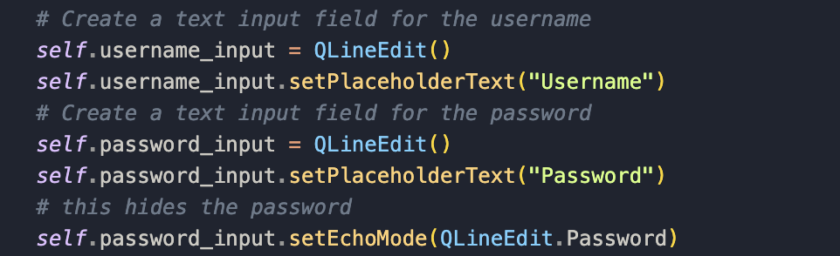
- self.username_input = QLineEdit() creates a text input field where users can type their username, and saves it in username_input.
- self.username_input.setPlaceholderText("Username") sets a placeholder text inside the input field, and saves it in password_input.
- I had to also search up how to hide letters in PyQt and found the ‘setEchoMode’ method which sets the text field to come up as dots (•), which fulfils competitors’ data of have a secure way of hiding a password.

I then created the variables that link to the buttons for logging In and signing up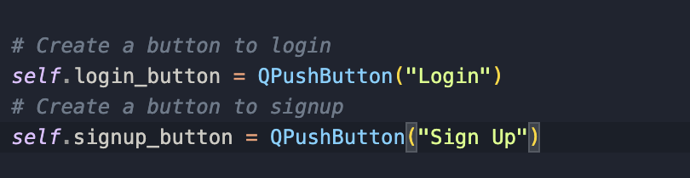
- This creates clickable buttons which are called login/signup buttons that will take you to their respective parts when connected to their respective methods, which I will go back and add later.
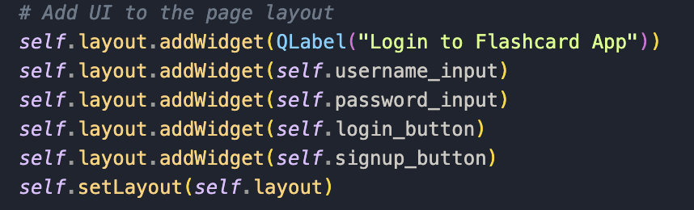
- Here I create a label that says, "Login to Flashcard App" and then I add it to self.layout to make sure it comes up at the top of the window.
- Then I add the username and password input fields to the layout, then add the login and sign-up buttons to the layout.
- I then used self.setLayout on the whole thing to make sure everything is automatically organised and is in a logical order.
That is the login class done for now but first before I run it, I need to add a few lines of code at the end.
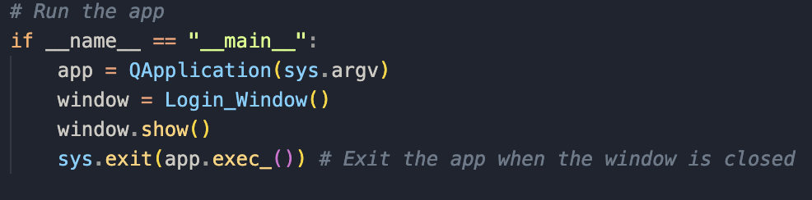
- This is a really important bit of code where first it makes sure it only runs when the file is executed.
- It then creates the instance that’s mandatory for any PyQt applications.
- The window that’s created is then the login window as that’s the first window when you run the app.
- The last line ensures the app keeps running until the user closes the window and sys.exit() ensures everything closes properly when exiting the app.
This is what I currently see when I run the app:
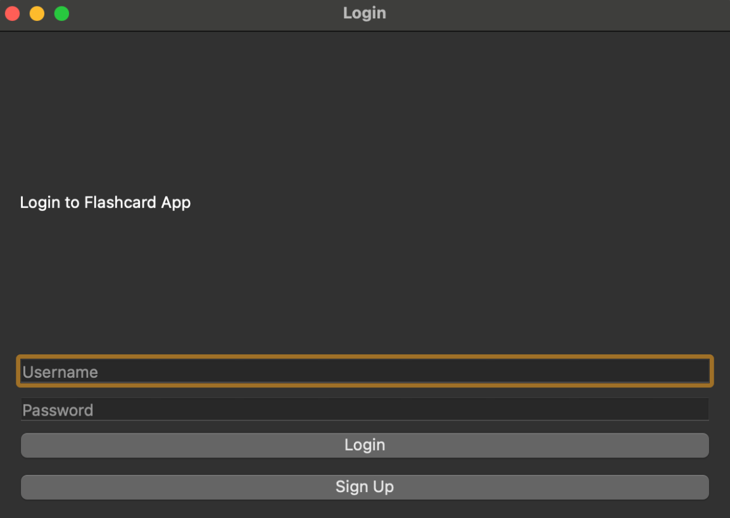

As you can see everything appears as it should. The placeholder text of username and password appears as it should and the login displays at the top like it should be. I do think I could centre the main body text but that’s low priority and something I can always do later – I will ask my stakeholder to see if it’s fine or not.

Login testing:
This is where I am going to test the login class only, and see what works and what doesn’t. I will be using the test table during development I made to test it out. However, as I made the login class first I will need to complete the signup class as well before I can do any further testing on either. So for these two classes I will provide a full test table for them at the end of signup creation.
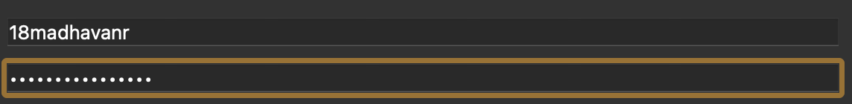
I then tested what I could to see if the input fields worked, and they worked as they should. I then clicked the login and signup buttons and as expected they done nothing as they aren’t connected to anything yet. With this that’s the login stuff temporarily done for now. Next, I am going to work on the signup class.

Prototype for signup class:
This is the prototype code for the signup class.

This is like the ‘skeleton’ of the signup class method. It includes the layout of what’s going to be on that page.
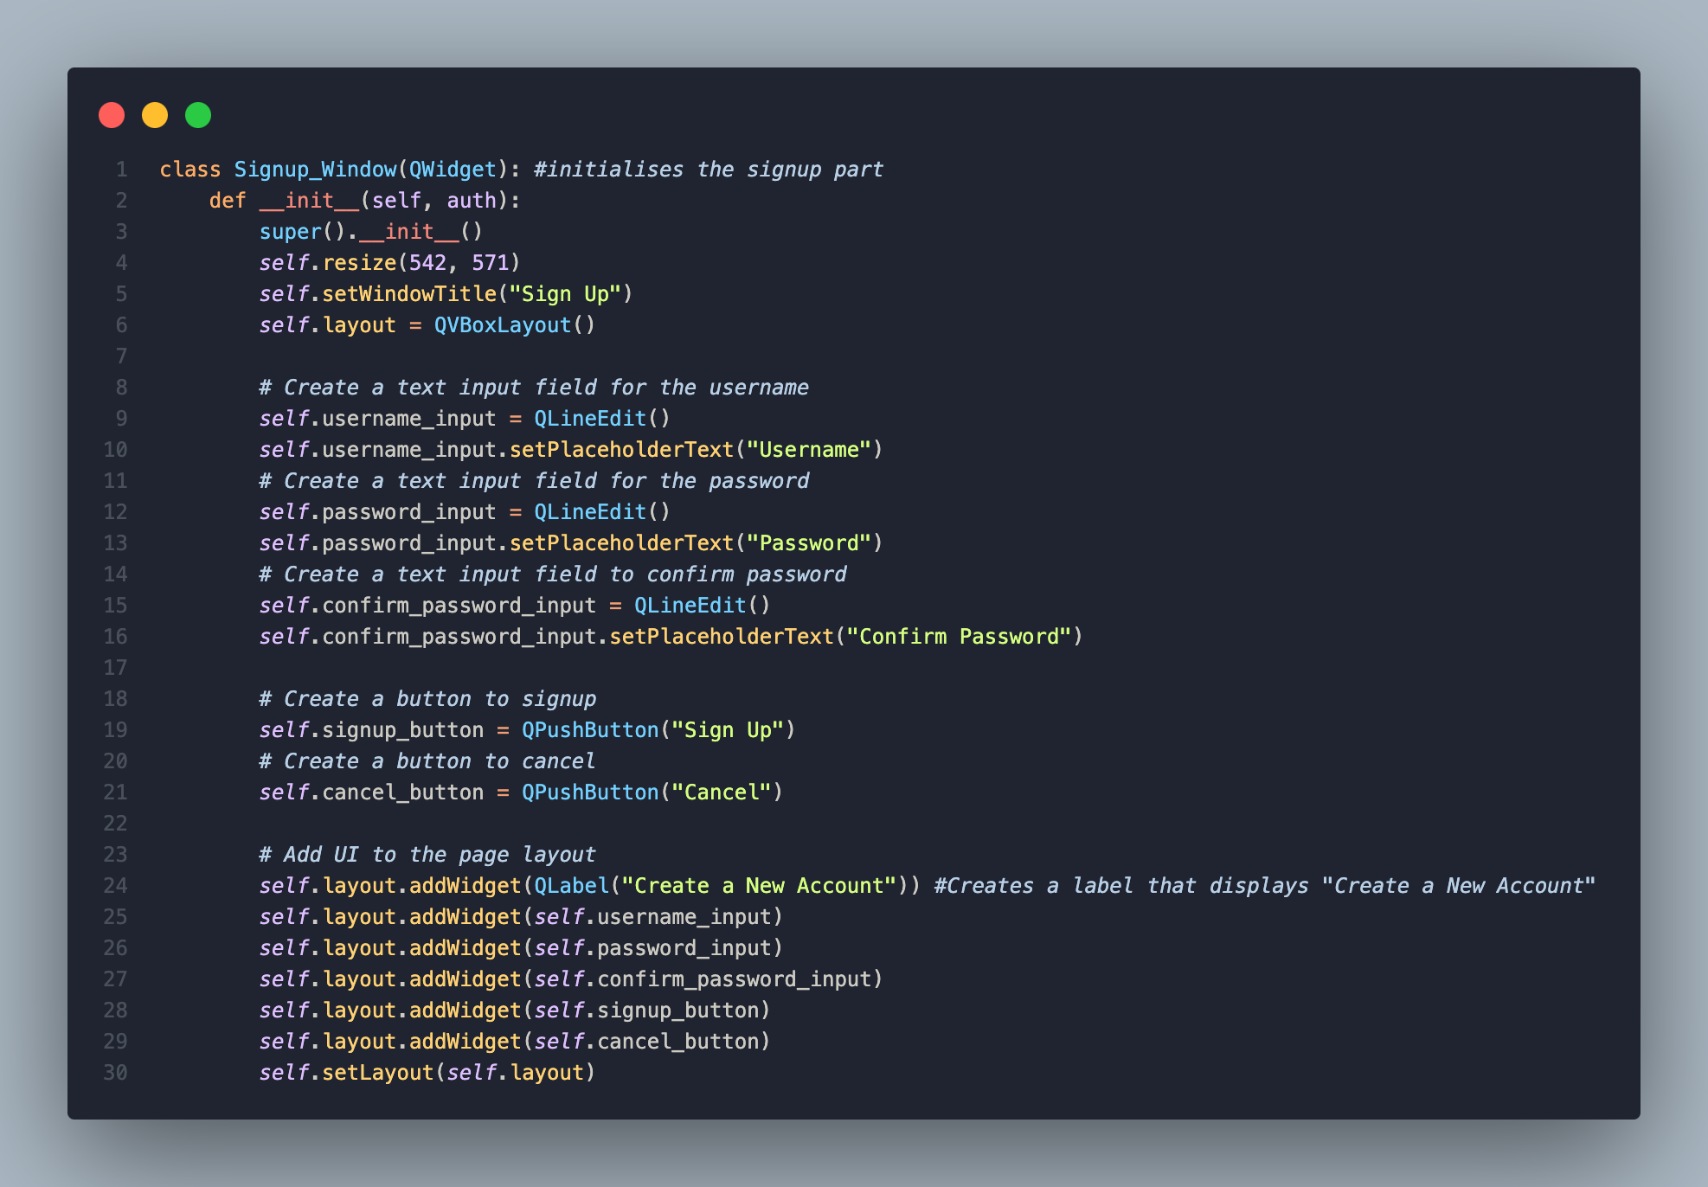

Signup/Login creation:
This is where I’ll be doing the signup page e.g. where there’s a new page and the user can enter their username and password to use to login with. This is also where ill be extending the login class. I will also add the validation code here as well and amending errors and adding in any extra code needed that wasn’t in my initial draft.
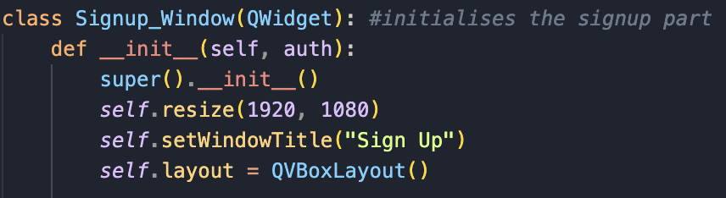
- def __init__(self, auth) is what’s called a constructor method and runs when an instance of Signup_Window is created.
- I wrote auth as a parameter as I knew I was going to tie the login and signup classes to the json file later.
- super().__init__() ensures QWidget features are properly initialised.
- I then initialise the layout with the title ‘Sign up’ and a have a standard resolution of 1920x1080, as that’s what’s used to make the app go full screen
- QVBoxLayout arranges widgets.

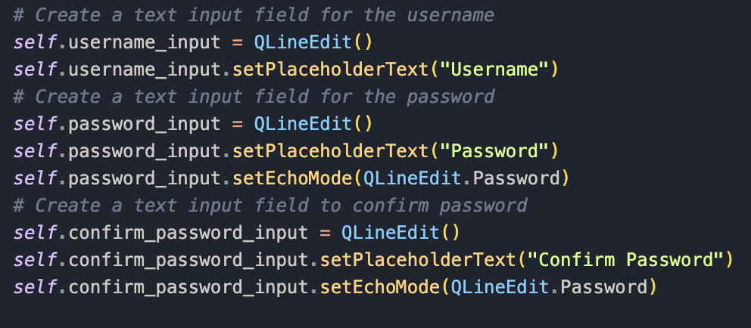
- The first line of code creates a text input field for the username
- The second line sets the placeholder ‘username’ to ensure the user knows where to type their username into.
- Then it’s the same thing but with the password.
- I also used .setEchoMode here as well like I did in the login section to ensure consistency.
- Like with both my competitors apps, they also have to confirm password before the account is created and therefore, I also implemented that as well.
- I am creating the main big classes for signup and login first then going back and adding the small functions necessary later, like the one to confirm the 2 passwords entered match, etc.
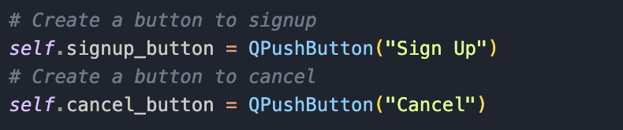
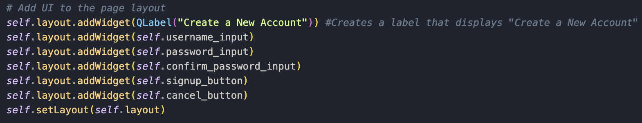
- This creates 2 buttons called sign up and cancel, the first being to confirm registration and the second one to cancel it.

- This is everything that’s needed for the ui elements in the singup page, similar to the login page.
- The first line creates a label displaying "Create a New Account".
- The next three lines adds the input fields (username, password, confirm password) to the layout page.
- The next two lines adds the 2 buttons that I mentioned before.
- The final line, like in the login section, uses self.setLayout us used to ensure everything is in order.
- With this, that’s the 2 main classes finished. I still need to add some functions to connect everything together which I am going to do right after I run the app now to see what its looking like currently.

Signup/login testing:
This is where ill test both classes as they are interlinked and see what works and what I need to add.
When I run the app now, this is what I see: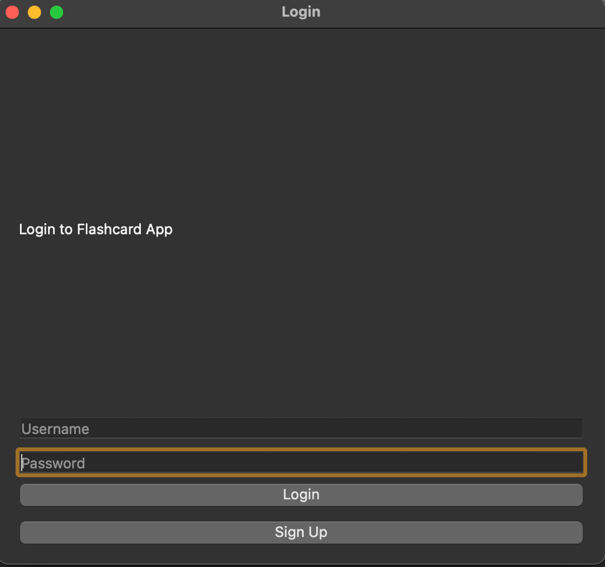:
When I try clicking the signup button nothing happens. I did expect this because I haven’t connected it to the login page. This was a test to see whether the signup class have any code errors, and it didn’t have any so now I can safely proceed to creating the functions necessary to tie everything together.
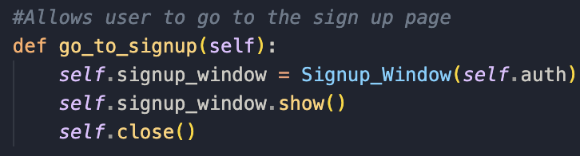
- So first I went back to the login class and created a function called ‘go_to_signup’. This function would enable me to go to the signup page, like it says.
- The second line creates an instance of the Signup_Window and passes ‘auth’ through, which as I explained is not needed now but by thinking ahead, I know I’ll need this to connect it to json to save credentials, which is why that’s there.
- When the signup button is clicked on the login page it’ll go to the signup window.
- self.close() closes the login window and removes it to show the signup window.

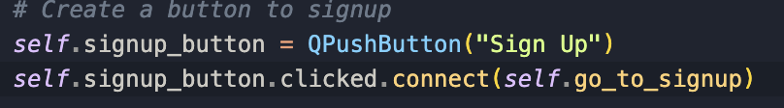
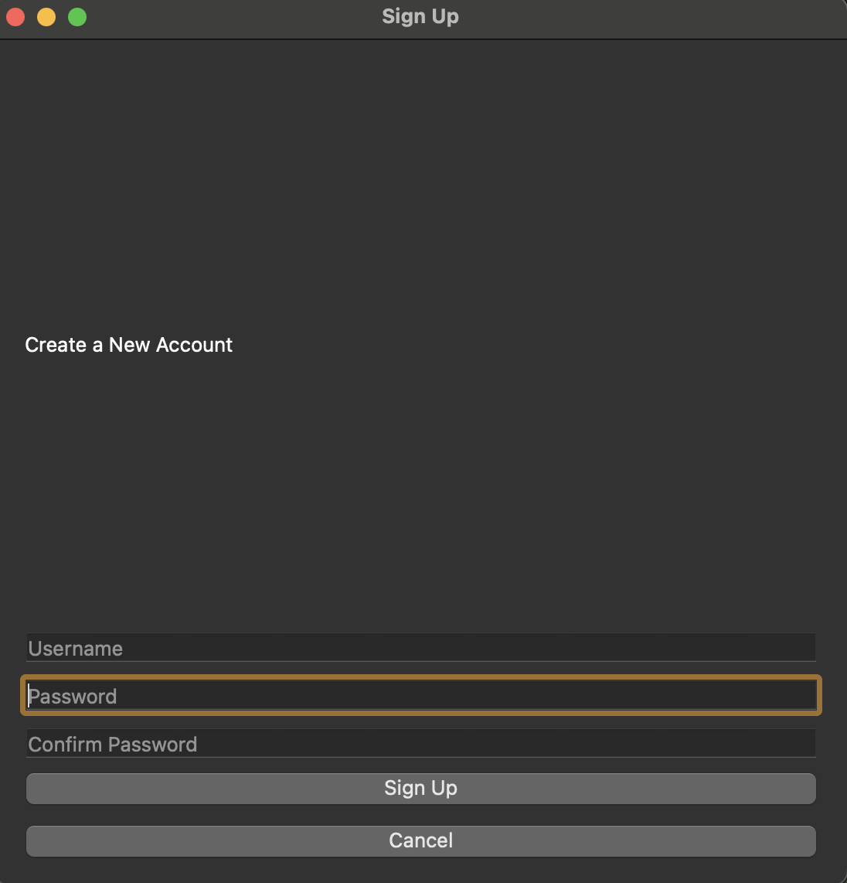
- I added self.signup_button.clicked.connect(self.go_to_signup) in the login section to connect the function to the button when clicked. I am now going to test if it works now:
For the cancel button to go back I created a function called go_back, similar to the one above:
When I click signup in the login page now, it takes me to the signup page, as it should, however, the signup and cancel buttons don’t do anything as they aren’t connected to anything, so I’ll be working on that next.

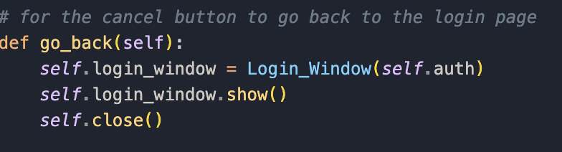
- def go_back(self): defines the go_back method.
- The second line of code creates an instance of Login_Window.
- The next line displays the login window as that’s what this cancel button is going to show when clicked.
- self.close() is there to make show the window closes and transitions cleanly.
- I now need to connect the method to the button in the class:
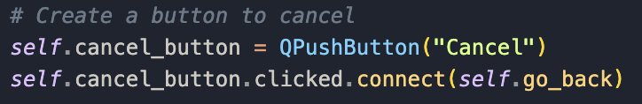
I have now tested and now the back button works now. I will now do the signup part now.

I will have to create a sign method:
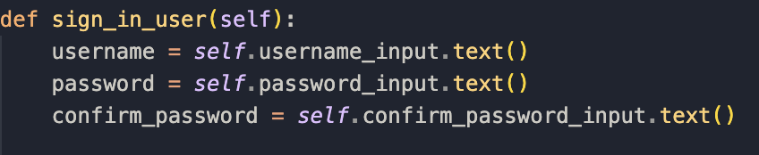
- username = self.username_input.text() gets the text entered in the username field.
- The same goes for the password section.
- The last line makes you enter the password again to save to the confirm_password variable. I now need to do code the validation for this now, and get the error and confirmation messages working.
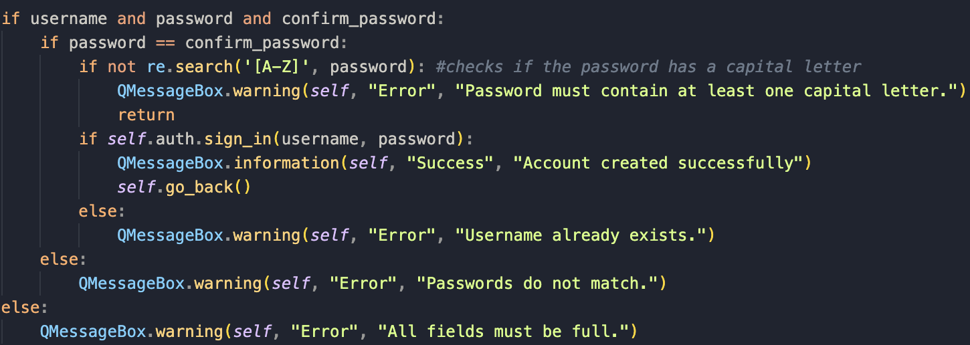
- The first if statement ensures both fields are full before moving on, and if they aren’t, a message pops up saying they must be, using the built-in warning feature in QMessageBox.
- The next step is the second if statement that ensures both passwords entered match, and if they don’t, an error message pops up.
- Next, to fulfil my validation requirements, I had to check the user had at least one capital letter in their password. The method re.search, checks the password to see if there is at least one capital letter. I found this method at: https://www.w3schools.com/python/python_regex.asp.
- I then had to ensure, to not have duplicate accounts, that the user inputted two different usernames. This will not work yet as it will call the database file to check that, but I haven’t yet made it.
- Once the account is made, I call self.go_back() to return to the login page to login. I will now have to connect the method into the classes:
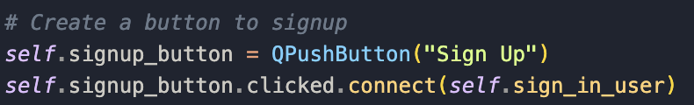
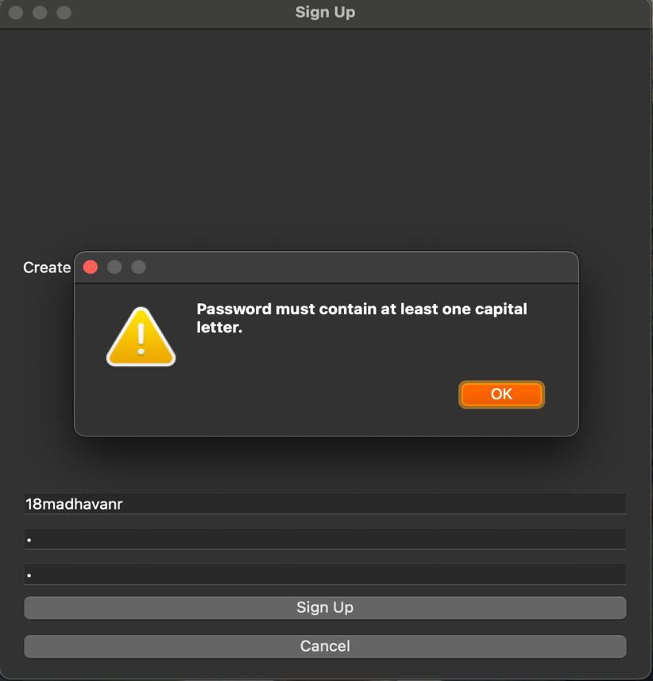
Now the user should be able to sign up. I will do some testing to see if it works as intended.

This is the error message that occurs if the user doesn’t meet the password requirements.
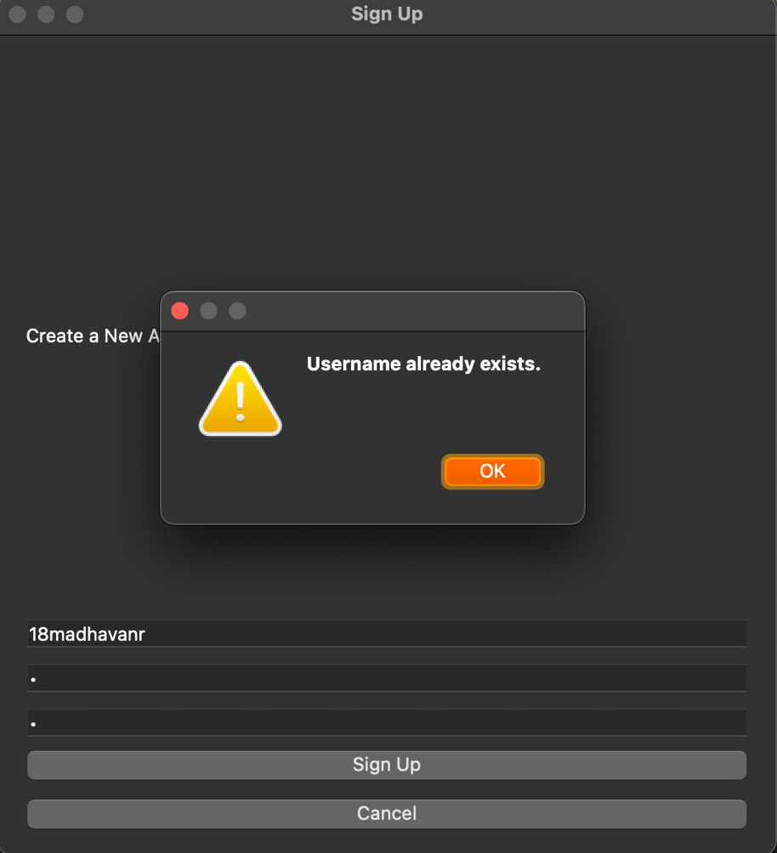

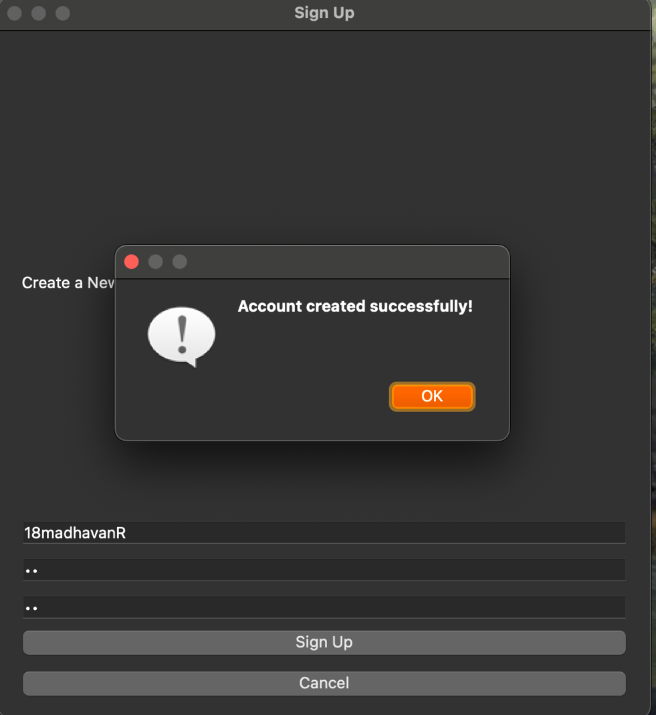
This is the error message that occurs when a duplicate username is used.

This is the message that occurs when you successfully create an account. I talked to my stakeholder, and they said this was satisfactory enough for a login/signup page.

I found out from my testing that the login button doesn’t work when you return back to the login page. I realised because it isn’t connected to anything. To fix this I will need to create 2 functions, one where it checks if the credentials entered are correct, and of they are to open the main window of my app.
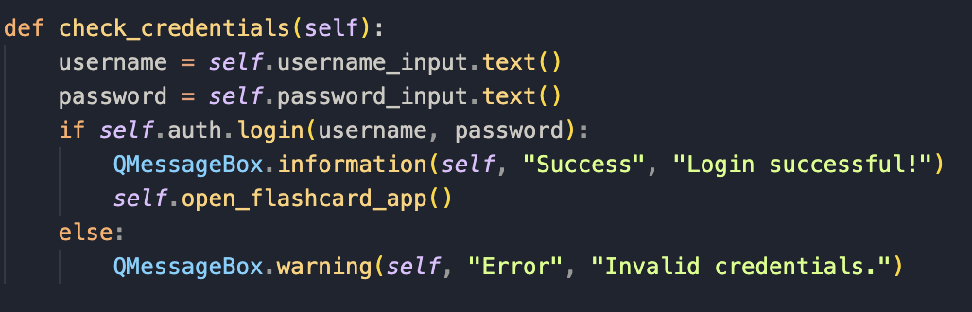
- This function is added into the login class and what it does it that it saves the username and password entered into the text box into the variable username/password.
- Then an if statement is ran where it calls the login method to check whether the credentials match an existing user record (if username/password matches what was In the signup part).
- If true, a success message is shown, and the user is taken to the flashcard app.
- Else, there is an error message, and the user has to try again.
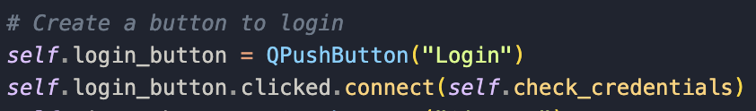
- I now connected the method to the button in the login page, so now it should open a new page.
I need to make the main window of my flashcard app that will open when the login is successful:
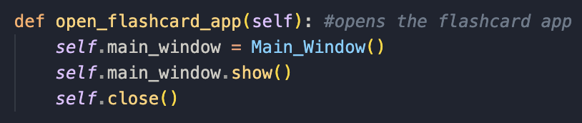
- This function is added in the login class which I connected the check_credentials method.
- I created a class called Main_Window.
- When this method is triggered it will close the login page and open the Main_window.

With the initial errors found and fixed I will do some (more) formal testing to see if the signup/login classes work fully:

End of module testing: (read across)
First will be the signup section:
What I’ll be testing: | Username and password input(s): valid username and password
Justification: | Ensures only valid username input is accepted, essential for my app.
Expected outcome: | Account created successfully
Actual outcome: | Account created successfully
Results: | 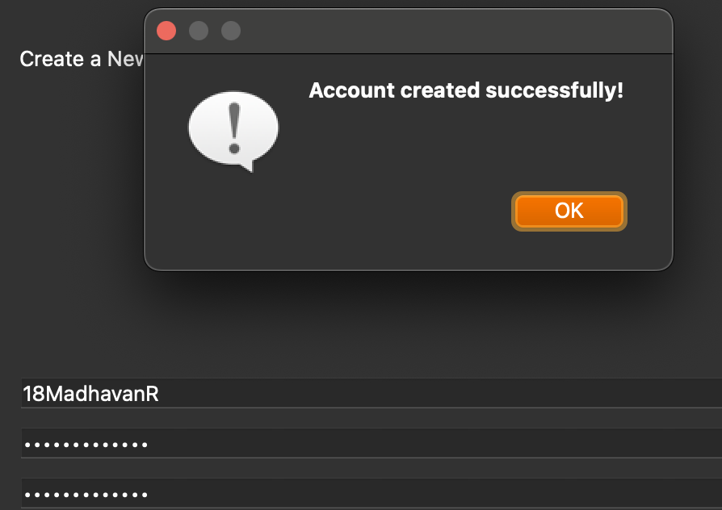

What I’ll be testing: | Username and password input(s): invalid username and password
Justification: | Ensures only valid username input is accepted, essential for my app.
Expected outcome: | Invalid credentials
Actual outcome: | Invalid credentials
Results: | 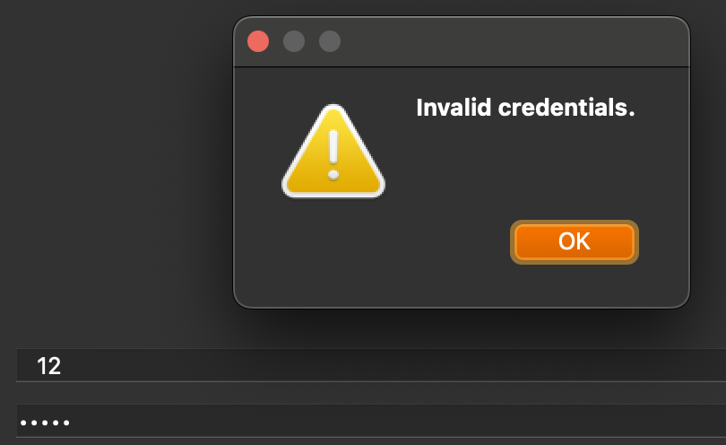

What I’ll be testing: | Username and password input(s): invalid password with username
Justification: | Ensures only valid username and password input is accepted, essential for my app.
Expected outcome: | Message saying at least one capital letter in the password
Actual outcome: | Password must at least contain at least one capital letter
Results: | 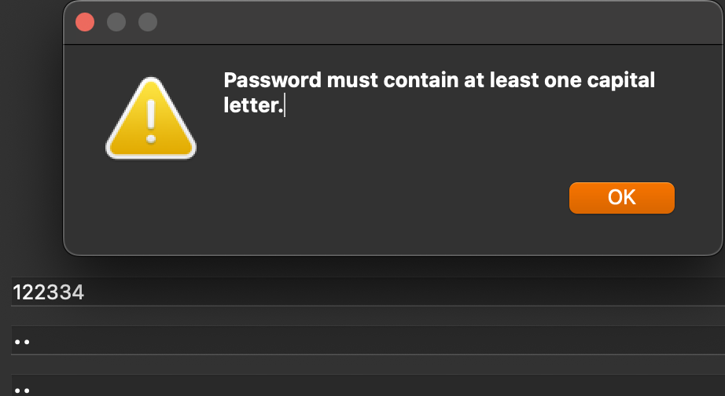

What I’ll be testing: | Username and password input(s): empty username and password field
Justification: | Ensures only valid username and password input is accepted, essential for my app.
Expected outcome: | All fields required message
Actual outcome: | All fields required message
Results: | 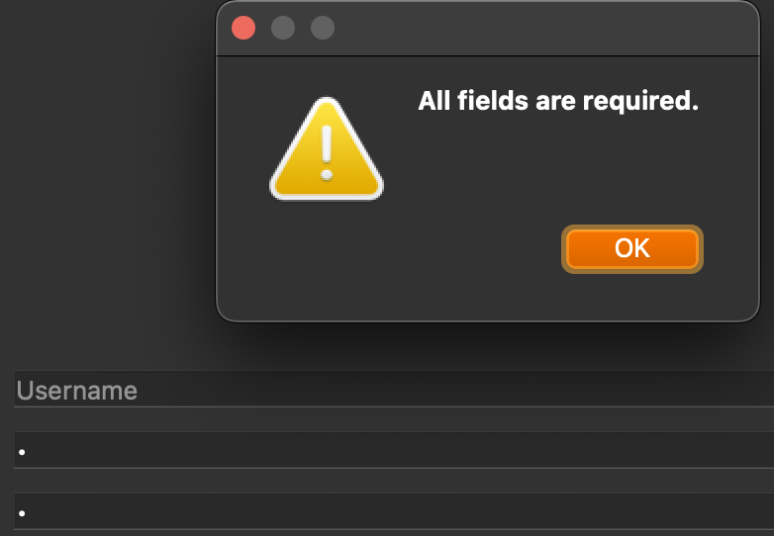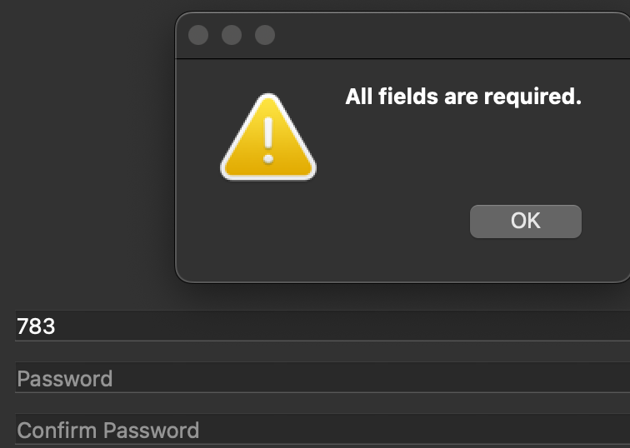

What I’ll be testing: | Username and password input(s): spaces in username/password
Justification: | Ensures only valid username and password input is accepted, essential for my app.
Expected outcome: | All fields required message
Actual outcome: | All fields required message  Invalid credentials
Results: |   

Errors:

From my testing, in the last test, spaces in username/password, kept causing an error in the system and wouldn’t let me create an account if I had a space in the text field. I have fixed this below by modifying the method sign_in_user:
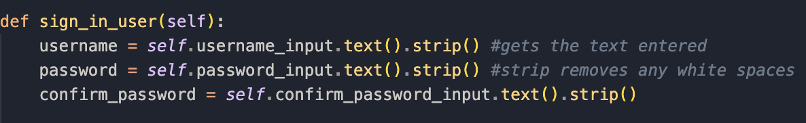
- username = self.username_input.text().strip() gets the text entered in the username field.
- The same goes for the password section.
- I discovered .strip() when I was reading through w3schools: https://www.w3schools.com/python/ref_string_strip.asp. This was useful as if the user accidentally hits space at any point this method removes it, making signing up possible, even with a space anywhere in the system, improving ux and fixing the error I kept getting.
Now testing the login page:
What I’ll be testing: | Username and password input(s): valid username and password
Justification: | Ensures only valid username and password input is accepted, essential for my app.
Expected outcome: | Success message
Actual outcome: | Success message
Results: | 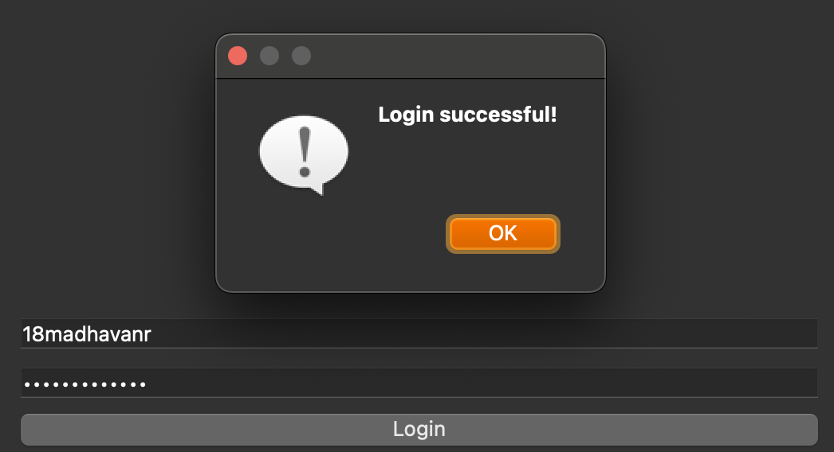

What I’ll be testing: | Username and password input(s): invalid username/ and password; not made from signup
Justification: | Ensures only valid username and password input is accepted, essential for my app.
Expected outcome: | Error message
Actual outcome: | Error message
Results: | 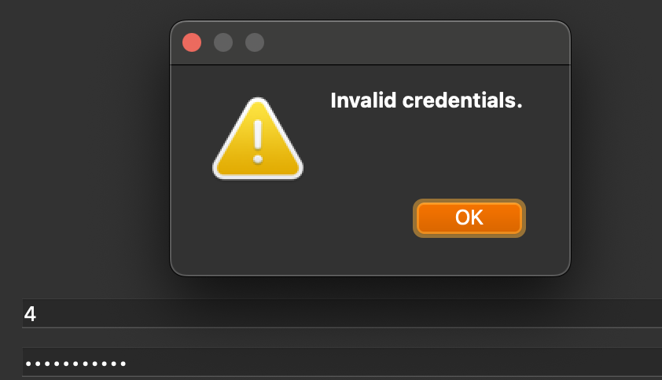

What I’ll be testing: | Username and password input(s): password that had a space in it from signing up (Q Q)
Justification: | Ensures only valid username and password input is accepted, essential for my app.
Expected outcome: | Login successful
Actual outcome: | Login successful
Results: | 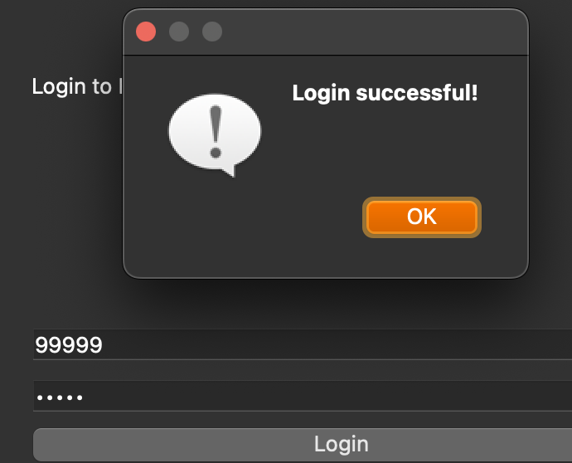

Stakeholder talk:

I wanted to have talk to my stakeholder to see if they like the direction I took the app in. I will perform an interview with them asking a few questions:
Interview script:
What do you think of the signup page?
- I like the signup page; it is simple in the sense I know what to do and it properly signs me up when I put in my username and password.
Do you like the validation in the signup page? Should I add more?
- I like the presence check validation in all the entry boxes as it means you have to put something in there. I also like how you have to enter your password twice which makes me sure I won’t forget the password I put in first. The capital letter adds a layer of security.
- However I think if you could add a minimum length check to the password that would make it even better, but I think you should focus on other things for now.
How do you feel about the login page?
- The login page is neat, but I think the ‘login’ text could be centred.
Review of the interview:
I think the feedback I got was good as it shows I’m on the right track; with minor adjustments I can make later to make the app feel better.

That is now the database, login and signup classes finished; I can now move onto making the main window of the app.

Prototype code for main window class:

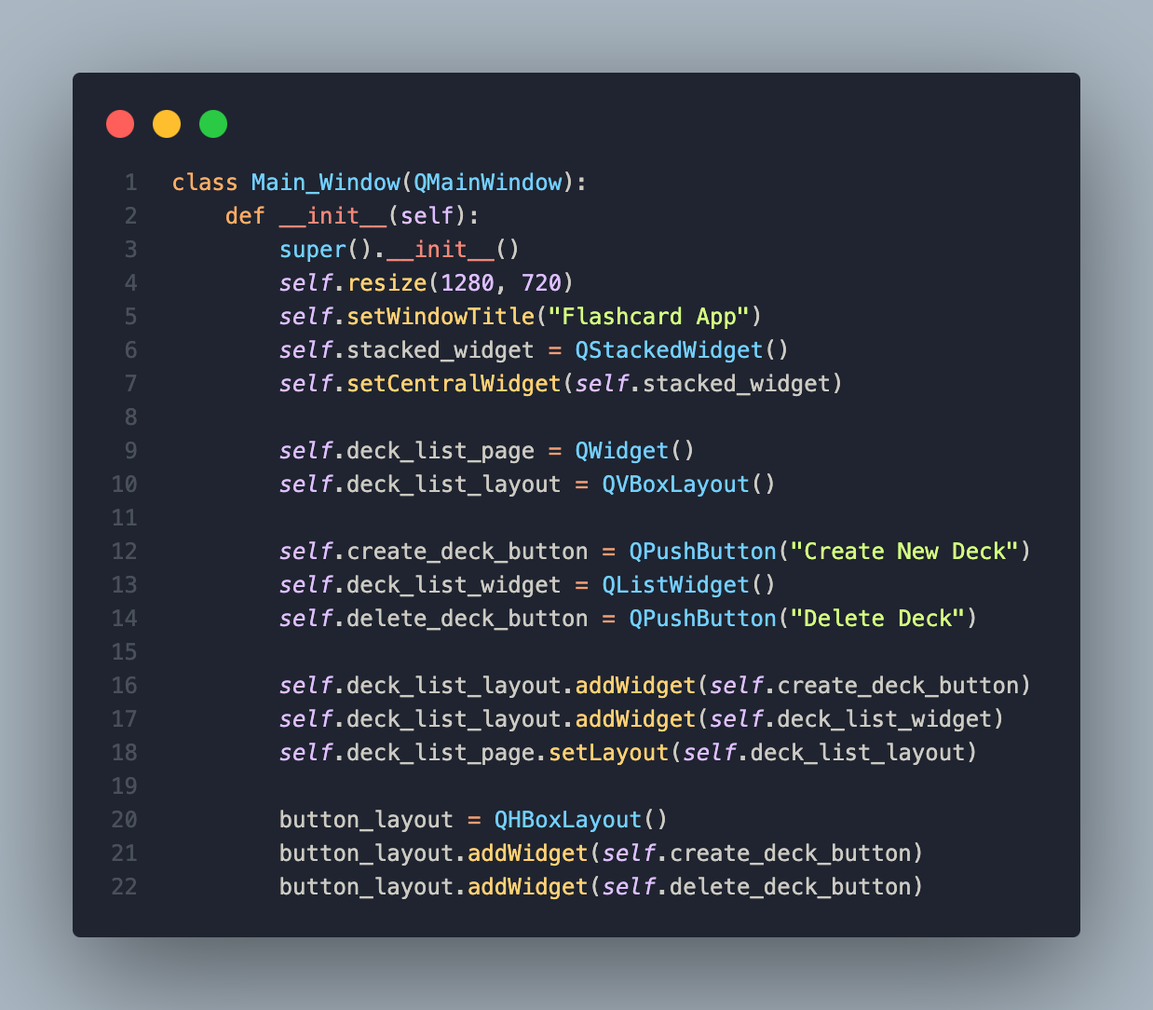

This is the initial code I made for the Main_Window class.

Main window creation:

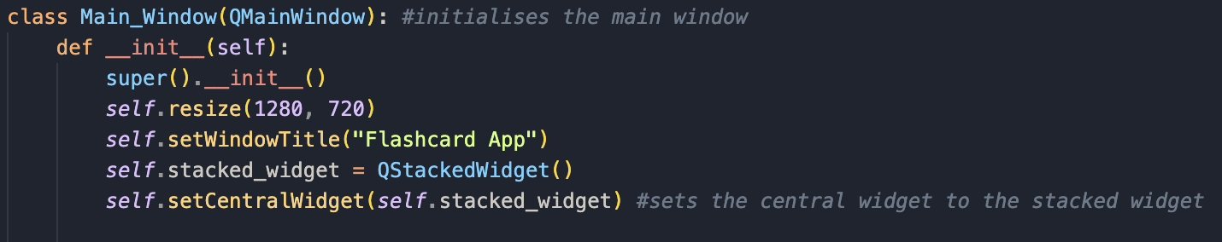

- The class this time inherits from QWindow, not QWidget, thus making it the main window of the application. QWindow is a built-in class from PyQt that is useful.
- Again, super().__init__() is necessary, as it ensures QMainWindow’s setup is properly finished before I start adding my own widgets.
- I chose to make the window smaller for testing purposes, but for the proper app itll be 1920x1080.
- self.setWindowTitle sets the title of the window to be called Flashcard App
- I make a stacked widget using QStackedWidget() which allows me to switch between pages e.g. ill need to go into the decks and back to the Main_Window.
- I then set QStackedWidget as the main widget, which means all the screens of the app can be accessed using this widget.
- self.deck_list_page = QWidget() creates an empty widget using QWidget()
- self.deck_list_layout = QVBoxLayout() creates a vertical layout

- self.create_deck_button creates a ‘push’ button with the label being create new deck.
- self.deck_list_widget = QListWidget() creates a list widget, to show all the decks you’ve made.
- self.delete_deck_button is another push button used to delete a deck.
- Later I will need to connect these buttons to their respective functions that will be made in other classes.

- The first line adds the "Create New Deck" button to the vertical layout, making it appear at the top of the page.
- The second line adds the list widget below the button.
- The third line applies the vertical layout to the page which ensures everything on the page is positioned correctly on the page.
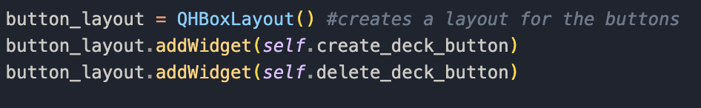
- The first line creates a horizontal layout as I’m using QHBoxLayout.
- The second line adds the "Create New Deck" button to the layout.
- The third line adds the delete deck button next to the create button; they’re both on the same row.
Next, I’m going to start making functions to add to the class:
- This method switches the current page to the create deck page, which ill be making after this

- This method handles going to the add flashcard page and choosing the deck to where the flashcard will get added to.
- The second line calls set_deck(deck_name) method on self.add_flashcard_page to ensure the new flashcard is added to the corrected deck.
- The third line switches the view to the self.add_flashcard_page using setCurrentWidget() which makes sure the user is now on the add flashcard screen.
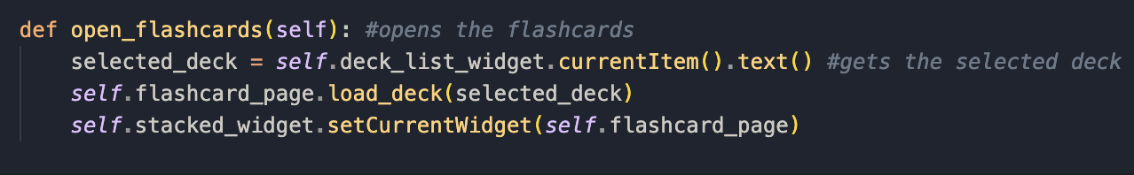
- The first line gets the currently selected deck from self.deck_list_widget. .current Item() gets the selected item, .text() extracts the deck name.
- The second line calls the load_deck method on self.flashcard_page, loading the flashcards for the selected deck.
- The third line changes current page to view self.flashcard_page so users see the flashcards.
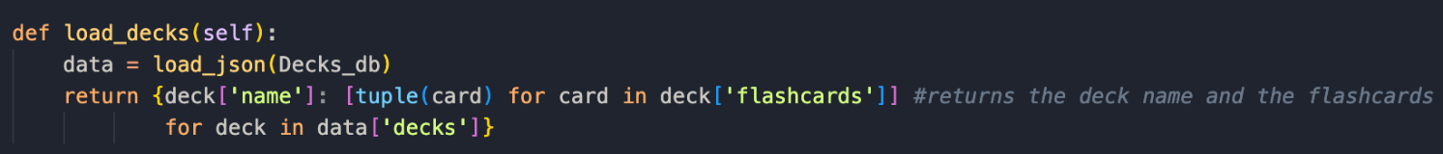
- data = load_json(decks_db): calls load_json(decks_db), which loads the contents of decks.json.
- the third line iterates over data[‘decks’] where each deck is being stored as a dictionary in which contains: the ‘name’, name of the deck, and ‘flashcards’ which are a list of flashcards. It then converts each flashcard (which is a list) into a tuple using: [tuple(card) for card in deck['flashcards']]. I know using my knowledge that tuples are an immutable data structure, hence why I chose to do that because iterating over tuples is safer, and if the program crashes, immutable tuples prevent any unexpended changes to the stored data.
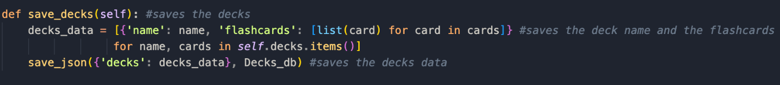
- the save_decks method is used to saving the current state of a deck to the json file.
- Decks_data converts decks into a json viable format. self.decks us a dictionary where the keys are the deck names, and the values are the lists of flashcards stored as tuples as mentioned earlier. However, since tuples don’t work with json, they’re converted back into lists using: [list(card) for card in cards] resulting in a list of dictionaries.
- I then call save_json to write that data to Decks_db. The dictionary {'decks': decks_data} ensures that all decks are stored under a single "decks" key.
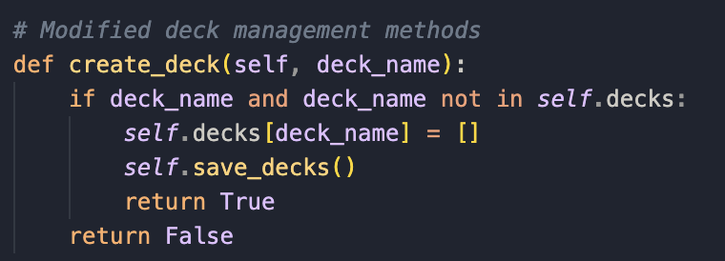
- This method handles creating a new deck and storing it in self.decks.
- First it ensures deck_name is not empty, and then checks the deck doesn’t already exist using deck_name not in self.decks. once both conditions are met you can start creating decks
- self.decks[deck_name] = [] adds a new deck with deck_name as the key, whilst assigning an empty list.
- Next, self.save_decks() calls save_decks() to keep any changes made to Decks_db, ensuring the new deck is saved permanently.
- If the deck is successfully created, the method returns the Boolean value of true, else, returning false.

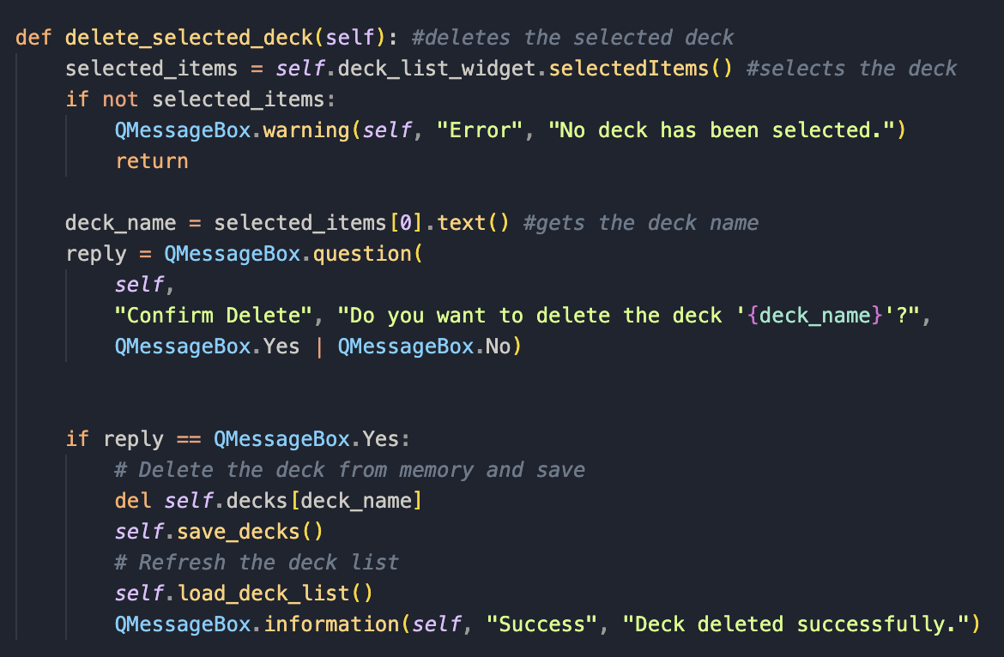
- This is the function for the ability to delete decks:
- selected_items gets the list of selected items from QListWidget which is where the decks are displayed. If no item is selected the list will be empty.
- if not selected_items, if selected_items was empty, a warning message will be shown using the built in .warning module, and the function will be stopped there.
- deck_name = selected_items[0].text() gets the text of the first selected item, which is needed as it will be getting the decks name.
- reply = QMessageBox.question( will display a confirmation dialog to ask the user whether they want to delete the deck or not.
- If the user confirms to delete the deck, the last if statement deletes the deck from self.decks (which holds all decks). Then it calls save_decks() to update the json file. It then calls load_deck_list() to refresh the deck list, and then shows a success message.

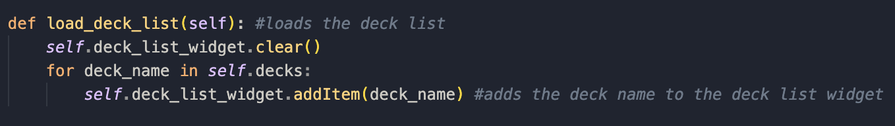
- This is the function needed to update the deck list in the interface.
- Self.deck_list_widget.clear() clears any previous existing list before reloading the list.
- It then loops through the stored decks using the for loop.
- Finally it adds each deck name to the list widget, making the decks selectable.

With the main functions finished, I now need to connect them to the main class:
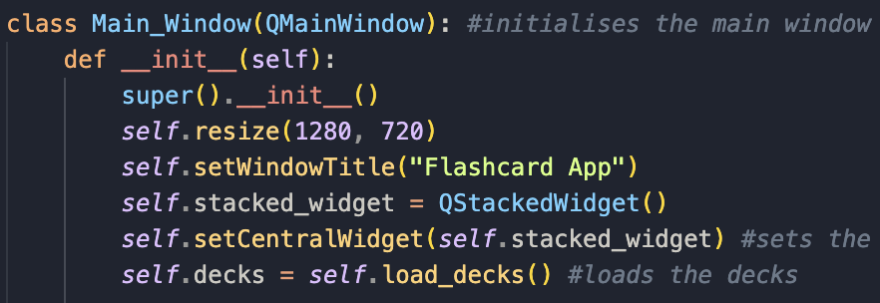
- I first started with connecting the load_decks() method.
- First I initialised it, as without it, self.decks would’ve been undefined.
- It calls the load_decks() method to get decks that’ve been stored in the json file.
- It then assigns that data to self.decks, which enables me to use it throughout my Main_Window class.
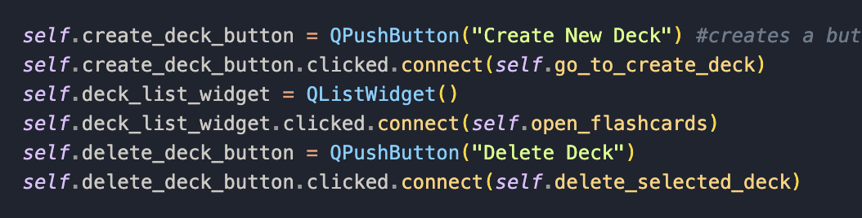
- I needed to connect these buttons to their respective methods as well (top and bottom):

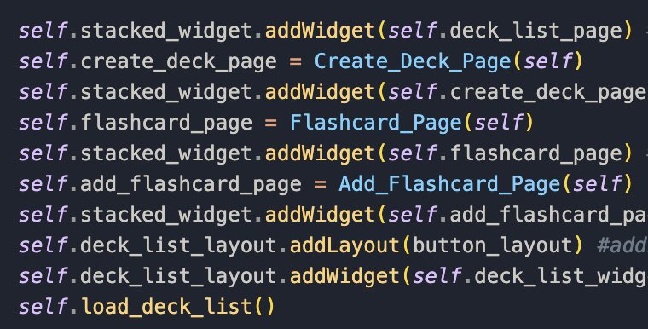

Before I can commence testing, I need to create the class to actually create the deck page where you can create a deck.

Prototype code for deck creation class:

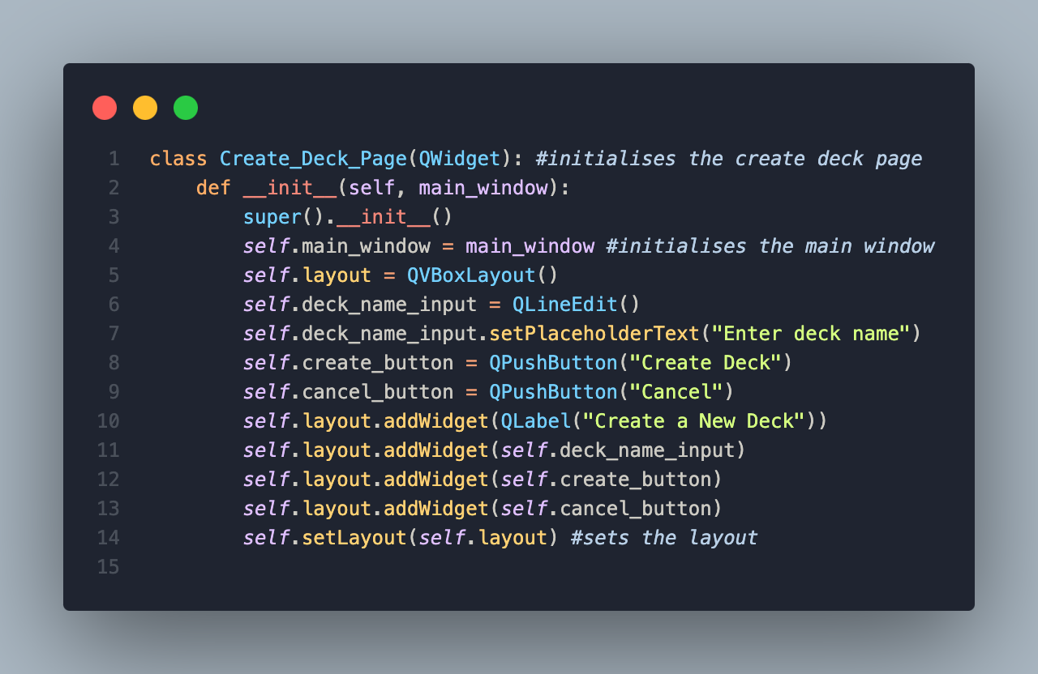

Deck creation class:
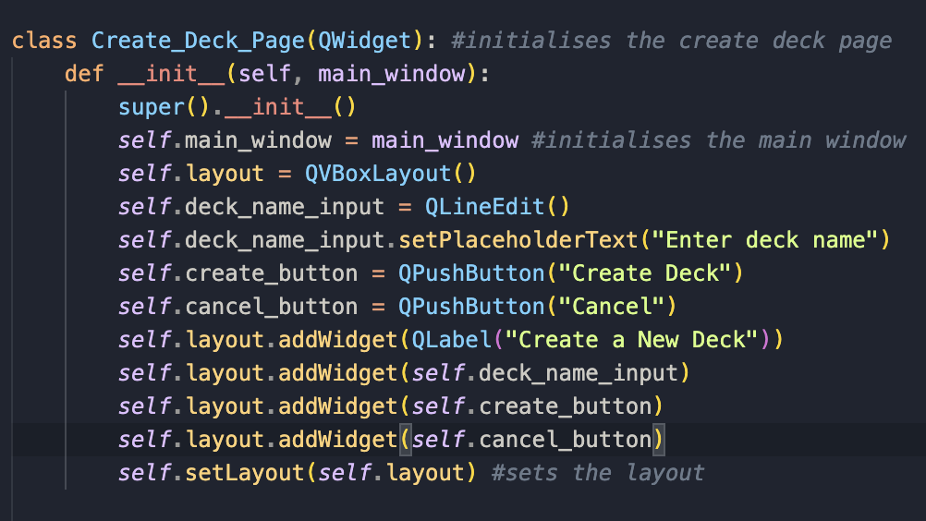

- I started with building the layout on how the page will look.
- super().__init__() calls the parent QWidget to initialise the window.
- self.main_window = main_window stores a reference to the Main_Window, this is so that it can call functions e.g. create_deck and switch pages.
- Next I create a layout using QVBoxLayout which allows me to stack widgets on top of each other.
- deck_name_input is a text box for entering the deck name.
- using .setPlaceholderText, I can create a placeholder word(s) inside my text box, indicating the user on what to type in that box.
- I then create two buttons; one for cancelling and one for creating a deck.
- The rest is just adding widgets to the layout. Again self.setLayout(self.layout) is used to format the page nicely.
I then created the method to create the deck:
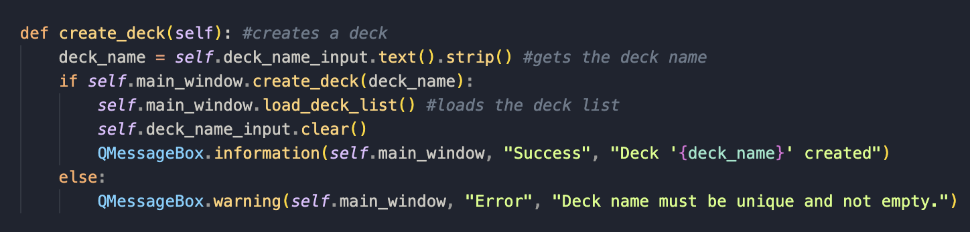
- First it starts off with retrieving the deck name that’s been entered.
- It then calls self.main_window.create_deck(deck_name), which will do one of two things depending on whether its successful.
- If successful:
  - Refreshes the deck list (load_deck_list()).
  - Clears the input field: deck_name_input.clear().
  - Shows a success message
- If unsuccessful e.g. duplicate or empty name, it shows an error message.
I then need a button that can return the user back to the page they were on:
- self.main_window.stacked_widget is referring back to the stacked widget in the main window I just made, which handles multiple pages. It’s like a container that can go between different pages.
- setCurrentWidget(self.main_window.deck_list_page) tells the stacked widget to display the deck list page which means the user can return to the main deck selection page.
Now I need to connect these methods to their buttons:
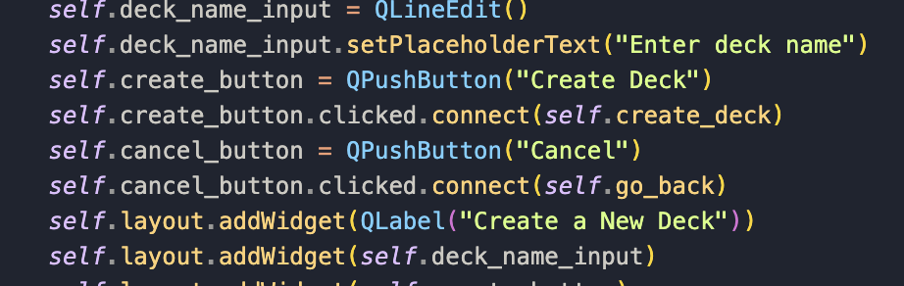
- self.create_button.clicked.connect(self.create_deck) connects the button the create_deck method.
- Similarly self.cancel_button.clicked.connect(self.go_back) connects the cancel button to go_back method.
Now that ive created the mainpage and the deck creation, I can start my end of module testing.

End of module testing: (both mainpage and deck creation)
What I’ll be testing: | The Mainpage displaying correctly.
Justification: | Ensures that the mainpage opens as expected to display everything accordingly.
Expected outcome: | Working mainpage
Actual outcome: | Mainpage displaying correctly
Results: | 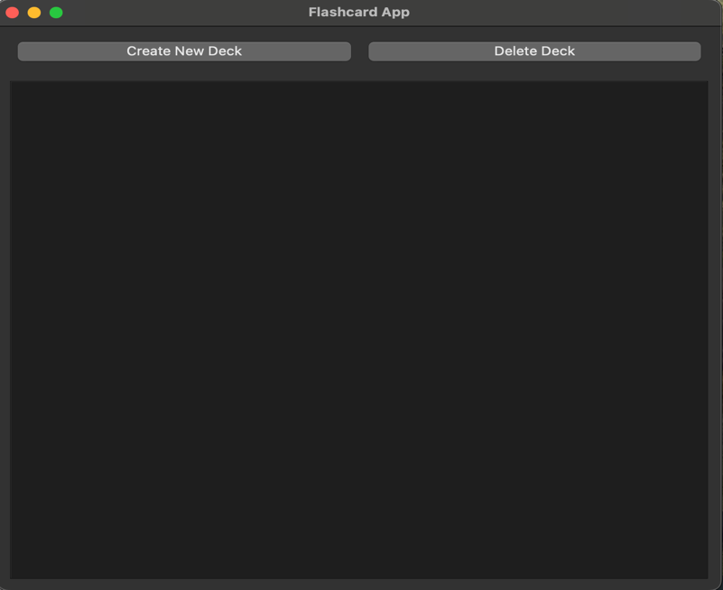

What I’ll be testing: | Deck creation: checking if create new deck button works
Justification: | Ensures that the user can create decks which is essential for my app
Expected outcome: | Screen where user can enter deck name
Actual outcome: | Screen where user can enter deck name
Results: | 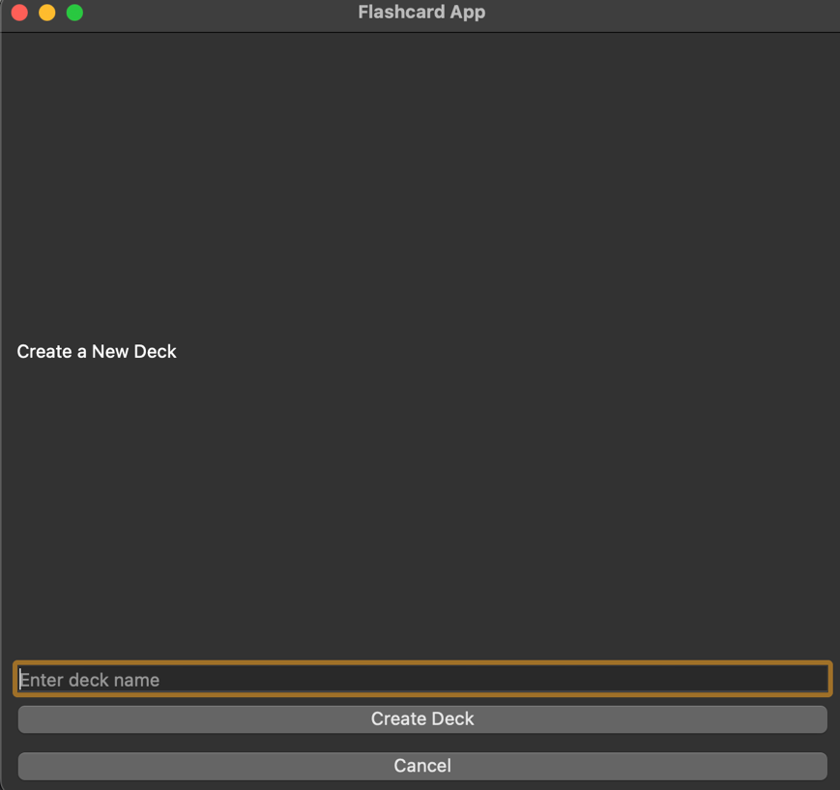
What I’ll be testing: | Deck creation: checking if you can enter a deck name
Justification: | Ensures that the user can create decks which is essential for my app
Expected outcome: | Screen where user can enter deck name
Actual outcome: | Screen where user can enter deck name
Results: | 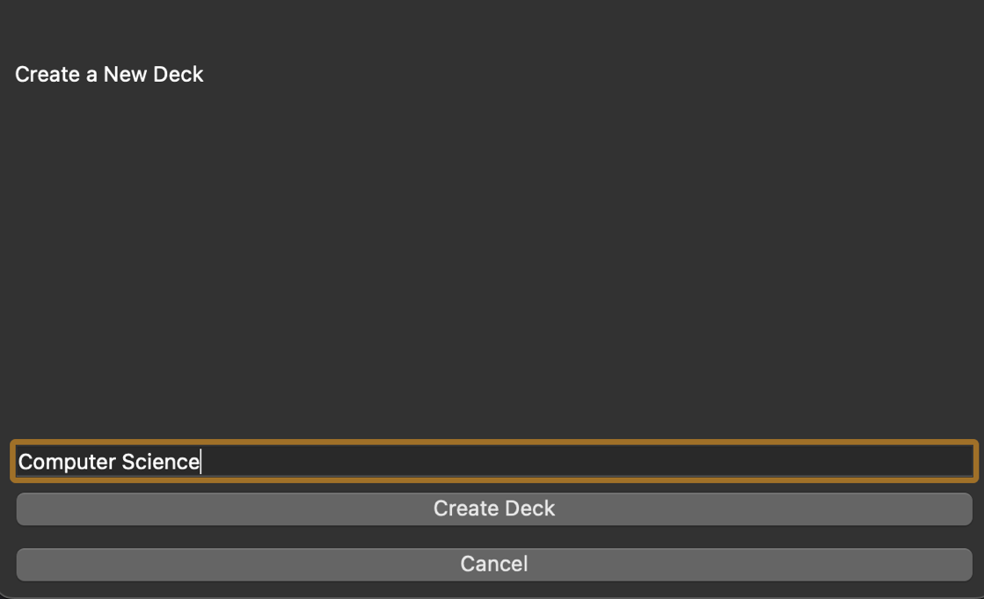

What I’ll be testing: | Deck creation: checking if the deck gets added to mainpage
Justification: | Ensures that the user can create decks which is essential for my app
Expected outcome: | Deck that was created gets added to homepage
Actual outcome: | Deck that was created gets added to homepage
Results: | 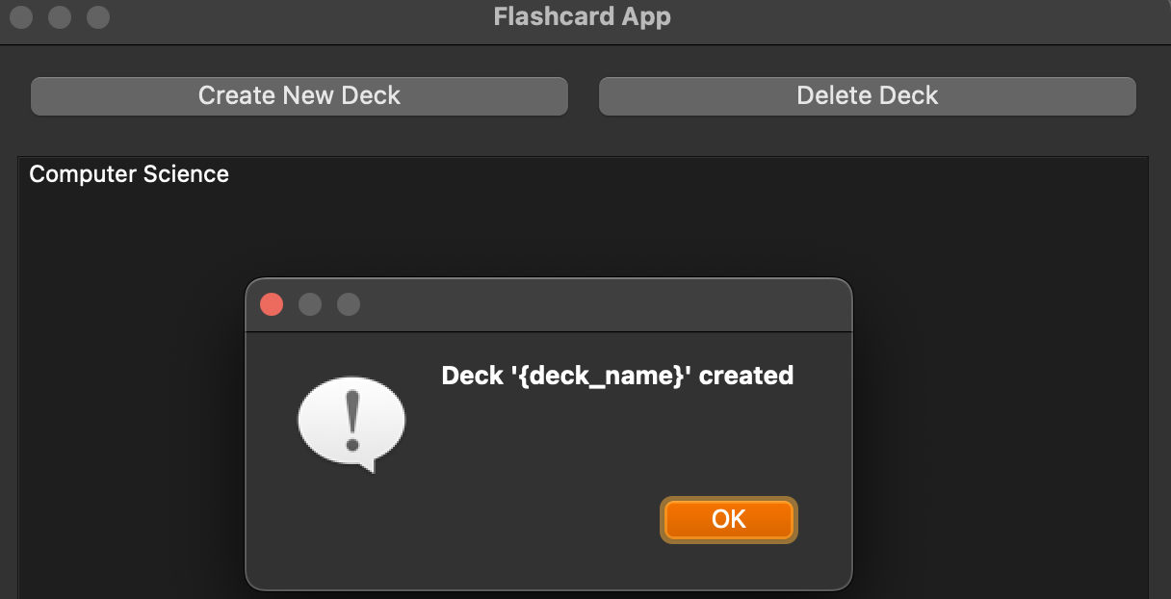

What I’ll be testing: | Deck creation: checking if you can delete decks made
Justification: | Ensures that the user can create decks which is essential for my app
Expected outcome: | Deck can get deleted
Actual outcome: | Deck is deleted successfully
Results: | 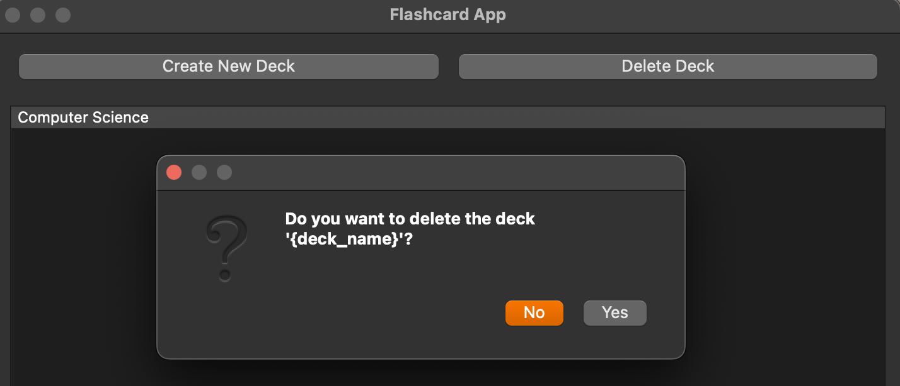  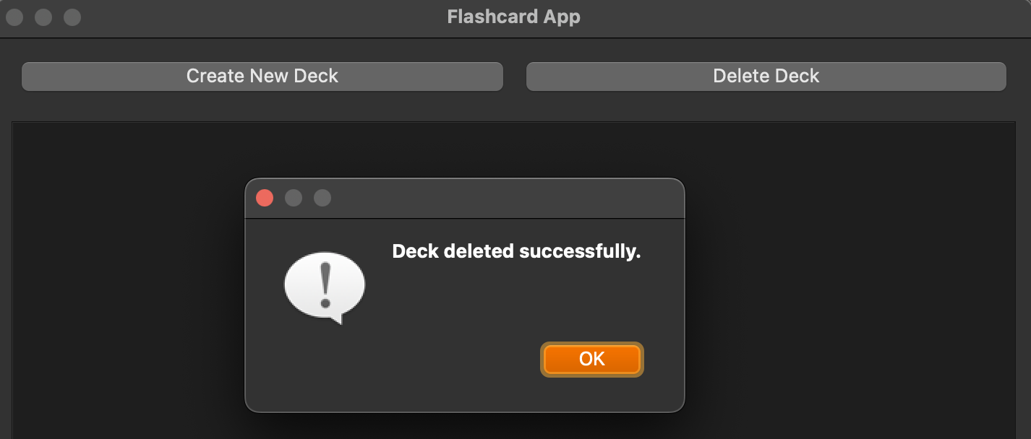

What I’ll be testing: | Deck creation: testing to see whether duplicate names is allowed in deck creation
Justification: | Ensures that the user can create decks which is essential for my app
Expected outcome: | Deck name must be unique and not empty.
Actual outcome: | Deck name must be unique and not empty.
Results: | 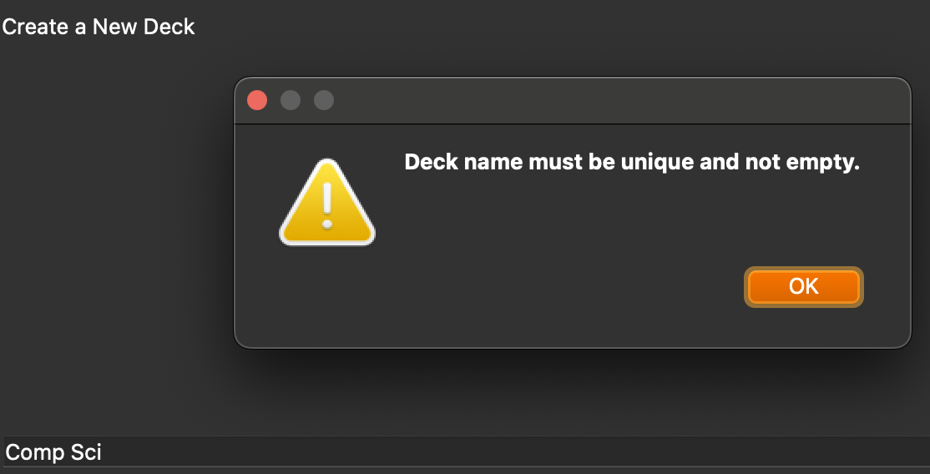

What I’ll be testing: | Deck creation: testing to see whether the app can handle multiple deck creations
Justification: | Ensures that the user can create and use decks which is essential for my app
Expected outcome: | Multiple decks shown on mainpage
Actual outcome: | Multiple decks shown on mainpage
Results: | 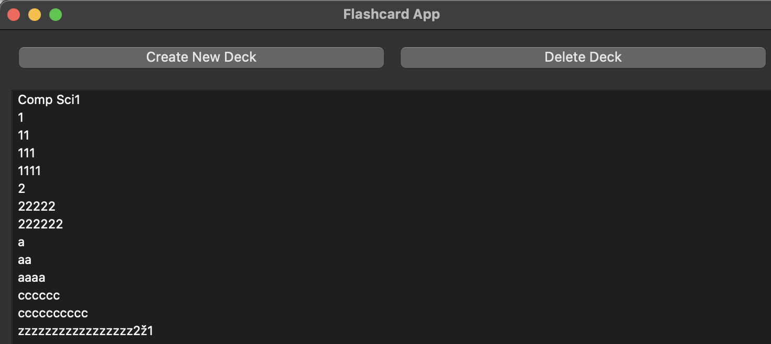

Errors:
I see there’s an error where is displays {deck_name} instead of the decks actual name both when the deck got created and when the deck was about to be deleted.
To fix this I started to look into the methods where those two are made in; Create_deck_page and mainpage.
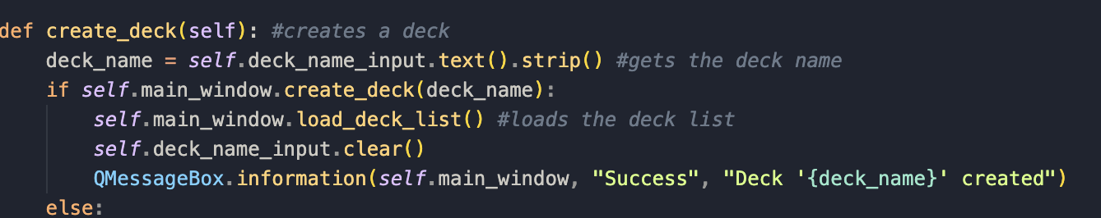
- In the QMessageBox, after success there should a f-string (a formatted string literals) which I learnt from https://www.geeksforgeeks.org/formatted-string-literals-f-strings-python/. F strings allow me to insert variables directly into a string using {}.
- To rectify this I need to add the ‘f’:

I now need to do this for the delete method as well:
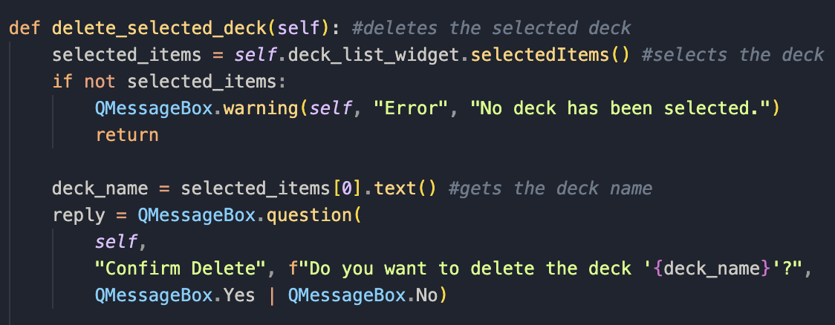

Now I’ll run the app again to check if the error is fixed:
What I’ll be testing: | Deck creation: checking if the deck name shows
Justification: | Ensures that the user can create decks which is essential for my app, and see what deck name it is
Expected outcome: | Deck name shown successfully when created
Actual outcome: | Deck name shown successfully when created
Results: | 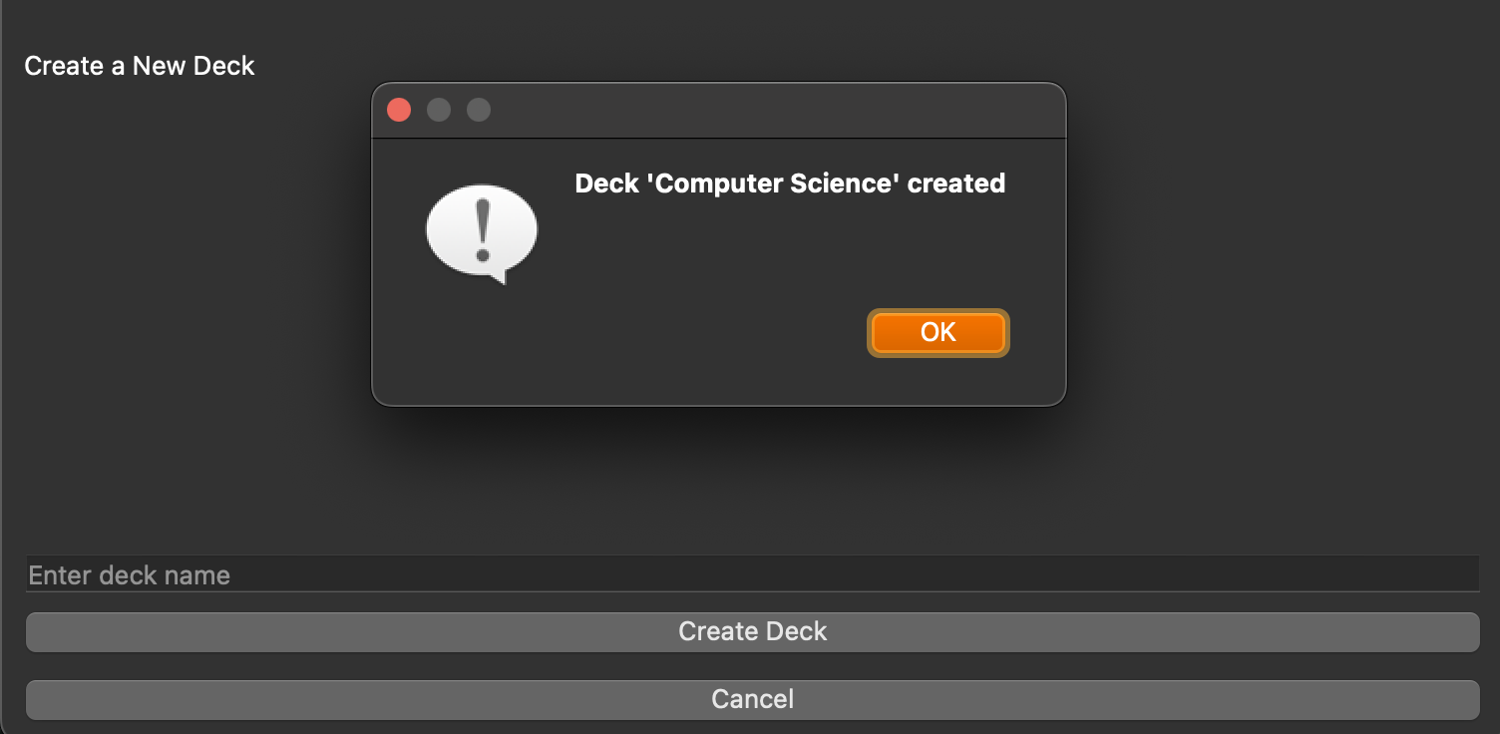

What I’ll be testing: | Deck creation: checking if the deck name shows
Justification: | Ensures that the user can create decks which is essential for my app, and see what deck name it is
Expected outcome: | Deck name shown successfully when deleted
Actual outcome: | Deck name shown successfully when deleted
Results: | 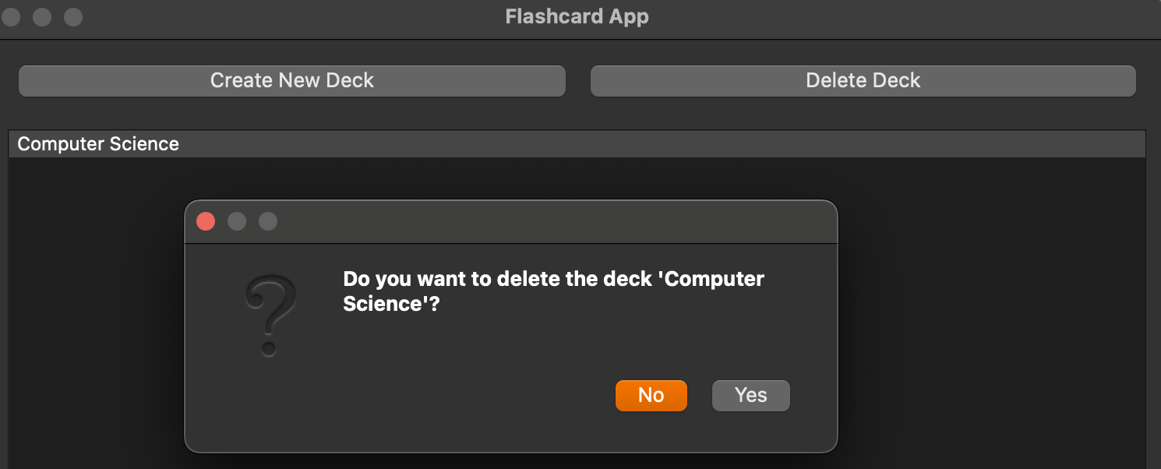

Stakeholder talk:
I wanted to have talk to my stakeholder to see if they like the direction I took the app in. I will perform an interview with them asking a few questions:
How do you feel about the way I handled deck implementation?
- I think it was done in a great way to be honest; it’s on par with apps like anki and has a simple interface, a one button click to create a deck and a one button way to delete a deck.
Is there any improvements I could make?
- Yes, what about those ‘subdecks’ where you can have decks inside decks for more customisation? I don’t think that’s a must now, but it would be nice to have later on. I’d rather have this feature over the streaks feature.
Anything else to add?
- No, keep up the good work!
Review of the interview:
I think this was a positive interview, with some thoughts I can definitely implement into the deck feature after I built everything else first.

Overall review:
I think up to now everything has been good so far code wise, and ive amended nay errors that I found. Next, I will be moving onto implementing the ability to add flashcards into a deck. I have also split this up into two classes, otherwise it’ll be too long and ill muddle things up. I have split my flashcard flowchart into two classes essentially as its also split into two when I completed my test table, etc. It also helps for debugging purposes and code readability when it’s been decomposed into two smaller classes. I’m going to however, work on both classes simultaneously as they are the same thing, and do the testing together as well.

Prototype code for flashcard page class:
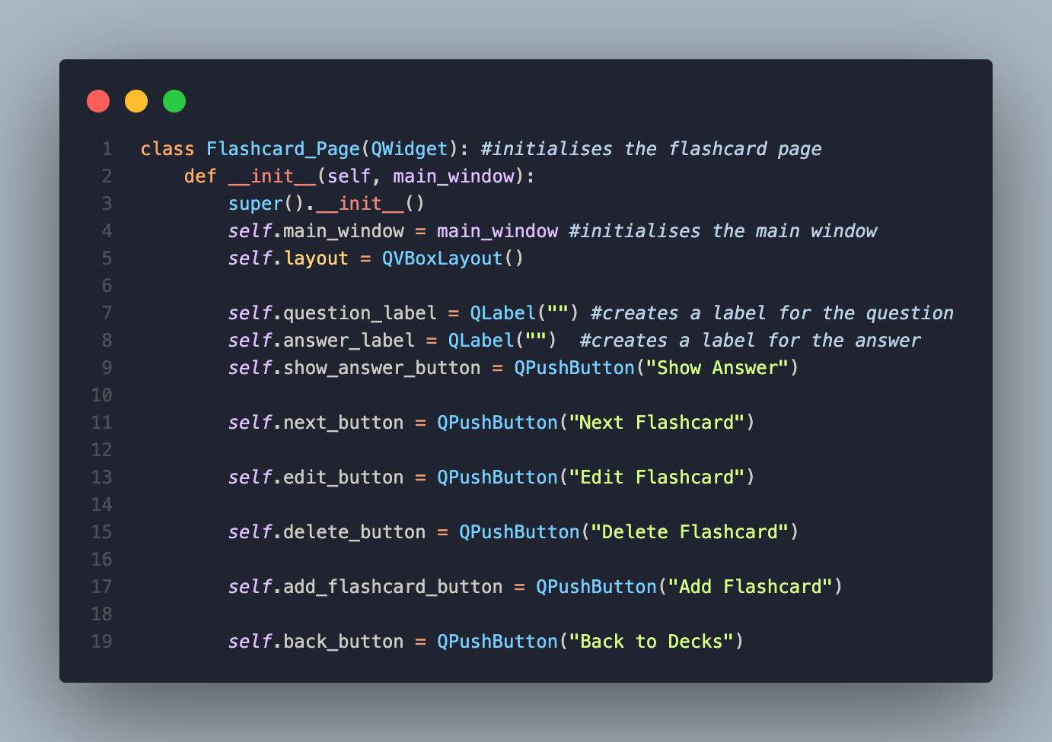

Flashcard creation:
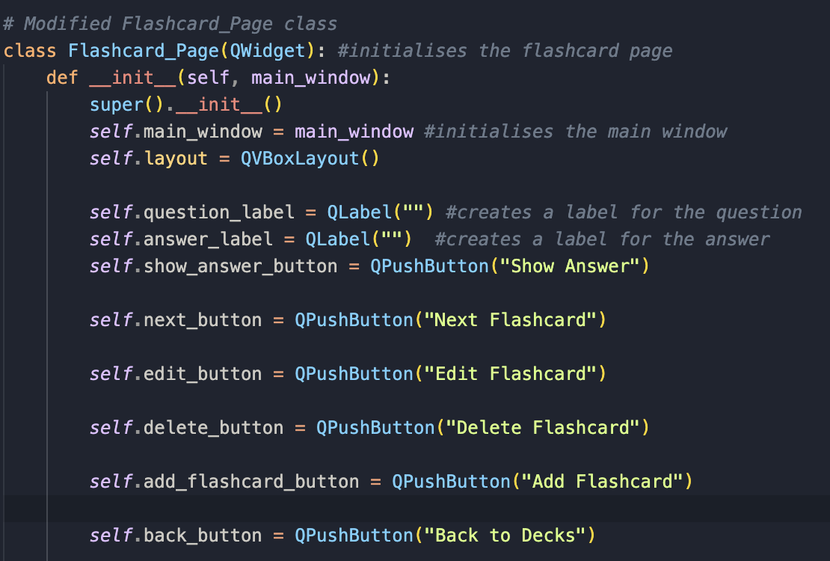
- I first created the first class for handling the flashcards, called Flashcard_Page. I define a new class which inherits from QWidget, thus making it a gui.
- Def __init__(self, main_window): is the constructor window which will run when an instance of Flashcard_Page is created. It also takes main_window as a parameter as it’ll then allow it to communicate with the Mainpage.
- super().__init__() calls the constructor QWidget, ensuring that Flashcard_Page inherits everything needed from the QWidget.
- self.main_window = main_window stores a copy of the main window to enable it to interact with everything else in the app.
- Next I made all the ui methods that I will need, such as: delete button, edit button, add button, back button, etc, and will connect it later.

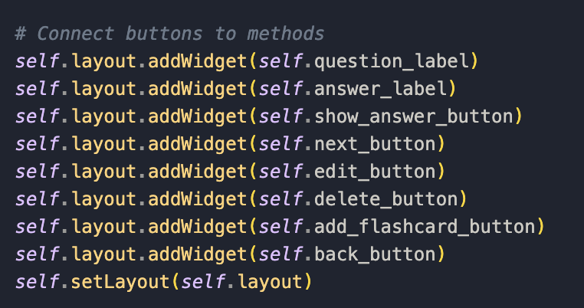
- I then added the widgets to the layout, also this is preparation for connecting the buttons to the methods later on.

Next I went to work on the other flashcard class:

Prototype code for the other flashcard page class:
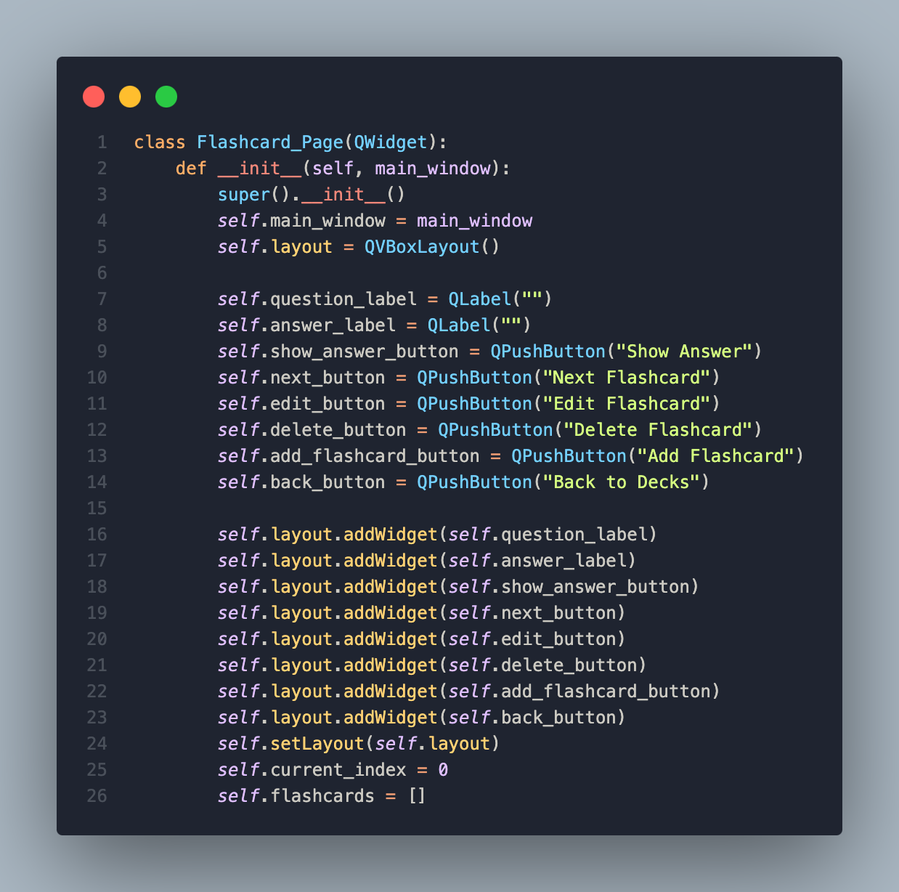

Flashcard class two creation:
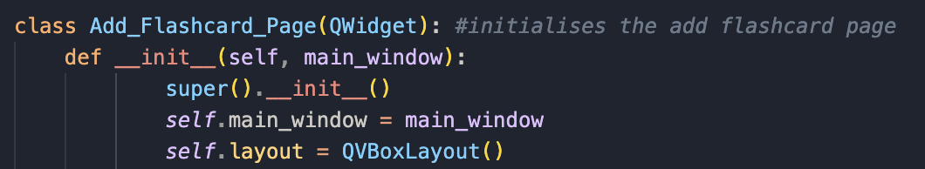
- The class Add_Flashcard_Page(QWidget) similarly like the previous class inherits QWidget enabling it to be a gui.
- super().__init__() calls the parent class constructor to initialise the widget.
- self.main_window = main_window stores a reference to the main application window, allowing the page to interact with it.
- self.layout = QVBoxLayout() is used to stack widgets like everywhere else in my app.

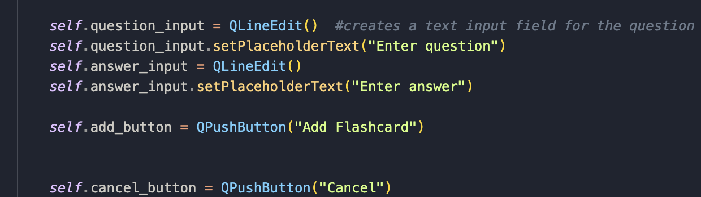
- I then add input fields.
- QLineEdit() creates a text box for you to enter in the question.
- setPlaceholderText("Enter question") adds the place holder "Enter question”.
- I made the same thing but for the answer input as well.
- I then made two buttons, one for adding the flashcard, and one to cancel the action and return to the previous page.
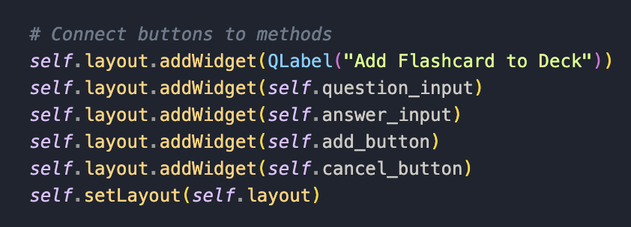
- Similarly to the first class I add the ui components to the layout.
- Self.setLayout(self.layout) ensures everything is displayed as expected.
I now start creating the methods needed to make flashcards. Some methods are in one class and some are in the other; depending on where I put the button for it.
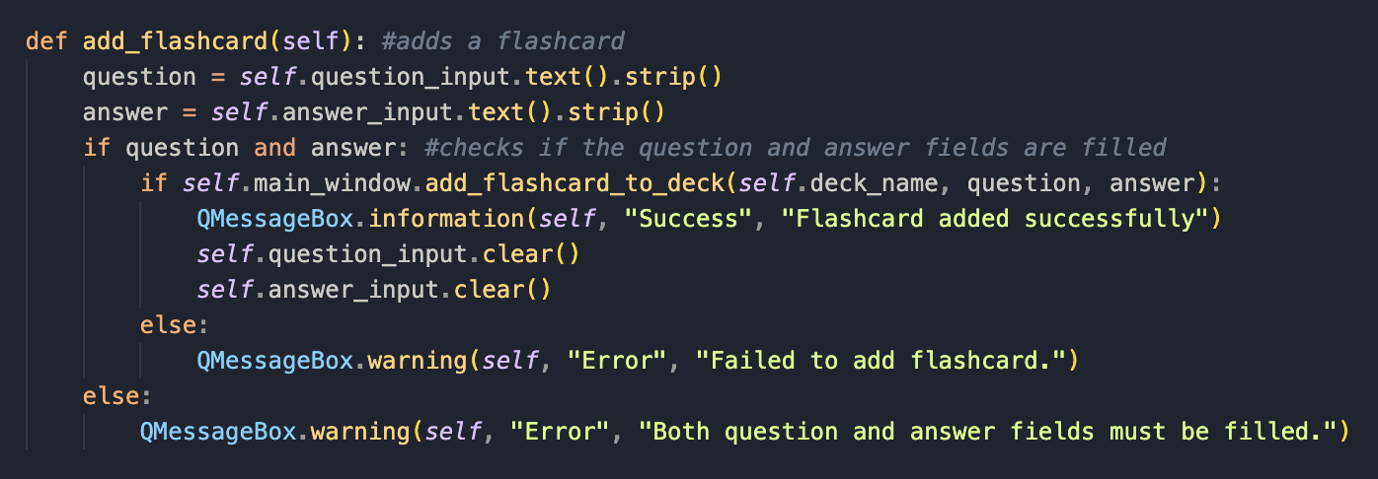
- The function add_flashcard(self) is needed to add a new flashcard to a deck.
- It first gets the question and answer using self.question_input and self.answer_input. Again I felt like using .strip() to get rid of any unnecessary spaces.
- I next check that both fields are full using the if statement. If empty, a warning message pops up.
- I then call self.main_window.add_flashcard_to_deck(self.deck_name, question, answer) which adds the flashcard to the dictionary/list.
- If successful a success message is shown, else a warning message is displayed.
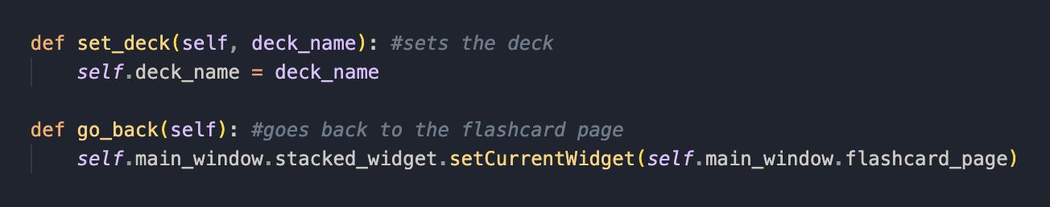
- The first function sets the deck the user is working with by taking the deck name and assigning it to self.deck_name which ensures future operations know what deck they are in.
- The second function is needed for the back button. It accesses self.main_window.stacked_widget which is a widget that can switch between pages. It then calls .setCurrentWidget(self.main_window.flashcard_page) changing the active page to the flashcard page.
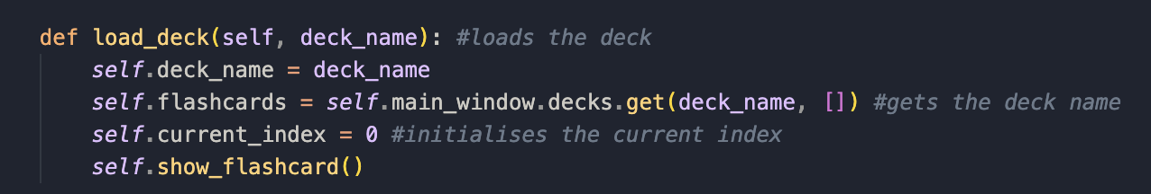
- This function loads a flashcard deck and prepares it to display it.
- self.deck_name = deck_name saves the selected deck_name so the class knows which deck is currently active.
- self.flashcards = self.main_window.decks.get(deck_name, []) Accesses self.main_window.decks, which is a dictionary storing all decks. It also uses .get(deck_name, []) to retrieve the flashcards for the given deck.
- If the deck doesn’t exist ir defaults to an empty list to stop errors occurring.
- self.current_index = 0 resets the current index to 0 to make the first flashcard be displayed.
- self.show_flashcard() calls self.show_flashcard() to display the first flashcard in the deck that’s been loaded in.
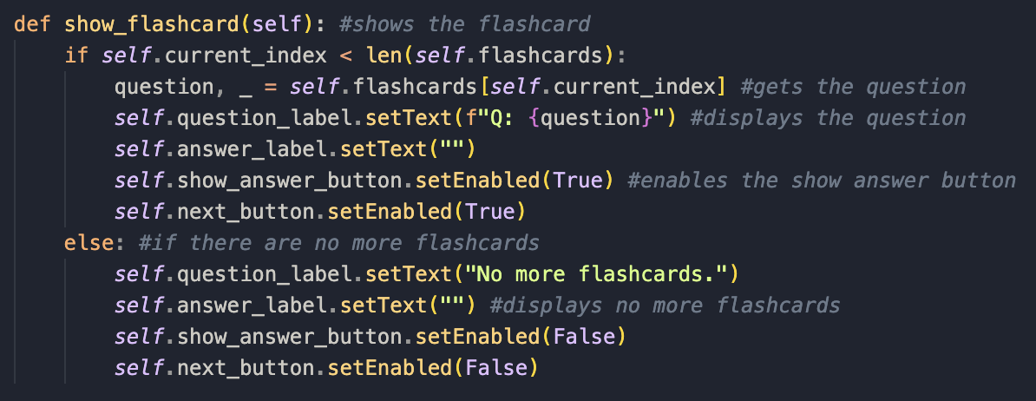
- This function displays the current flashcard’s question and controls the ui based on whether or not there are more flashcards left.
- First it checks if there are remaining flashcards using the if statement: if self.current_index < len(self.flashcards): this ensures that self.current_index is within the bounds of self.flashcards. If there are flashcards left, it proceeds to display one else, it disables navigation and tells the user.
- Nex tit retrieves and displays the questions: question, _ = self.flashcards[self.current_index]
- self.question_label.setText(f"Q: {question}") extracts the question from the current flashcard which have been stored as tuples. It then updates self.question_label to show the question.
- It then clears the answer page using self.answer_label.setText("") which ensures the answer is initially hidden, like my stakeholder wanted.
- I then enable the show answer and next buttons using self.show_answer_button.setEnabled(True) and self.next_button.setEnabled(True).
- The else statement is used to handle when there are no flashcards left:
- It first displays "No more flashcards." And clears the answer box and disables the buttons.
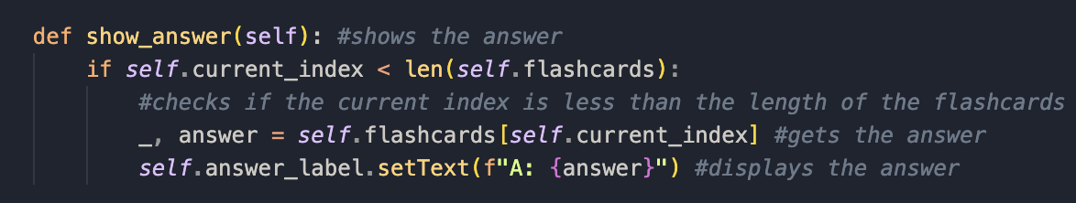
- This method is used to display the answer of a flashcard when called.
- The if statement is used to check if the current index (self.current_index) is still within the range of the flashcards list. If it is, the method proceeds to show the answer.
- _, answer = self.flashcards[self.current_index] retrieves the current flashcard using self.current_index. It's unpacking the tuple/list where the first element is ignored (_), and the answer is assigned to the variable answer.
- self.answer_label.setText(f"A: {answer}") sets the text of the label (self.answer_label) to display the answer.

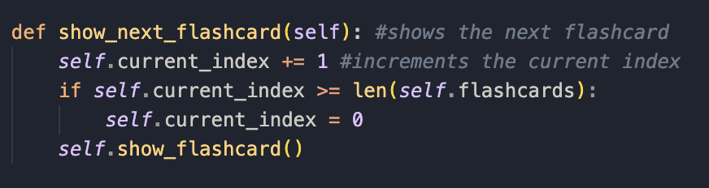
- this method is responsible for going to the next flashcard and displaying it.
- self.current_index += 1 increments the current_index by 1, moving to the next flashcard.
- if self.current_index >= len(self.flashcards): checks if the current_index has reached or gone past the length of the flashcards list. If it has, it means you've gone past the last flashcard.
- What self.current_index = 0 is that if the current_index is past the last flashcard, it resets the index to 0, looping back to the first flashcard.
- self.show_flashcard() calls show_flashcard that updates the screen with the new flashcard at the updated current_index.
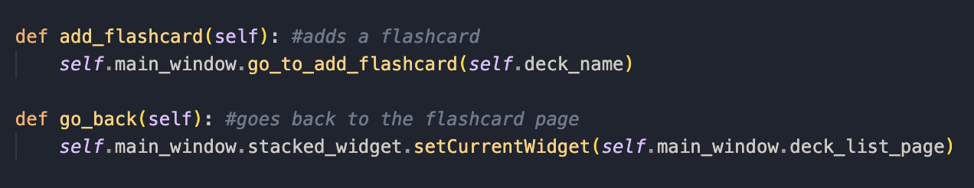
- the first function adds the flashcard to a deck.
- self.main_window.go_to_add_flashcard(self.deck_name) calls go_to_add_flashcard on the main_window, passing deck_name as an argument. This is to go to the ‘add flashcard’ page where the user can input the new flashcard details.
- This method is used for the user to go back to the flashcard list page.
- The second line changes the current widget to the deck_list_page, which is the page displaying the list of decks; navigating the user to the previous page.
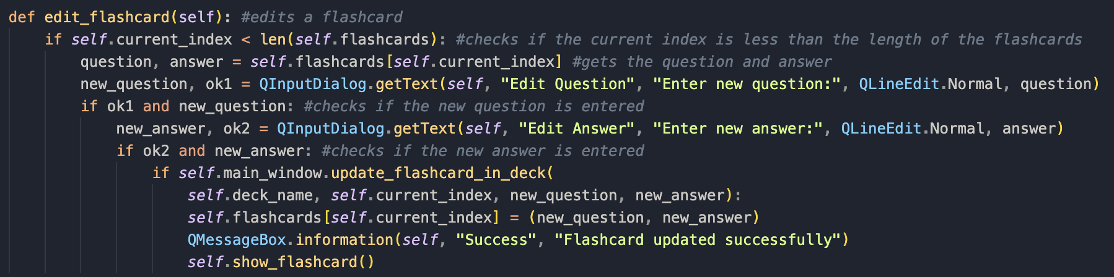
- This method allows you to modify the question and answer of the current flashcard.
- The first if statement checks if the current index is in the range of available flashcards. If it's valid, the method can then carry on.
- question, answer = self.flashcards[self.current_index] gets the current flashcard, splitting it into question and answer.
- new_question, ok1=… shows a box where the user can input the new question. ok1 is actually being used as a Boolean here and will be true if user confirms the input.
- if ok1 and new_question: checks whether the user entered a new question and clicked ok.
- new answer, ok2 is the same but for answer.
- if ok2 and new_answer: same as step five.
- if self.main_window.update_flashcard_in_deck(...) calls update_flashcard_in_deck from main_window, which passes the updated question and answer, with the deck name and index.
- self.flashcards[self.current_index] = (new_question, new_answer) updates the flashcards list in memory.
- QMessageBox. Information(self, "Success"….) is a message displayed if the edit was successful.
- self.show_flashcard() method is called to display the new updated flashcard.

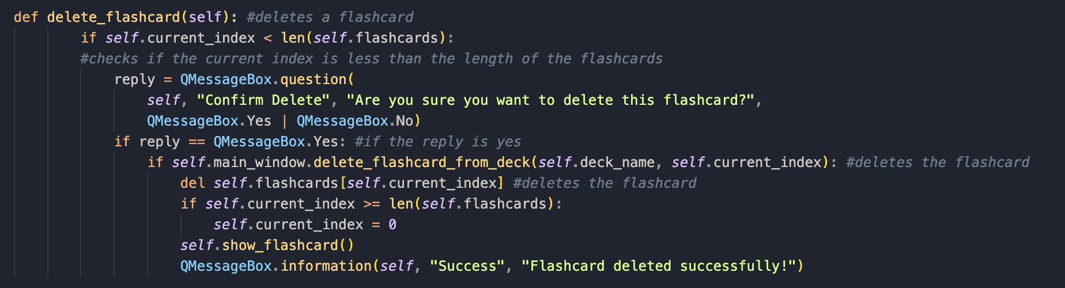
- This method allows the user to delete a flashcard after confirming to delete it.
- if self.current_index < len(self.flashcards): checks if the current_index is valid by ensuring it's within the bounds of the flashcards list.
- reply = QMessageBox.question(...) shows a confirmation box asking the user if they’re sure they want to delete the flashcard. The box shows two options: "Yes" and "No". The reply variable stores the user's response.
- if reply == QMessageBox.Yes: If the user confirms the deletion by clicking "Yes", the method proceeds with the deletion.
- if self.main_window.delete_flashcard_from_deck(...) calls delete_flashcard_from_deck in the main_window to delete the flashcard from the deck. If the deletion is successful, the method continues.
- del self.flashcards[self.current_index] deletes the flashcard from the flashcards list at the current_index.
- if self.current_index >= len(self.flashcards): is where after deletion, if the current_index is longer than the length of the remaining flashcards, the index is reset to 0.
- The self.show_flashcard() method updates the display to show the next flashcard after the deletion.
- Then a success message is shown if the flashcard is deleted successfully.

Now that ive made all the methods I need to complete both classes, I need to now connect them to the buttons I made earlier:

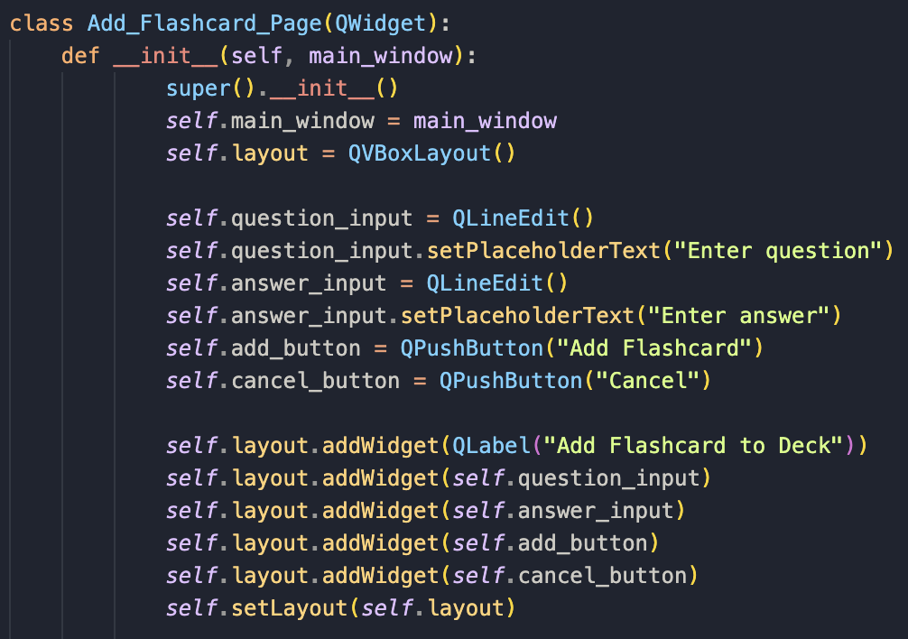
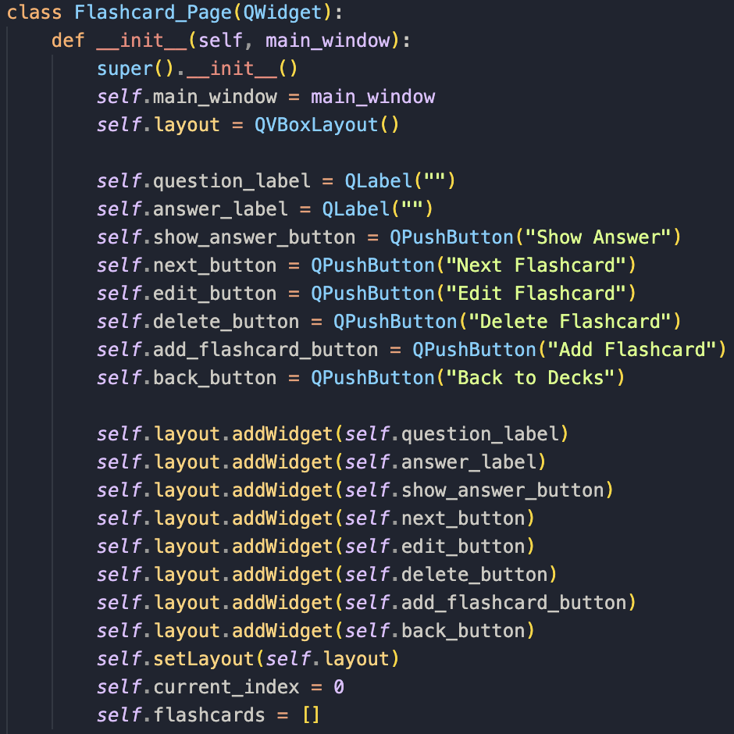
Before I can start testing however, I need to do a few more things:
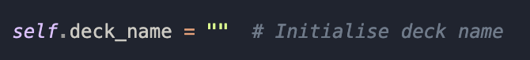
- self.deck_name stores the name of the deck where flashcards will be added. Other methods in the class will update later with an actual deck name later.
- This is being initialised as an empty string when the object is created, which ensures that self.deck_name exists before being used elsewhere in the class.
I then need to make functions for the flashcards in the Main_Window class as well because that’s where everything is controlled from. The flashcards need to be saved as well to the json file which will happen there. Earlier I already pre-wrote some of the functions’ names I would’ve needed for later for the flashcards, which is now.
In the Main_Window class now:
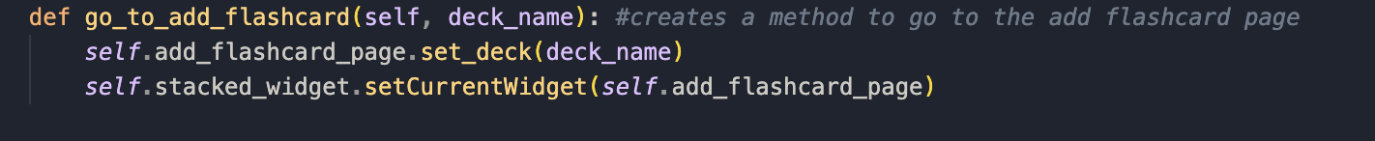
- The first line defines go_to_add_flashcard, which belongs to an object. It then takes deck_name as a parameter, representing the name of the deck where the user wants to add a flashcard.
- self.add_flashcard_page.set_deck(deck_name) calls the set_deck method on self.add_flashcard_page, passing deck_name.
- add_flashcard_page is an instance of another class responsible for handling the flashcard addition page.
- set_deck(deck_name) updates the flashcard page to know which deck the new flashcard should be added to.
- setCurrentWidget(self.add_flashcard_page) changes the current view to add_flashcard_page, showing the flashcard addition page.
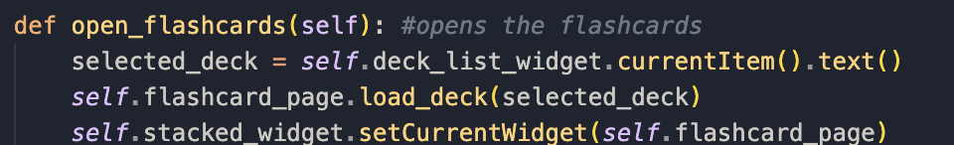
- This method handles opening the flashcards for a selected deck.
- self.deck_list_widget is a QListWidget that displays a list of available decks. .currentItem() gets the currently selected item in the list. .text() retrieves the name of the selected deck as a string.
- self.flashcard_page.load_deck(selected_deck) calls the load_deck method on self.flashcard_page, passing selected_deck. load_deck(selected_deck) loads the flashcards for the selected deck into the flashcard page.
- The last line switches to view the flashcard_page.

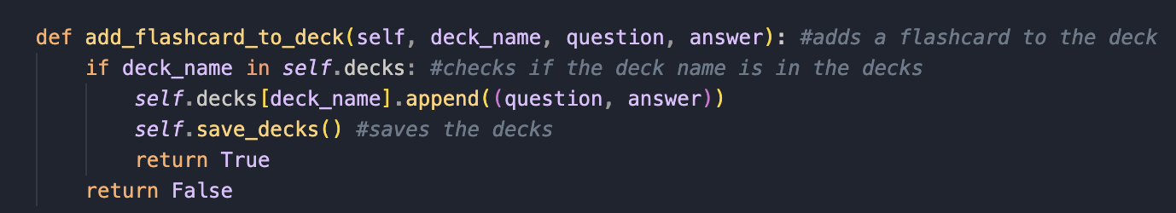
- This method adds a flashcard to a deck that the user will have chosen.
- First it checks if the deck exists with the if statement.
- It then adds the flashcard using self.decks[deck_name].append((question, answer)), storing it as a tuple for reasons I mentioned earlier.
- Self.save_decks() updates the json file.
- If the flashcard was added, it returns true, if for e.g. the deck didn’t exist, returns false.
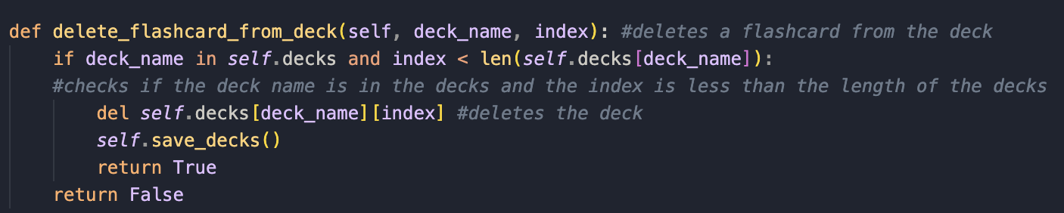
- This method removes a flashcard from a deck that the user will have chosen.
- First, the if statement checks if the deck exists and whether or not the index it valid. if deck_name in self.decks and index < len(self.decks[deck_name]) ensures that the deck first of all exists in self.decks.
- del self.decks[deck_name][index] removes the flashcard at that particular point in the list.
- Self.save_decks() updates the json file to make sure the change is permanent.
- If it was able to properly delete it, the method returns true, else, returns false.
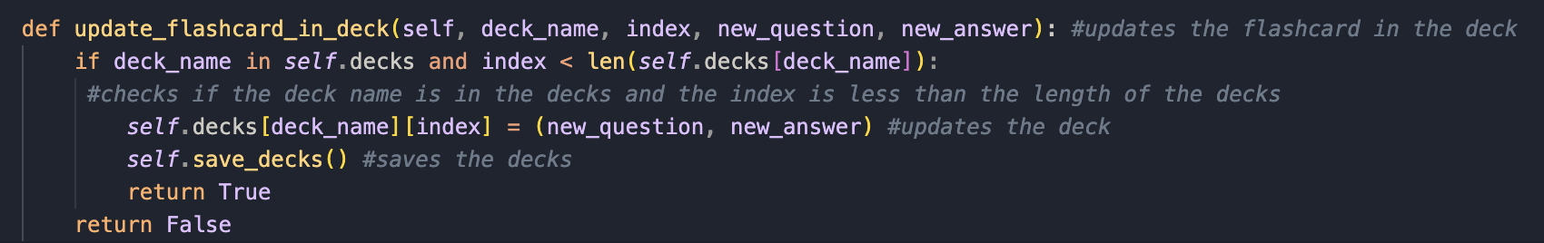
- This method updates an existing flashcard in a deck by replacing its question and answer with new inputs.
- Defines a method update_flashcard_in_deck that takes four parameters:
  - deck_name: The name of the deck where the flashcard is stored.
  - Index: The position of the flashcard within the deck’s list.
  - new_question: The updated question.
  - new_answer: The updated answer.
- The second line ensures the deck exists and ensures the index is within the bounds to check the flashcard exists.
- self.decks[deck_name][index] = (new_question, new_answer) updates the flashcard at the index with the new question and answer.
- self.save_decks() saves it to the json file.
- It returns true if successful, else return false.
- I then connect the function to the button/gui.
Now with everything set up I can start testing for this module:

Flashcard creation testing:

What I’ll be testing: | Flashcard creation: checking if I can add a flashcard to a deck.
Justification: | Ensures that the user can create flashcards which is essential for my app.
Expected outcome: | Flashcard added successfully
Actual outcome: | Flashcard added successfully
Results: | 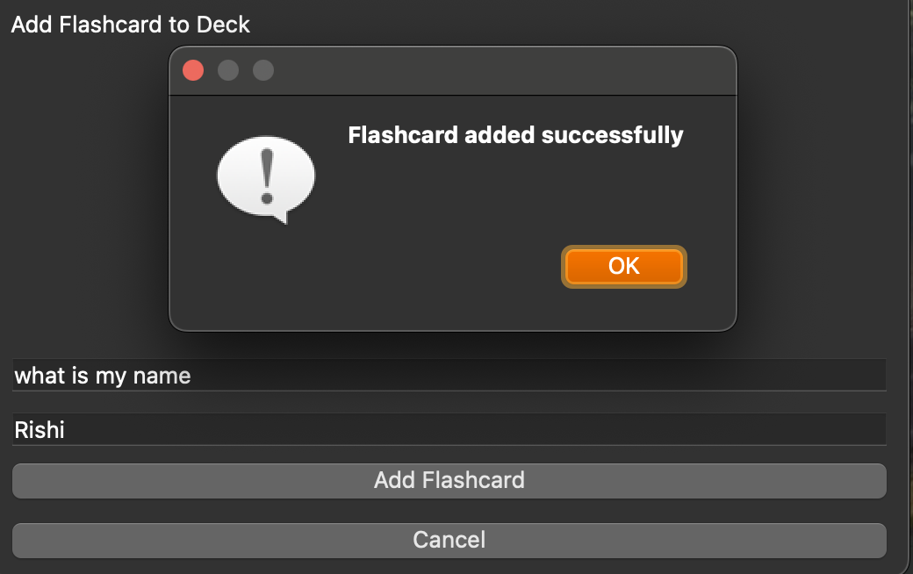

What I’ll be testing: | Flashcard creation: checking if the back button works
Justification: | Ensures that the user can go back to the mainpage
Expected outcome: | User is at mainpage
Actual outcome: | User is at mainpage
Results: | 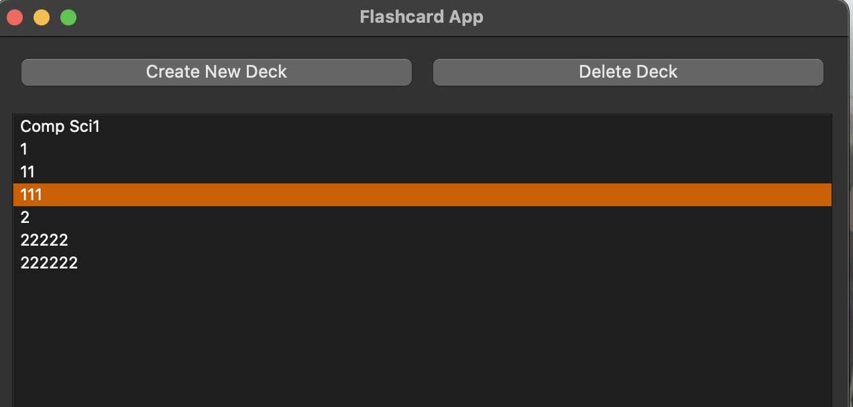

What I’ll be testing: | Flashcard creation: checking if I can add a flashcard to a deck when question is empty
Justification: | Ensures that the user can create flashcards which is essential for my app.
Expected outcome: | Both question and answer fields must be filled
Actual outcome: | Both question and answer fields must be filled
Results: | 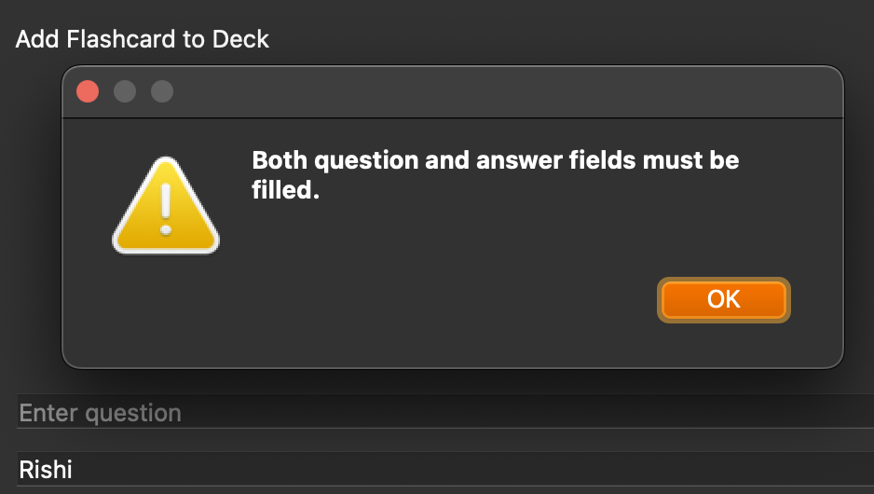
What I’ll be testing: | Flashcard creation: checking if I can add a flashcard to a deck when answer is empty
Justification: | Ensures that the user can create flashcards which is essential for my app.
Expected outcome: | Both question and answer fields must be filled
Actual outcome: | Both question and answer fields must be filled
Results: | 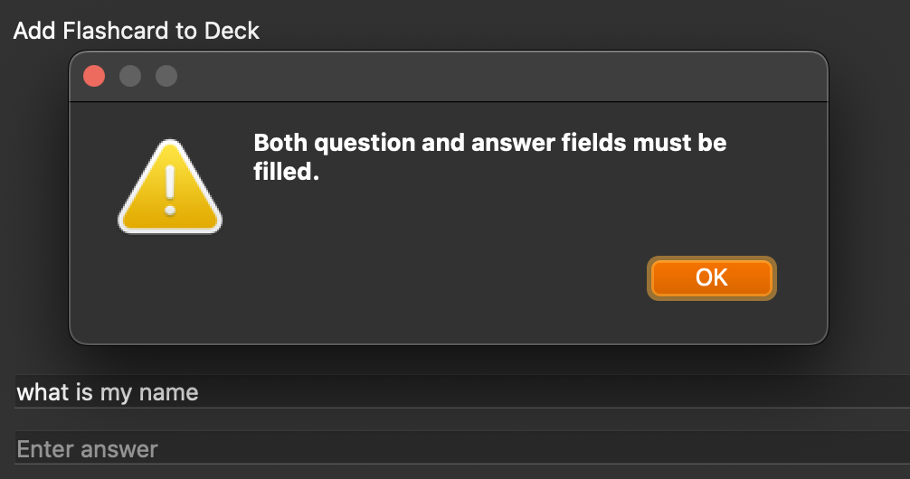

What I’ll be testing: | Flashcard creation: checking if I can start doing flashcards
Justification: | Ensures that the user can use the flashcards which is essential for my app.
Expected outcome: | Both question and answer shown when clicked shown answer
Actual outcome: | Question and answer are shown
Results: | 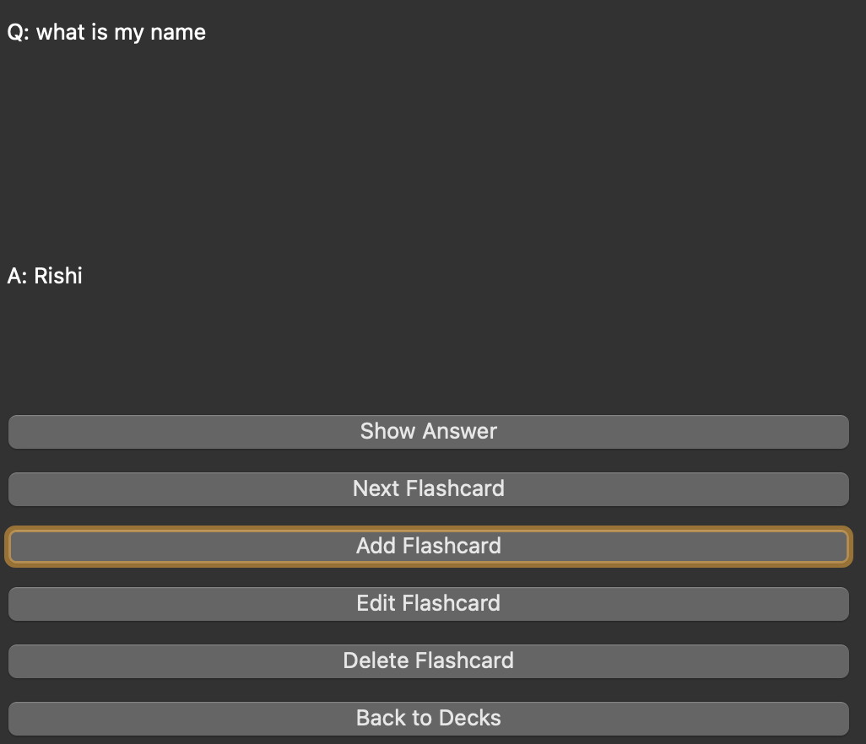
What I’ll be testing: | Flashcard creation: checking if I can go to the next flashcard
Justification: | Ensures that the user can use the flashcards which is essential for my app.
Expected outcome: | Next flashcard is shown
Actual outcome: | Next flashcard is shown
Results: | 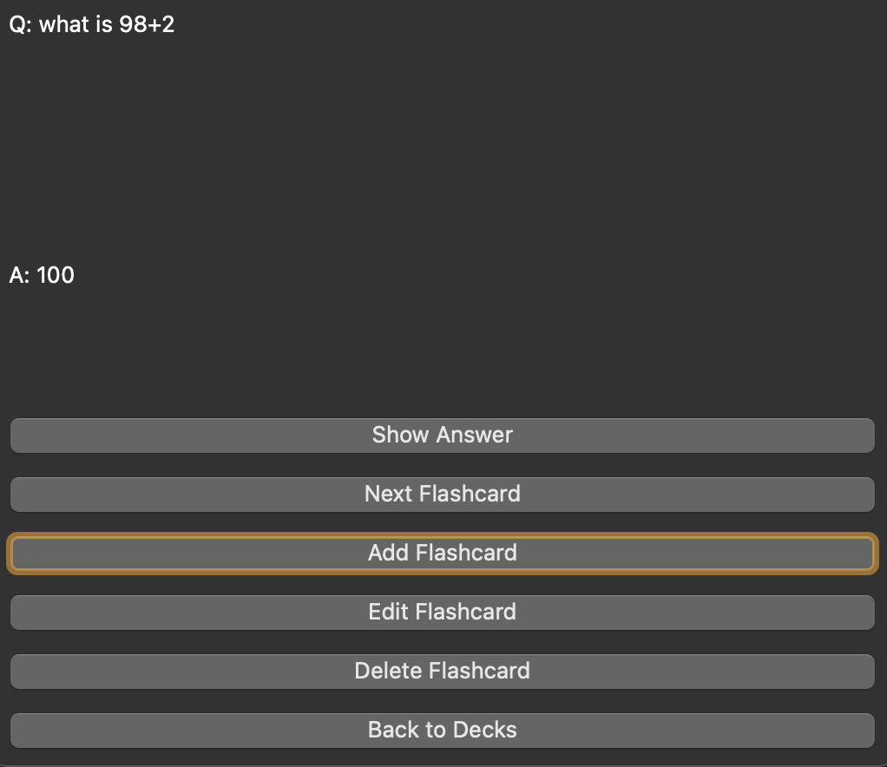

What I’ll be testing: | Flashcard creation: checking if I can edit the flashcard
Justification: | Ensures that the user can change flashcards which is essential for my app; also competitors data
Expected outcome: | Flashcard is changed and saved when opened again.
Actual outcome: | Flashcard updated successfully
Results: | 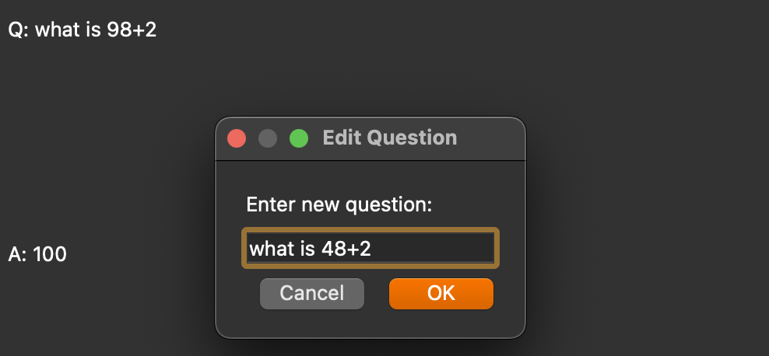  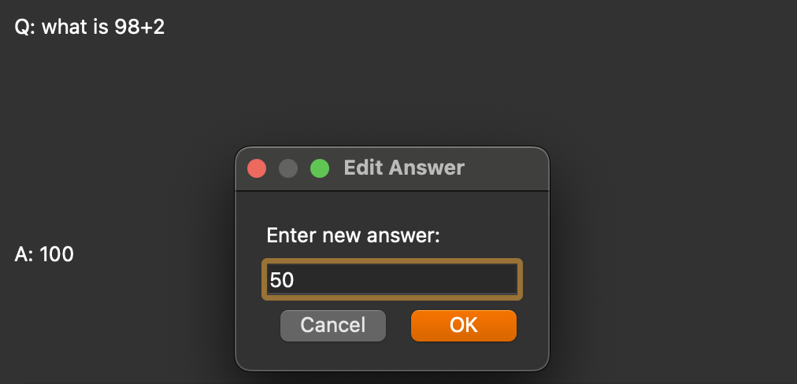  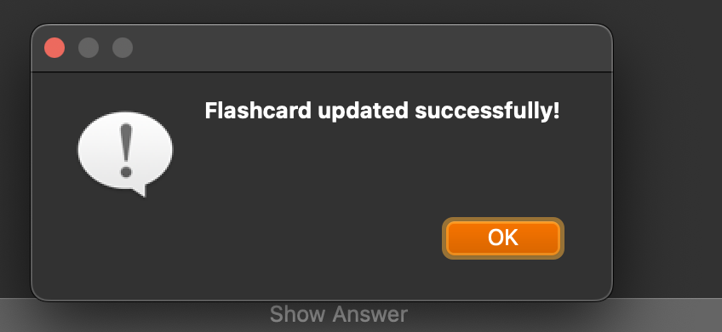  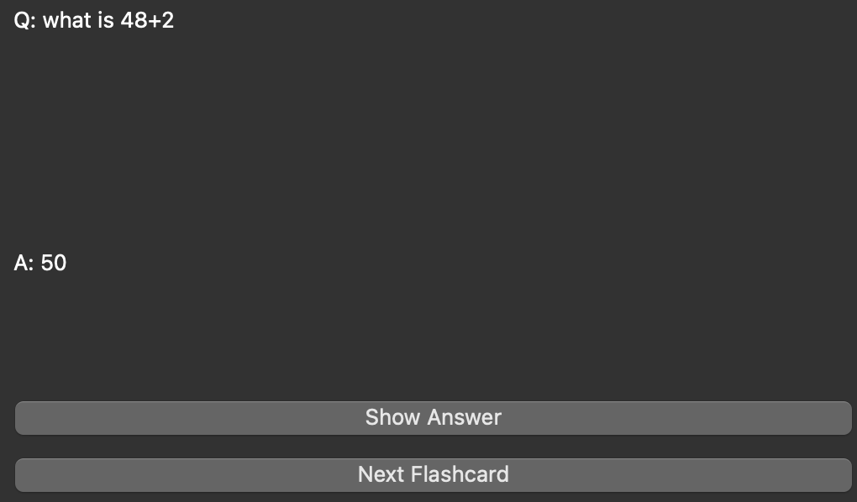

What I’ll be testing: | Flashcard creation: checking if I can delete flashcards
Justification: | Ensures that the user can get rid of flashcards which is essential for my app.
Expected outcome: | Flashcard should be deleted from the deck
Actual outcome: | App crashed
Results: | N/A (it crashed the app)

Errors:

From my testing done, I can see everything works, except for the delete button, which when I click it, crashes the app. So now I will be working on remedying that.
After looking through the delete flashcard method the potential issues that could be causing the app to crash are:
- If the index is out of range: which means that when I click delete, the app might be trying to remove a card from the index that doesn’t exist.
- It could also be that the deck name hasn’t been found: if the deck isn’t properly referenced, the deletion can fail.
- Or what I have a feeling it is that it’s affecting the list when its iterating through the flashcards: when I delete a flashcard its affecting the currently displayed flashcard and that could cause a crash if it isn’t handled properly.
After further testing I fixed it by changing parts of the delete method:
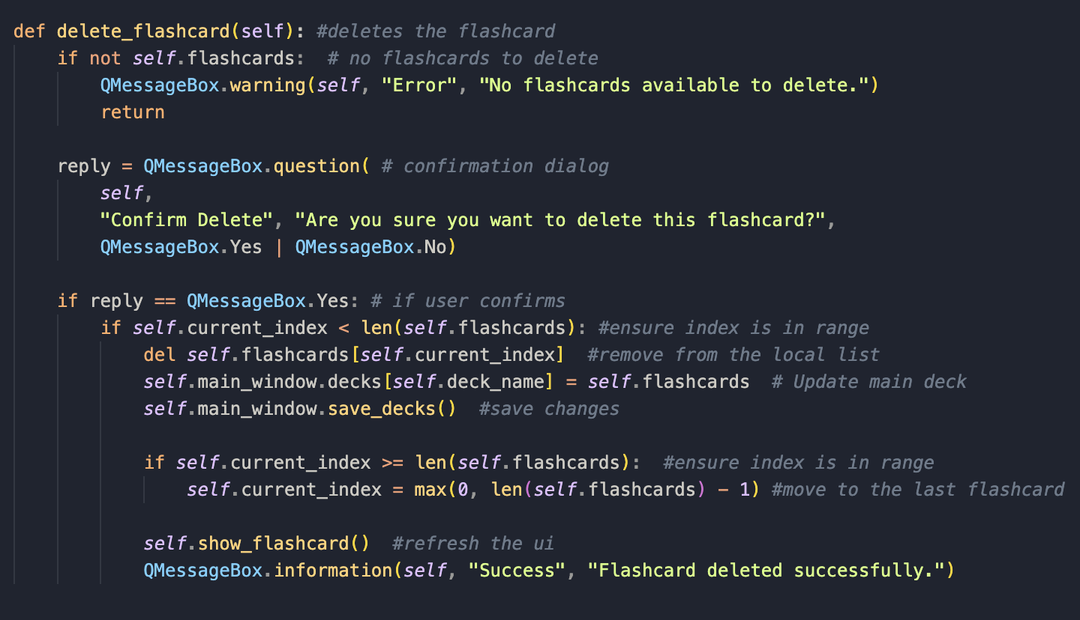
What was causing the problem and solution:
- In the old method, when you deleted a flashcard, it was removed from the self.flashcards list but not updated in self.main_window.decks causing errors.
- The method also didn’t refresh the ui after deleting a flashcard, and I think that was causing the app to reference an index that was out of bounds.
- Now, self.main_window.decks[self.deck_name] is updated properly after a flashcard is deleted.
- I ensured that self.current_index never goes out of bounds. If the last flashcard is deleted, the index is changed to prevent errors.
- The ui is refreshed immediately after a flashcard is removed now.
- Now, if self.flashcards is empty, it now shows a message instead of attempting deletion.
Now I will test again to see if it works now:
What I’ll be testing: | Flashcard creation: checking if I can delete the flashcard without it crashing
Justification: | Ensures that the user can delete flashcards which is essential for my app; also competitors data
Expected outcome: | Flashcard is deleted successfully
Actual outcome: | Flashcard is deleted successfully
Results: | 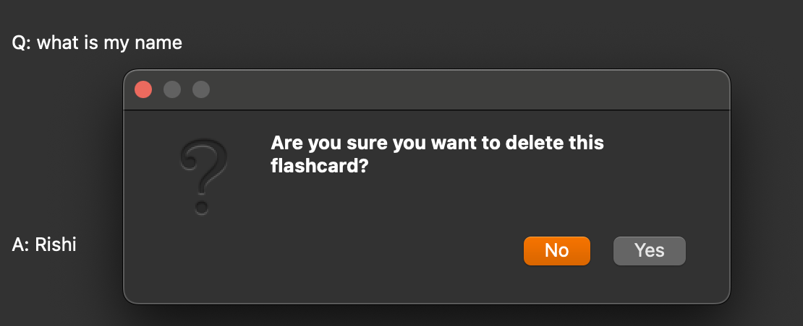  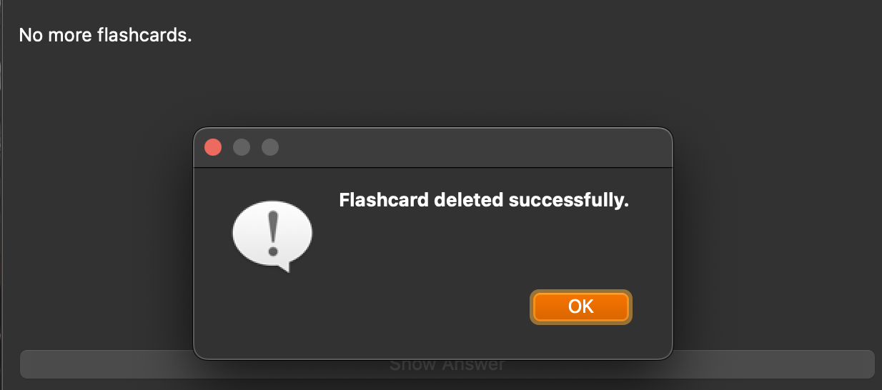

Stakeholder talk:
I wanted to have talk to my stakeholder to see if they like the direction I took the app in. I will perform an interview with them asking a few questions:
What do you think of the implementation of the flashcard addition page?
- I think it was a good implementation, however it would be even better if it was on a different page, rather than being tied to the deck page
Do you like all the features provided?
- Yes, it has everything I need for a flashcard addition page, however I would maybe like to see the addition of images if possible, but this is not that important to me now. What happened to the ai section though?
Is there anything else you want to add?
- No, but next I’d like to see the browse page being implemented.

Review of the interview:
I think my stakeholder likes the features I provide, but I think I will separate the addition of flashcards into a new window later on though.

Overall review:
After looking through my code I found it structurally sound, however it irritated me that if you only click once it takes you to a new deck, so I thought about changing that:
I changed that into this using: itemDoubleClicked. I found out about this method on https://zetcode.com/pyqt/qlistwidget/.

AI problem:
As my stakeholder pointed out I haven’t implemented any ai features that I promised in the earlier sections. This is because every ai api I found needed money to either use it, or to buy tokens with money to use it. I did look for alternatives and found google bard (Gemini). However when I tried to use it I got hit with this page: https://ai.google.dev/gemini-api/docs/available-regions. Google vertex ai also cost money as well. Therefore I have chosen to omit ai from my project.

Prototype code for the browse class:
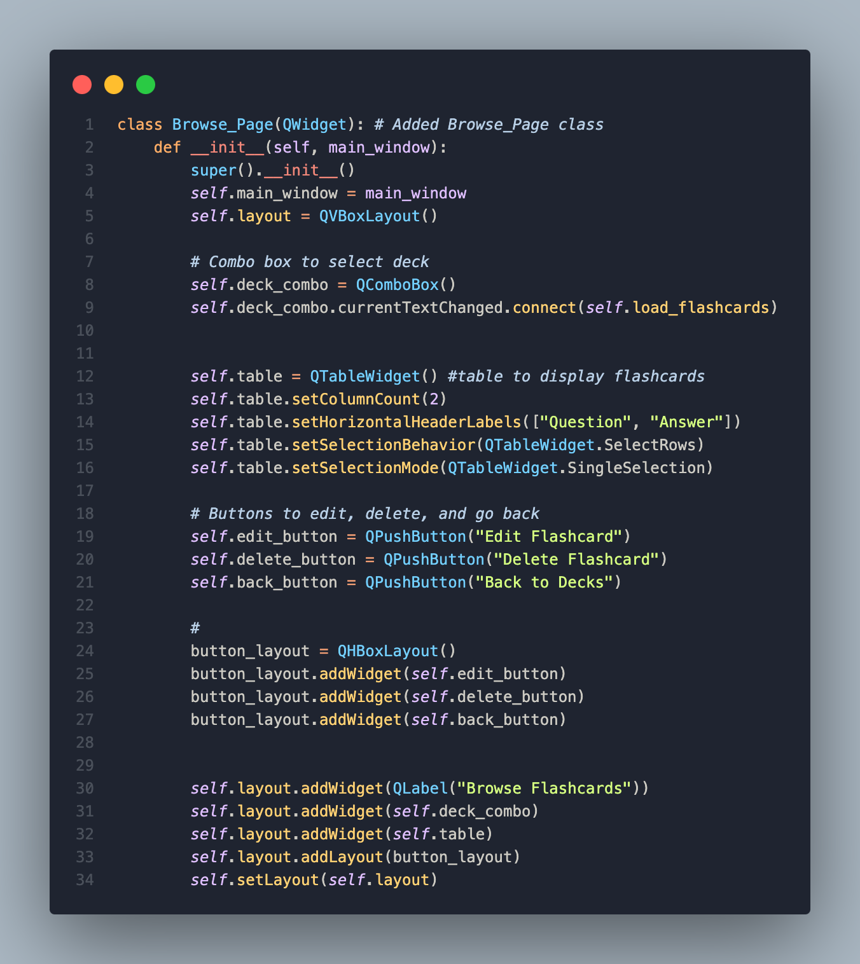

Browse page creation:
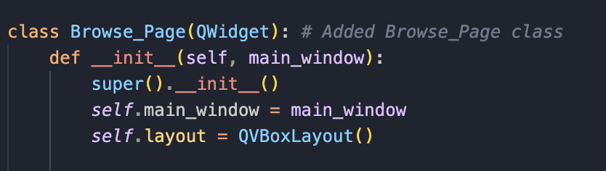
- Like every other class, this also inherits from Qwidget, making it a custom widget in my app.
- The constructor initialises the widget.
- super().__init__() calls the QWidget constructor.
- self.main_window stores a reference to the main window, possibly for communication between pages.
- self.layout = QVBoxLayout() sets up a vertical layout.
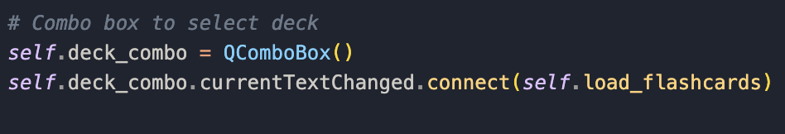
- QComboBox lets users select a deck of flashcards.
- When the selected deck changes, it calls self.load_flashcards().
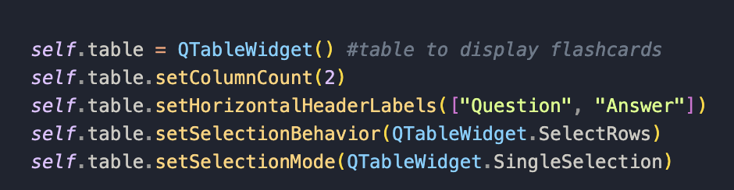
- I then made a table with two columns: ‘question’ and ‘answer’.
- setSelectionBehavior makes it so that clicking anywhere on a row selects the whole row, so question and answer are selected.
- setSelectionMode makes it so that you can only select one row at a time.

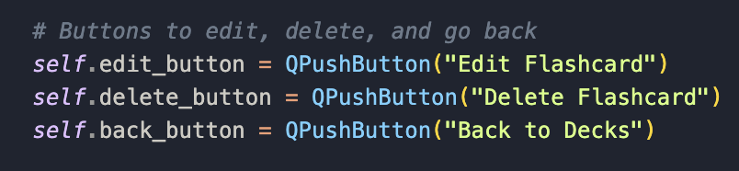
- I made buttons for the page now: these three buttons allow the user to:
- Edit a selected flashcard.
- Delete a selected flashcard.
- Return to the main deck selection page.

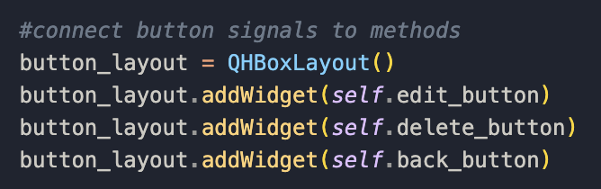
- This creates a horizontal layout for the buttons, making them appear side by side.

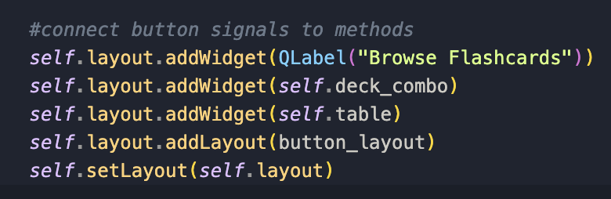
- I then added the final layout setup, which adds:
    - Adds a title label called "Browse Flashcards".
    - Adds the combo box for deck selection.
    - Adds the flashcard table.
    - Adds the button layout.
    - Sets self.layout as the main layout of the page.

I then started to make the functions needed for the browse class:

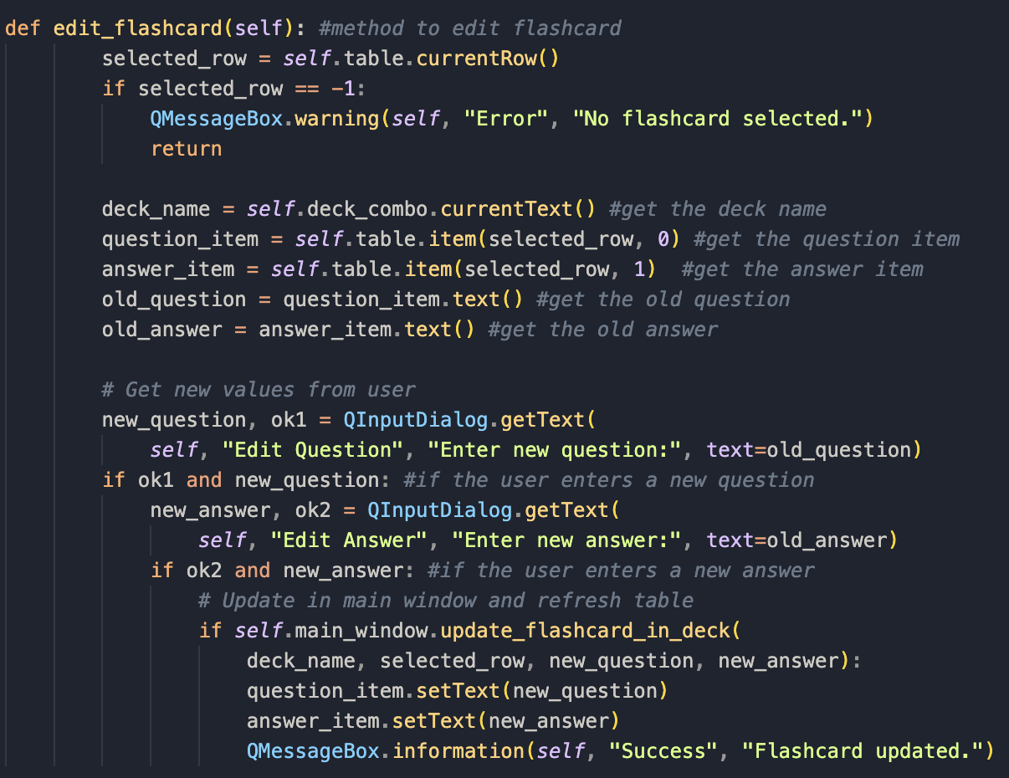
- This is the method for editing a flashcard for within the browse page.
- self.table.currentRow() gets the currently selected row. If no row is selected (-1 is no selection), it shows a warning message and exits the function.
- deck_name = self.deck_combo.currentText() gets the name of the selected deck from the drop-down box.
- The next four lines retrieves the question and answer items from the selected row. It then gets out the text from the old question and answer.
- new_question, ok1 = QInputDialog.getText( opens an input box asking the user to put a new question in. like previously, ok1 will be true if the user confirms, and false if they cancel.
- if ok1 and new_question: checks if the user entered a new question. If they did, ok1 is true and it continues on, else it skips editing the flashcards.
- new_answer, ok2 = QInputDialog.getText( prompts the user for a new answer, and works the same as the one for the new question , but using ok2 for truths.
- if self.main_window.update_flashcard_in_deck( this if statement updates the flashcard in the main window by calling update_flashcard_in_deck in main_window to update the flashcard in the json file.
- question_item.setText(new_question)and answer_item.setText(new_answer) update the values stored in the table if the update in main_window was successful.
- Finally a success message is shown if the flashcard was updated successfully.

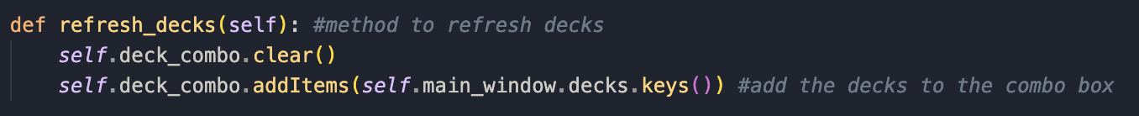
- This method updates the deck selection on the combo box with the latest lift of decks that are in the main window.
- Self.deck_combo.clear() removes all items from the combo which ensures that no duplicate decks appear when refreshing.
- The next line gets the latest list oof decks from self.main_window.decks. decks.keys() retrieves the names of all deck where decks is a dictionary and they keys are deck names.
- addItems() then adds the deck names to the combo box.

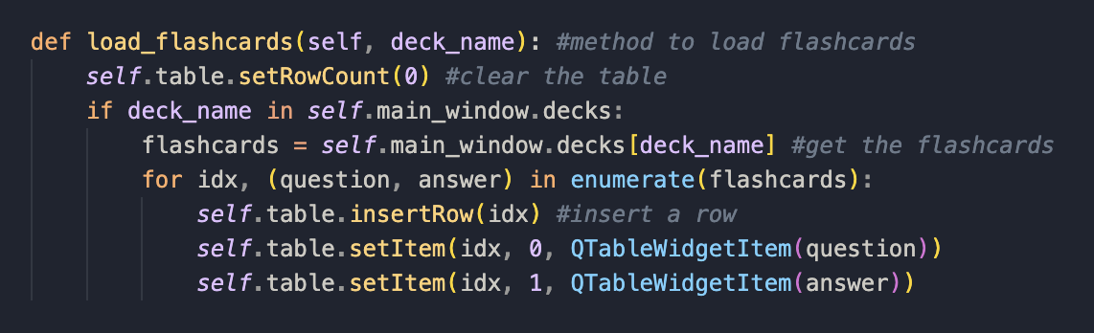
- This method loads flashcards from the selected deck into the table, updating the ui when the user selects a deck.
- self.table.setRowCount(0) removes all rows from the table before loading new flashcards. This ensures that the table doesn’t contain leftover data from a previous deck.
- if deck_name in self.main_window.decks: prevents errors in case the user selects a deck that doesn’t exist. It then looks up the selected deck in self.main_window.decks; decks is a dictionary where the key is the deck name and value is the list of flashcards.
- flashcards = self.main_window.decks[deck_name] gets the list of flashcards stored under the selected deck_name. As mentioned before each flashcard is stored as a tuple: (question, answer).
- I then populate the table using: for idx, (question, answer) in enumerate(flashcards): where this loops through the flashcard using enumerate() to track the row index. I found enumerate on https://www.geeksforgeeks.org/enumerate-in-python/.
- self.table.insertRow(idx) inserts a new row at index for each flashcard.
- self.table.setItem(idx, 0, QTableWidgetItem(question)) and self.table.setItem(idx, 1, QTableWidgetItem(answer)) creates a new QTableWidgetItem for each question and answer and places them in the appropriate rows where the column 0 is the question and column 1 is the answer.

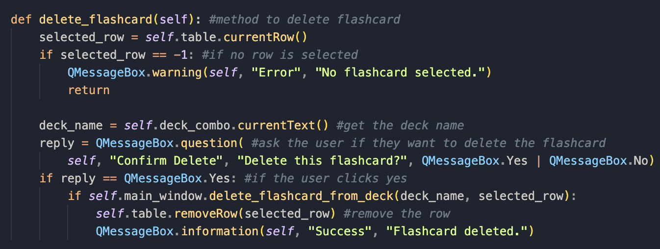
- This method allows the user to remove a selected flashcard from the table and the related deck in the main window.
- It first gets the currently selected row using self.table.currentRow(). If no row is selected it shows a warning message and quits the function.
- Next it gets the deck name using self.deck_combo.currentText().
- It then asks the user to confirm whether they want to delete the flashcard, where the user can select yes or no.
- If the user clicks Yes, the method calls self.main_window.delete_flashcard_from_deck(deck_name, selected_row).
- If the deletion is successful, it removes the corresponding row from self.table using self.table.removeRow(selected_row).

- This accesses the main windows stacked widget to use the back method.
Now, I need to create some methods in other classes to integrate the browse feature properly and connect the methods to the buttons:

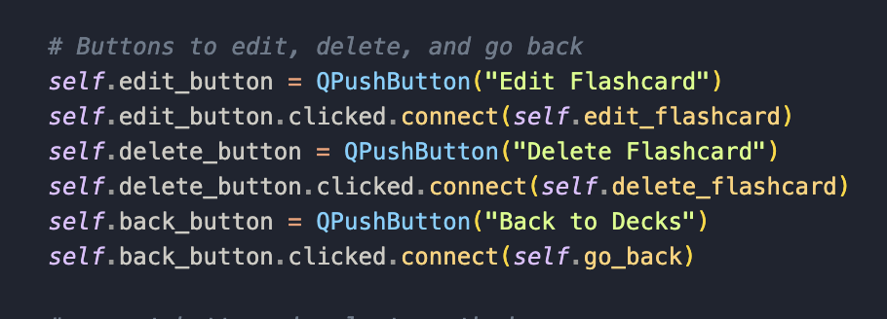
- I connected the buttons to the method.
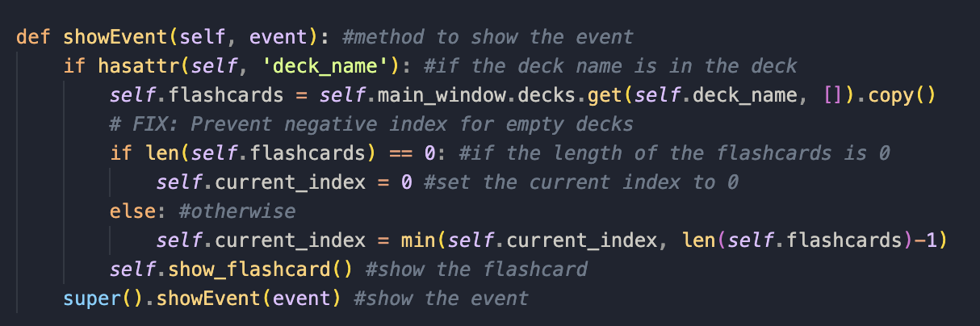This method was added the Flashcard_Page class. The showEvent method in PyQt is triggered whenever the Browse Page widget is shown. This ensures that the displayed flashcards are updated correctly when the page appears.
- I first check if the deck name exists using if hasattr(self, ‘deck_name’). The hasattr(self, 'deck_name') function checks if the deck_name attribute exists in the browse Page instance. If deck_name exists, it means a specific deck has been selected, and we should load its flashcards.
- I then reload the flashcards by retrieving the latest flashcards from self.main_window.decks to make sure data is the new flashcards. self.flashcards = self.main_window.decks.get(self.deck_name, []).copy() .copy() ensures that modifications to self.flashcards don't directly alter self.main_window.decks.
- I then prevent any negative indexes, as they’ve caused a problem for me in the past by using if len(self.flashcards) == 0… which ensures that If the deck is empty, self.current_index is set to 0. Otherwise, it ensures self.current_index is within bounds.
- It then shows the current flashcard using self.show_flashcard() by calling the method to update the ui.
- super().showEvent(event) ensures that any behaviour defined in the class QWidget still runs.
- I also imported: from PyQt5.QtCore import Qt which imports the Qt module from the PyQt5.QtCore package.

Now that I have finished budling the browse page, I will commence testing on the browse page:

Browse page testing:
What I’ll be testing: | Browse page creation: checking if I the browse page works as intended
Justification: | Ensures that the user can use the browse page to view and edit and delete flashcards; competitors data
Expected outcome: | Check if drop down box is shown correctly
Actual outcome: | drop down box is shown correctly
Results: | 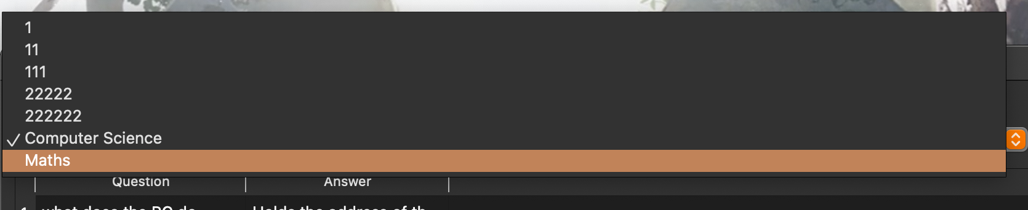

What I’ll be testing: | Browse page creation: checking if I the browse page works as intended
Justification: | Ensures that the user can use the browse page to view and edit and delete flashcards; competitors data
Expected outcome: | Check if all the flashcards of a deck are shown correctly
Actual outcome: | all the flashcards of a deck are shown correctly
Results: | 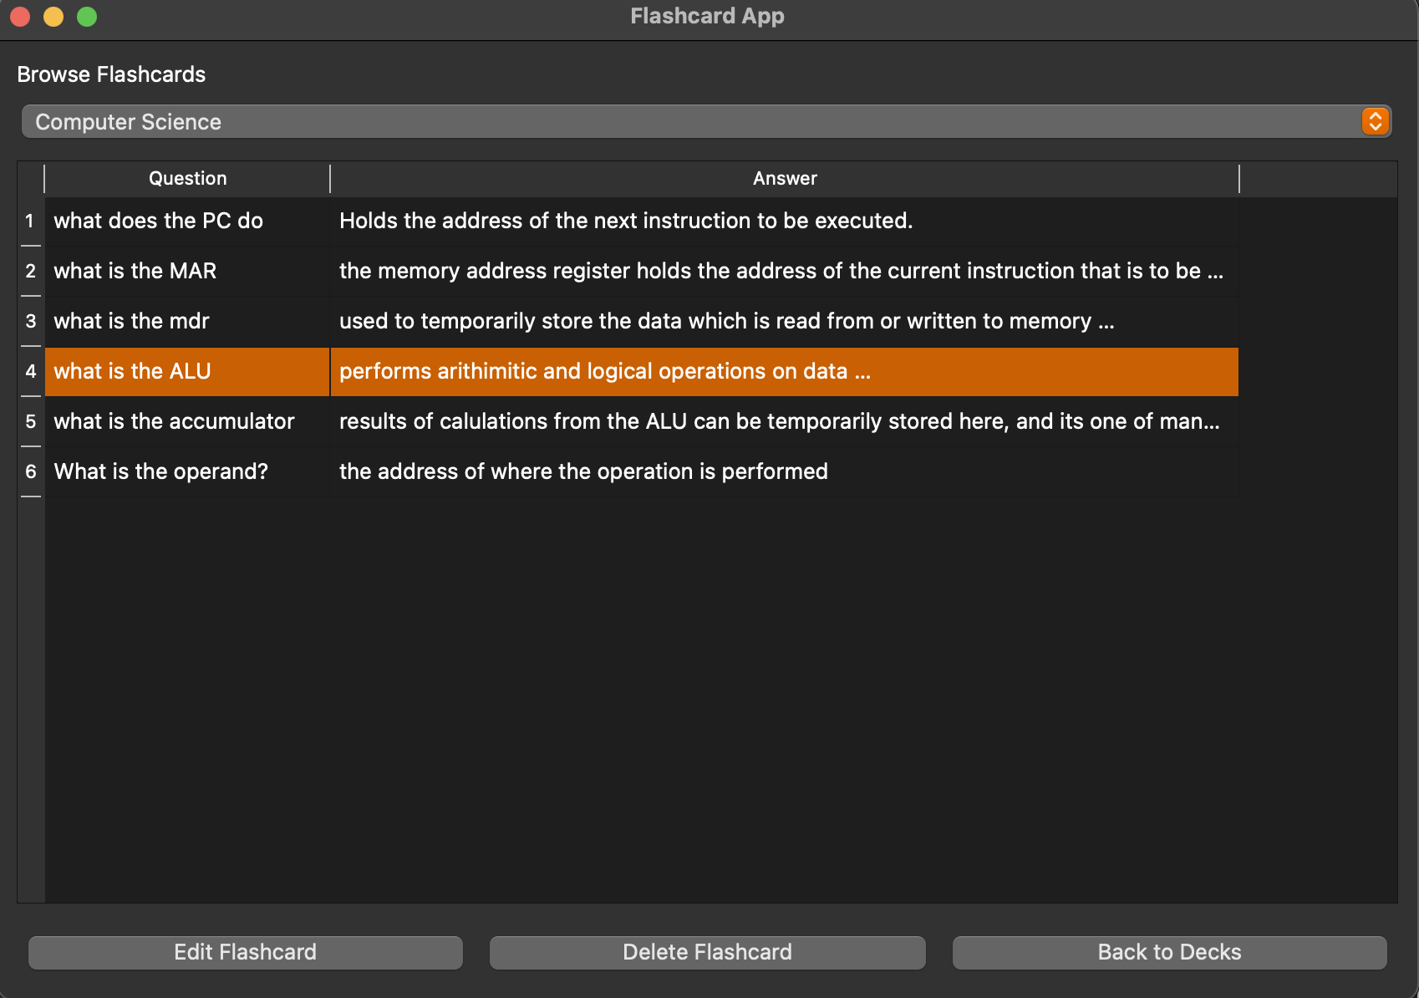

What I’ll be testing: | Browse page creation: checking if I the browse page works as intended
Justification: | Ensures that the user can use the browse page to view and edit and delete flashcards; competitors data
Expected outcome: | Checking if the browse button and back to decks buttons work
Actual outcome: | It takes me to the browse page and back to decks button takes me back to mainpage
Results: | N/A (they did work)

What I’ll be testing: | Browse page creation: checking if I the browse page works as intended
Justification: | Ensures that the user can use the browse page to view and edit and delete flashcards; competitors data
Expected outcome: | Checking if I can edit a flashcard
Actual outcome: | The flashcard has been edited
Results: | 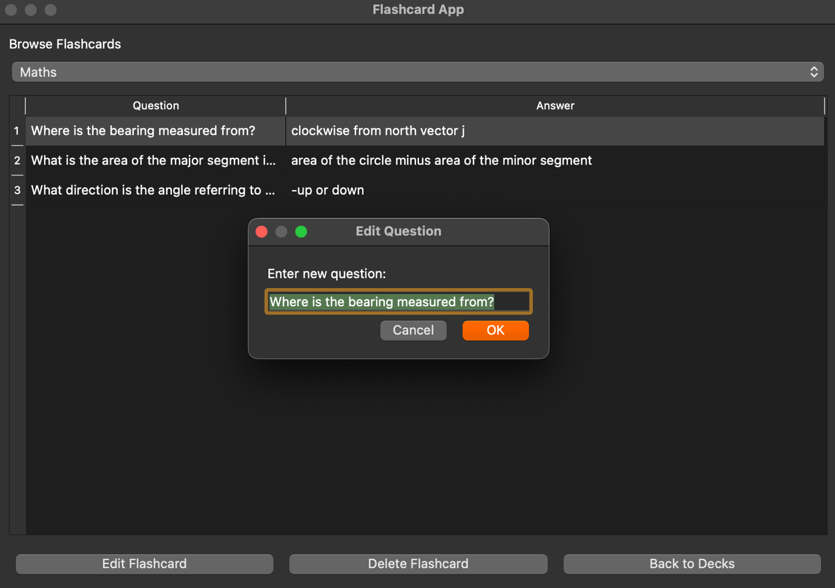  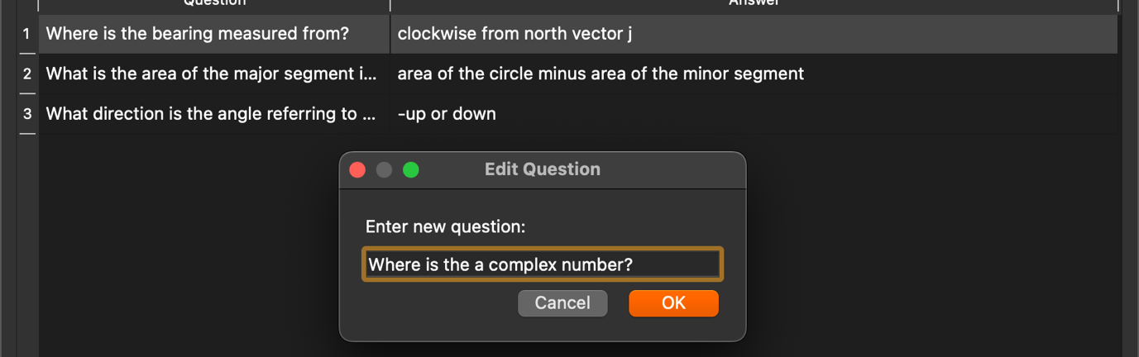  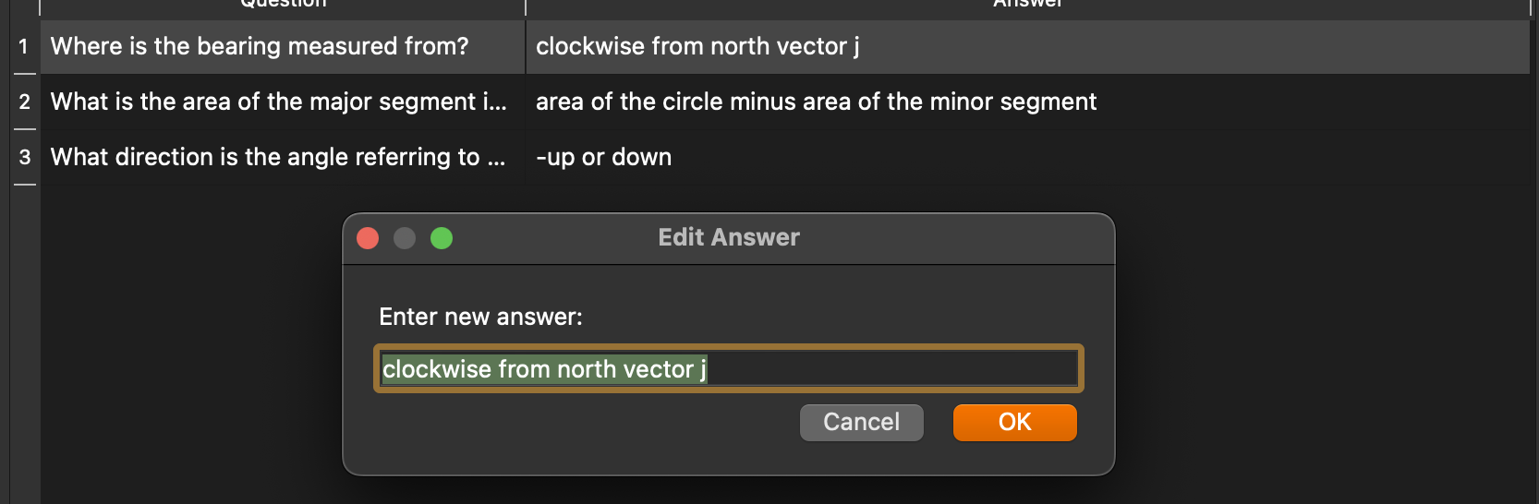  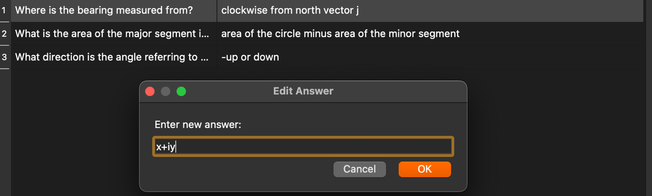  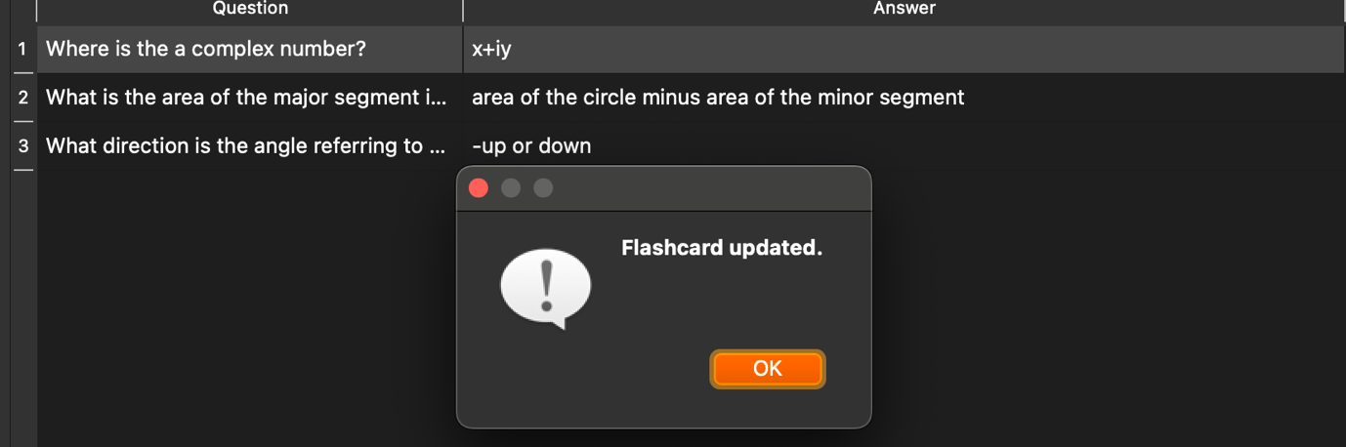

What I’ll be testing: | Browse page creation: checking if I the browse page works as intended
Justification: | Ensures that the user can use the browse page to view and edit and delete flashcards; competitors data
Expected outcome: | Checking if the delete flashcard button works
Actual outcome: | the delete flashcard button deletes the flashcard
Results: | 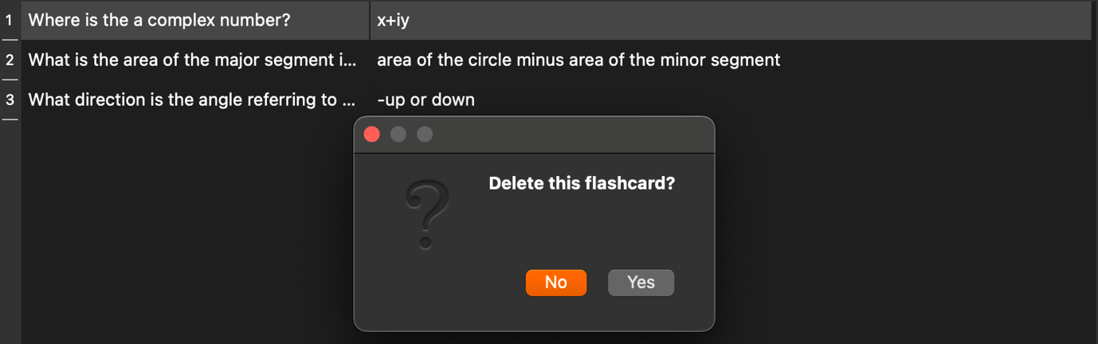  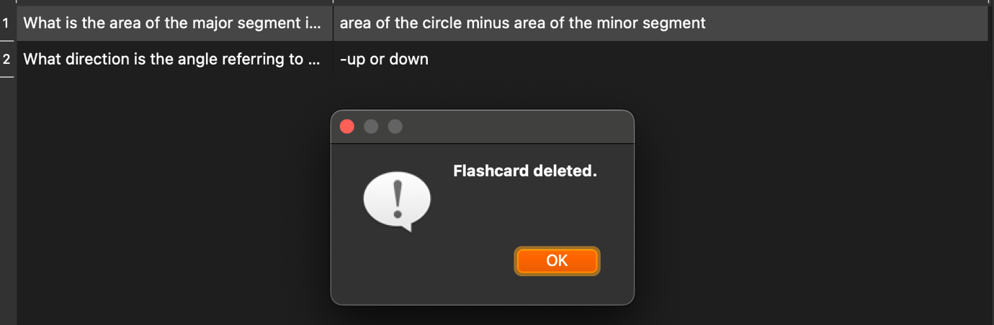

Errors:
Thankfully there are no errors in the browse page class.

Stakeholder talk:
I wanted to have talk to my stakeholder to see if they like the direction I took the app in. I will perform an interview with them asking a few questions:
Do you like the way I implemented the browse page?
- Yes, I think the way you added it is perfect to be honest, it works just like ankis browse page and I have no complaints.
Anything else you want to add?
- I would like to see the stats feature next. Also, ive thought about this for a while but I actually don’t want a way to implement wallpapers in the flashcard app as I feel like that would only distract me from doing flashcards. So please skip that feature.
Review: The settings page was going to have nothing in it anyway as the save function is automatically saved now. So getting rid of the wallpaper makes the app look cleaner as well.

